

What is one of the fastest growing team sports in Australia??

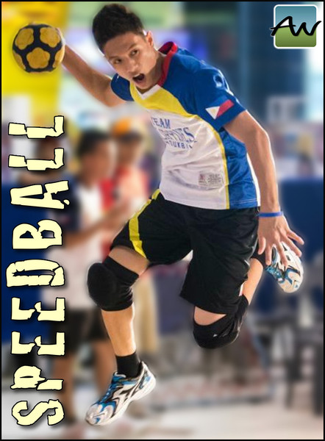

Kelly sports are offering kids in years 3-6 the chance to be a part of an exciting new program. Speedball is a fast paced, exciting sport that is energizing and entertaining!!!!

What is SPEEDBALL?

Speedball is a combination of soccer, basketball and handball. It is fast paced and fun. The game is played with a soccer ball. When it is on the ground, soccer rules apply. If the ball is kicked in the air and caught, basketball rules apply. There are different scoring options and games can be played with big groups or small.

See the link below for a video description.

https://www.youtube.com/watch?v=Zi3NqQ34oQI

When will it take place?

Kelly Sports will be running this program starting on Wednesday 24th of August. It will run every Thursday until the end of term 3 – 14th September. 3.10pm – 4.10pm.

Where will it be run?

The program will be run in the Kingswood College gym.

Make sure you get in quick! $40 for 4 weeks

Sign up now at [www.kellysports.com.au](http://www.kellysports.com.au), enter your postcode and then select Kingswood College or…

Contact *Gary Hoskin*: [gary@kellysports.com.au](mailto:gary@kellysports.com.au)

0437 076 897