 

**T** 0437 076 897

**$72 FOR**

**6 WEEKS**

**E** gary@kellysports.com.au

**SPORTLINK AT VERMONT**

**Want to do Kelly Sports but it’s not offered at your school? Well, now you can! Kelly Sports is now offering sessions at Sportlink, Vermont.**

**ADVENTUROUS AUTUMN SPORTS**



**WHEN:** Thursday

**COMMENCING:** 19/05/16

**CONCLUDING:** 23/06/16

**TIME:** 4:00pm – 5:00pm

**COST:** $72 for 6 weeks

Soccer – Basketball – AFL

Take on new adventures this term! Adventurous Autumn Sports dynamic and active programs run for the rest of the term; sports covered include soccer, basketball, and AFL. This Program will not only provide an essential base for your child's motor skills but help build awareness, co-ordination and friendship all in an enjoyable environment.

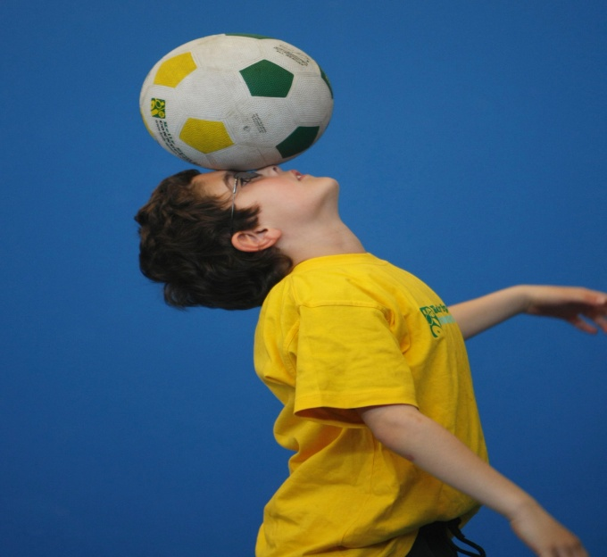

**­**



**JUST DANCE!**

JUST DANCE!

Children have the opportunity to learn a variety of modern Dance steps culminating in a routine performed in front of parents and friends. Come and learn fun dance routines and have fun and laughter with your friends. Easy for all ages and experience to pick up from trained Kelly Sports instructors.

**WHEN:** Tuesday

**COMMENCING:** 17/04/16

**CONCLUDING:** 21/06/16

**TIME:** 4:00pm – 5:00pm

**COST:** $72 for 6 weeks





HOW DO YOU ENROL?

SIMPLY GO TO [WWW.KELLYSPORTS.COM.AU](http://WWW.KELLYSPORTS.COM.AU) ENTER YOUR POSTCODE, SELECT VERMONT SPORTLINK AND ENROL FROM THERE.

**­**

**It’s here online enrolments !**

**To enrol**, please visit [www.kellysports.com.au](http://www.kellysports.com.au) or

fill out the enrolment form & **send** with a cheque or credit card details to:

Kelly Sports PO BOX 71, Moonee Vale, VIC, 3055.

Payment options available!

Do **not** leave enrolment forms at the school office