 

**T** 0437 076 897

**FOLLOW US**

**ONLINE**

**E** gary@kellysports.com.au



**PARKSIDE PRESCHOOL**



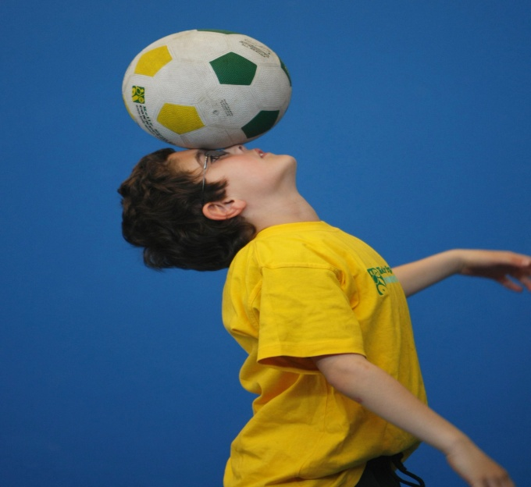

**FUNDAMENTAL MOTOR SKILLS PROGRAM**

Kelly Sports runs programs to teach children the fundamentals of sport. This 11 WEEK program is all inclusive with high participation. Our key aims are to develop and enhance the following skills – running, jumping, catching, throwing, passing, kicking and striking:

The Fundamental Skills Program includes:

- Motor Skill Development

- Balance and Hand- Eye Coordination

- Introduction to a variety of sports -Soccer, Basketball, Handball, Hockey, Football and more.

**­**

**WHEN:** Wednesday

**COMMENCING:** 13/04/16

**CONCLUDING:** 22/06/16

**TIME:** 9:30am – 10:30am

**COST:** $99 for 11 weeks



HOW DO YOU ENROL?

SIMPLY GO TO [WWW.KELLYSPORTS.COM.AU](http://WWW.KELLYSPORTS.COM.AU) ENTER YOUR POSTCODE, SELECT PARKSIDE PRESCHOOL AND ENROL FROM THERE.

**It’s here online enrolments !**

**To enrol**, please visit [www.kellysports.com.au](http://www.kellysports.com.au) or

fill out the enrolment form & **send** with a cheque or credit card details to:

Kelly Sports PO BOX 71, Moonee Vale, VIC, 3055.

Payment options available!

Do **not** leave enrolment forms at the school office