 P.O. Box 5185, Pinewood, 3149

**FOLLOW US**

**ONLINE**

**T** 0437 076 897

**E** gary@kellysports.com.au



**MITCHAM PRIMARY SCHOOL**

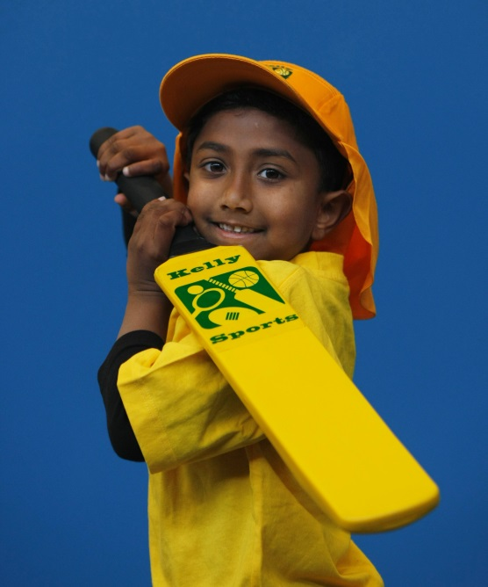

**SUPER SUMMER SPORTS**

**Soccer – Cricket – Basketball**

Have fun in the sun this term! Super Summer Sports dynamic and active programs run over 7 weeks; these include: Soccer, Basketball and Cricket..This Program will not only provide an essential base for your child's motor skills but help build awareness, co-ordination and friendship all in an enjoyable environment.

**WHEN:** Monday

**COMMENCING:** 8/2/16

**CONCLUDING:** 21/3/16

**TIME:** 3.20pm – 4.20pm

**YEAR LEVELS:** P – 4

**COST:** $70



**GYM CLUB**

**GYM CLUB**

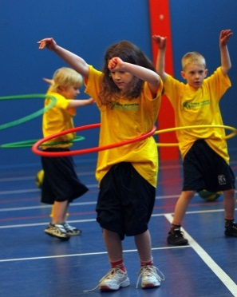

**BEND YOUR WAY TO GYM CLUB THIS TERM!** This fast paced, highly active and nonstop program is an introduction for your child to the world of gymnastic. Colourful Ribbons, Entertaining Hula Hoops, Fantastic Rhythmical Routines and Group Dynamics allow your child to build up their thirst for energetic activities

**WHEN:** Monday

**COMMENCING:** 8/2/16

**CONCLUDING:** 21/3/16

**TIME:** 1.20pm – 2.20pm

**YEAR LEVELS:** P – 4

**COST:** $70



**GET IN QUICK FOR TERM 1 AS PLACES FILLING FAST**

**It’s here online enrolments !**

**To enrol**, please visit [www.kellysports.com.au](http://www.kellysports.com.au) or

fill out the enrolment form & **send** with a cheque or credit card details to:

Kelly Sports PO BOX 71, Moonee Vale, VIC, 3055.

Payment options available!

Do **not** leave enrolment forms at the school office

**$70 FOR 7 WEEK PROGRAM**

**­**

NEW IMPROVED ONLINE BOOKING SYSTEM!!!

SIMPLY GO TO [WWW.KELLYSPORTS.COM.AU](http://WWW.KELLYSPORTS.COM.AU) ENTER YOUR POST CODE AND ENROL FROM THERE. OR

FILL OUT THE BELOW ENROLMENT FOR & SEND WITH A CHEQUE OR CREDIT CARDS DETAILS TO:

**PO BOX 5185, PINEWOOD 3149**

PAYMENT OPTIONS AVALIABLE!

**It’s here online enrolments !**

**To enrol**, please visit [www.kellysports.com.au](http://www.kellysports.com.au) or

fill out the enrolment form & **send** with a cheque or credit card details to:

Kelly Sports PO BOX 71, Moonee Vale, VIC, 3055.

Payment options available!

Do **not** leave enrolment forms at the school office

**ENROLMENT FORM**

□ **Super Summer Sports** □ **Gym Club**

School: Year Level:

Name: Room No:

Address: Post Code:

Phone: Mobile/Work:

Email: Medical Conditions:

At the completion of after school clinics, does your child? □ Go to after care □ Get collected

**Parents’ consent: I hereby authorise Kelly Sports to act on my behalf should my child require medical attention, and release   
Kelly Sports Blackburn from any liability for injury incurred by my child at Kelly Sports programs.**

Parent/Caregiver name: Signature:

Amount Paid: $ Credit card payment: □ **Visa** □ **Master card**

Card Number: □□□□ □□□□ □□□□ □□□□Expiry Date: □□/□□CVV:□□□

**THINGS TO KNOW**

Kelly Sports is a Registered Child Care provider

Don’t leave forms at the School Office

Spaces are limited so please make sure you enrol online or return form to Kelly Sports.

**It’s here online enrolments !**

**To enrol**, please visit [www.kellysports.com.au](http://www.kellysports.com.au) or

fill out the enrolment form & **send** with a cheque or credit card details to:

Kelly Sports PO BOX 71, Moonee Vale, VIC, 3055.

Payment options available!

Do **not** leave enrolment forms at the school office

**It’s here online enrolments !**

**To enrol**, please visit [www.kellysports.com.au](http://www.kellysports.com.au) or

fill out the enrolment form & **send** with a cheque or credit card details to:

Kelly Sports PO BOX 71, Moonee Vale, VIC, 3055.

Payment options available!

Do **not** leave enrolment forms at the school office

**It’s here online enrolments !**

**To enrol**, please visit [www.kellysports.com.au](http://www.kellysports.com.au) or

fill out the enrolment form & **send** with a cheque or credit card details to:

Kelly Sports PO BOX 71, Moonee Vale, VIC, 3055.

Payment options available!

Do **not** leave enrolment forms at the school office