 

P.O. Box 5185, Pinewood, 3149

**T** 0437 076 897

**FOLLOW US**

**ONLINE**

**E** gary@kellysports.com.au



**KERRIMUIR PRIMARY SCHOOL**

**DANCE**

**Hip Hop (P-2)** - Our Specialized dance coaches can get your child’s hips swinging, feet rocking and heads bumping to all of the modern music contemporary Have fun in the sun this term! Super Summer Sports dynamic and active programs run over 7 weeks; these include: Soccer, Basketball and Cricket.. This Program will not only provide an essential base for your child's motor skills but help build awareness, co-ordination and friendship all in an enjoyable environment.

music classics.

Sign up fast as places are limited for our 7 week program and let our coaches beat, ignite your child’s feet!



**WHEN:** Tuesday

**COMMENCING:** 19/4/16

**CONCLUDING:** 21/6/16

**TIME:** 1.40pm – 2.30pm

**YEAR LEVELS:** P – 4

**COST:** $100



NEW IMPROVED ONLINE BOOKING SYSTEM!!!

SIMPLY GO TO [WWW.KELLYSPORTS.COM.AU](http://WWW.KELLYSPORTS.COM.AU) ENTER YOUR POST CODE AND ENROL FROM THERE.

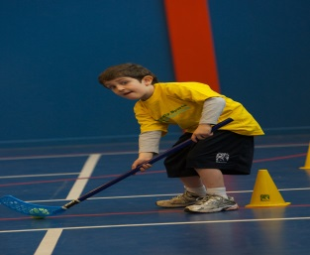**­**

**It’s here online enrolments !**

**To enrol**, please visit [www.kellysports.com.au](http://www.kellysports.com.au) or

fill out the enrolment form & **send** with a cheque or credit card details to:

Kelly Sports PO BOX 71, Moonee Vale, VIC, 3055.

Payment options available!

Do **not** leave enrolment forms at the school office

**It’s here online enrolments !**

**To enrol**, please visit [www.kellysports.com.au](http://www.kellysports.com.au) or

fill out the enrolment form & **send** with a cheque or credit card details to:

Kelly Sports PO BOX 71, Moonee Vale, VIC, 3055.

Payment options available!

Do **not** leave enrolment forms at the school office

**It’s here online enrolments !**

**To enrol**, please visit [www.kellysports.com.au](http://www.kellysports.com.au) or

fill out the enrolment form & **send** with a cheque or credit card details to:

Kelly Sports PO BOX 71, Moonee Vale, VIC, 3055.

Payment options available!

Do **not** leave enrolment forms at the school office

**It’s here online enrolments !**

**To enrol**, please visit [www.kellysports.com.au](http://www.kellysports.com.au) or

fill out the enrolment form & **send** with a cheque or credit card details to:

Kelly Sports PO BOX 71, Moonee Vale, VIC, 3055.

Payment options available!

Do **not** leave enrolment forms at the school office