 

P.O. Box 5185, Pinewood, 3149

**T** 0437 076 897

**FOLLOW US**

**ONLINE**

**E** gary@kellysports.com.au



**KERRIMUIR PRIMARY SCHOOL**

**DANCE**

**Hip Hop (P-2)** - Our Specialized dance coaches can get your child’s hips swinging, feet rocking and heads bumping to all of the modern music contemporary hits.

Sign up fast as places are limited for our 10 week program and let our coaches beat, ignite your child’s feet!



**WHEN:** Tuesday

**COMMENCING:** 19/4/16

**CONCLUDING:** 21/6/16

**TIME:** 1.40pm – 2.30pm

**YEAR LEVELS:** P – 4

**COST:** $100



NEW IMPROVED ONLINE BOOKING SYSTEM!!!

SIMPLY GO TO [WWW.KELLYSPORTS.COM.AU](http://WWW.KELLYSPORTS.COM.AU) ENTER YOUR POST CODE AND ENROL FROM THERE.

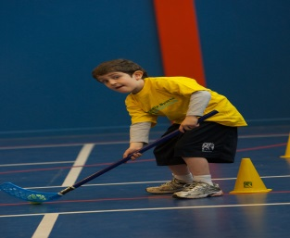**­**

**It’s here online enrolments !**

**To enrol**, please visit [www.kellysports.com.au](http://www.kellysports.com.au) or

fill out the enrolment form & **send** with a cheque or credit card details to:

Kelly Sports PO BOX 71, Moonee Vale, VIC, 3055.

Payment options available!

Do **not** leave enrolment forms at the school office

**It’s here online enrolments !**

**To enrol**, please visit [www.kellysports.com.au](http://www.kellysports.com.au) or

fill out the enrolment form & **send** with a cheque or credit card details to:

Kelly Sports PO BOX 71, Moonee Vale, VIC, 3055.

Payment options available!

Do **not** leave enrolment forms at the school office

**It’s here online enrolments !**

**To enrol**, please visit [www.kellysports.com.au](http://www.kellysports.com.au) or

fill out the enrolment form & **send** with a cheque or credit card details to:

Kelly Sports PO BOX 71, Moonee Vale, VIC, 3055.

Payment options available!

Do **not** leave enrolment forms at the school office

**It’s here online enrolments !**

**To enrol**, please visit [www.kellysports.com.au](http://www.kellysports.com.au) or

fill out the enrolment form & **send** with a cheque or credit card details to:

Kelly Sports PO BOX 71, Moonee Vale, VIC, 3055.

Payment options available!

Do **not** leave enrolment forms at the school office