 

P.O. Box 5185, Pinewood, 3149

**T** 0437 076 897

**FOLLOW US**

**ONLINE**

**E** gary@kellysports.com.au



**KERRIMUIR PRIMARY SCHOOL**

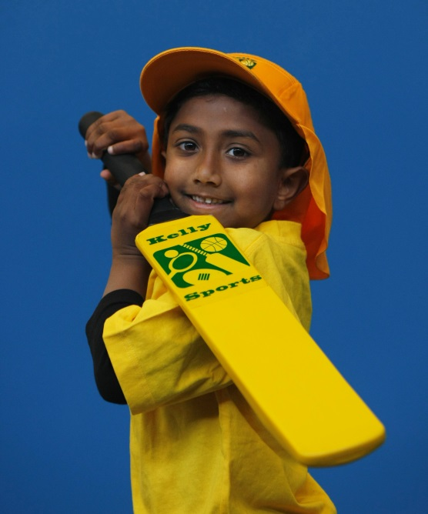

**SUPER SUMMER SPORTS**

**Soccer – Cricket – Basketball**

Have fun in the sun this term! Super Summer Sports dynamic and active programs run over 7 weeks; these include: Soccer, Basketball and Cricket.. This Program will not only provide an essential base for your child's motor skills but help build awareness, co-ordination and friendship all in an enjoyable environment. Reminder – no session on Monday 14.3.

**WHEN:** Monday

**COMMENCING:** 15/2/16

**CONCLUDING:** 21/3/16

**TIME:** 3.40pm – 4.40pm

**YEAR LEVELS:** P – 4

**COST:** $50



**DANCE**



**Hip Hop (P-2)** - Our Specialized dance coaches can get your child’s hips swinging, feet rocking and heads bumping to all of the modern music contemporary Have fun in the sun this term! Super Summer Sports dynamic and active programs run over 7 weeks; these include: Soccer, Basketball and Cricket.. This Program will not only provide an essential base for your child's motor skills but help build awareness, co-ordination and friendship all in an enjoyable environment.

music classics.

Sign up fast as places are limited for our 7 week program and let our coaches beat, ignite your child’s feet!

**WHEN:** Tuesday

**COMMENCING:** 16/2/16

**CONCLUDING:** 22/3/16

**TIME:** 1.40pm – 2.30pm

**YEAR LEVELS:** P – 4

**COST:** $60



**GET IN QUICK FOR TERM 1 AS PLACES FILLING FAST**

**It’s here online enrolments !**

**To enrol**, please visit [www.kellysports.com.au](http://www.kellysports.com.au) or

fill out the enrolment form & **send** with a cheque or credit card details to:

Kelly Sports PO BOX 71, Moonee Vale, VIC, 3055.

Payment options available!

Do **not** leave enrolment forms at the school office

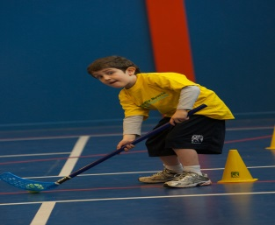**­**

NEW IMPROVED ONLINE BOOKING SYSTEM!!!

SIMPLY GO TO [WWW.KELLYSPORTS.COM.AU](http://WWW.KELLYSPORTS.COM.AU) ENTER YOUR POST CODE AND ENROL FROM THERE. OR

FILL OUT THE BELOW ENROLMENT FOR & SEND WITH A CHEQUE OR CREDIT CARDS DETAILS TO:

**PO BOX 5185 PINEWOOD 3149**

PAYMENT OPTIONS AVAILABLE!

**It’s here online enrolments !**

**To enrol**, please visit [www.kellysports.com.au](http://www.kellysports.com.au) or

fill out the enrolment form & **send** with a cheque or credit card details to:

Kelly Sports PO BOX 71, Moonee Vale, VIC, 3055.

Payment options available!

Do **not** leave enrolment forms at the school office

**ENROLMENT FORM**

□ **Super summer sports** □ **Dance**

School: Year Level:

Name: Room No:

Address: Post Code:

Phone: Mobile/Work:

Email: Medical Conditions:

At the completion of after school clinics, does your child? □ Go to after care □ Get collected

**Parents’ consent: I hereby authorise Kelly Sports to act on my behalf should my child require medical attention, and release   
Kelly Sports Blackburn from any liability for injury incurred by my child at Kelly Sports programs.**

Parent/Caregiver name: Signature:

Amount Paid: $ Credit card payment: □ **Visa** □ **Master card**

Card Number: □□□□ □□□□ □□□□ □□□□Expiry Date: □□/□□CVV:□□□

**It’s here online enrolments !**

**To enrol**, please visit [www.kellysports.com.au](http://www.kellysports.com.au) or

fill out the enrolment form & **send** with a cheque or credit card details to:

Kelly Sports PO BOX 71, Moonee Vale, VIC, 3055.

Payment options available!

Do **not** leave enrolment forms at the school office

**It’s here online enrolments !**

**To enrol**, please visit [www.kellysports.com.au](http://www.kellysports.com.au) or

fill out the enrolment form & **send** with a cheque or credit card details to:

Kelly Sports PO BOX 71, Moonee Vale, VIC, 3055.

Payment options available!

Do **not** leave enrolment forms at the school office

**It’s here online enrolments !**

**To enrol**, please visit [www.kellysports.com.au](http://www.kellysports.com.au) or

fill out the enrolment form & **send** with a cheque or credit card details to:

Kelly Sports PO BOX 71, Moonee Vale, VIC, 3055.

Payment options available!

Do **not** leave enrolment forms at the school office