 P.O. Box 5185, Pinewood, 3149

**FOLLOW US**

**ONLINE**

**T** 0437 076 897

**E** gary@kellysports.com.au



**HOLY SAVIOUR PRIMARY SCHOOL**

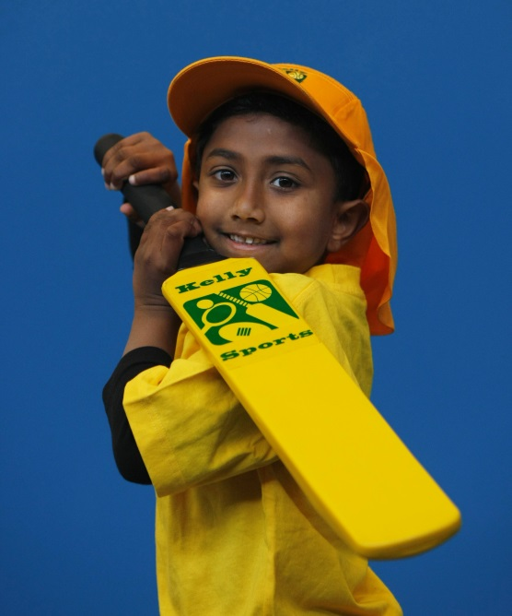

**SUPER SUMMER SPORTS**

**Soccer – Cricket – Basketball** Have fun in the sun this term! Super Summer Sports dynamic and active programs run over 7 weeks; these include: Soccer, Basketball and Cricket.. This Program will not only provide an essential base for your child's motor skills but help build awareness, co-ordination and friendship all in an enjoyable environment.

**WHEN:** Friday

**COMMENCING:** 12/2/16

**CONCLUDING:** 18/3/16

**TIME:** 3.40pm – 4.40pm

**YEAR LEVELS:** P – 4

**COST:** $60



**DANCE**



**WHEN:** Monday

**COMMENCING:** 8/2/16

**CONCLUDING:** 21/3/16

**TIME:** 1.30pm – 2.30pm

**YEAR LEVELS:** P – 4

**COST:** $70

**Hip Hop (P-4)** Our Specialized dance coaches can get your child’s hips swinging, feet rocking and heads bumping to all of the modern music contemporary music classics.

Sign up fast as places are limited for our 7 week program and let our coaches beat, ignite your child’s feet!



**GET IN QUICK FOR TERM 1 AS PLACES FILLING FAST**

**It’s here online enrolments !**

**To enrol**, please visit [www.kellysports.com.au](http://www.kellysports.com.au) or

fill out the enrolment form & **send** with a cheque or credit card details to:

Kelly Sports PO BOX 71, Moonee Vale, VIC, 3055.

Payment options available!

Do **not** leave enrolment forms at the school office

**­**

NEW IMPROVED ONLINE BOOKING SYSTEM!!!

SIMPLY GO TO [WWW.KELLYSPORTS.COM.AU](http://WWW.KELLYSPORTS.COM.AU) ENTER YOUR POST CODE AND ENROL FROM THERE. OR

FILL OUT THE BELOW ENROLMENT FORM & SEND WITH A CHEQUE OR CREDIT CARDS DETAILS TO:

**PO BOX 5185, PINEWOOD, 3149**

PAYMENT OPTIONS AVAILABLE!

**It’s here online enrolments !**

**To enrol**, please visit [www.kellysports.com.au](http://www.kellysports.com.au) or

fill out the enrolment form & **send** with a cheque or credit card details to:

Kelly Sports PO BOX 71, Moonee Vale, VIC, 3055.

Payment options available!

Do **not** leave enrolment forms at the school office

**ENROLMENT FORM**

□ **Super Summer Sports** □ **End of Year Cheer**

School: Year Level:

Name: Room No:

Address: Post Code:

Phone: Mobile/Work:

Email: Medical Conditions:

At the completion of after school clinics, does your child? □ Go to after care □ Get collected

**Parents’ consent: I hereby authorise Kelly Sports to act on my behalf should my child require medical attention, and release   
Kelly Sports Blackburn from any liability for injury incurred by my child at Kelly Sports programs.**

Parent/Caregiver name: Signature:

Amount Paid: $ Credit card payment: □ **Visa** □ **Master card**

Card Number: □□□□ □□□□ □□□□ □□□□Expiry Date: □□/□□CVV:□□□

**THINGS TO KNOW**

Kelly Sports is a Registered Child Care provider

Don’t leave forms at the School Office

Spaces are limited so please make sure you enrol online or return form to Kelly Sports.

**It’s here online enrolments !**

**To enrol**, please visit [www.kellysports.com.au](http://www.kellysports.com.au) or

fill out the enrolment form & **send** with a cheque or credit card details to:

Kelly Sports PO BOX 71, Moonee Vale, VIC, 3055.

Payment options available!

Do **not** leave enrolment forms at the school office

**It’s here online enrolments !**

**To enrol**, please visit [www.kellysports.com.au](http://www.kellysports.com.au) or

fill out the enrolment form & **send** with a cheque or credit card details to:

Kelly Sports PO BOX 71, Moonee Vale, VIC, 3055.

Payment options available!

Do **not** leave enrolment forms at the school office

**It’s here online enrolments !**

**To enrol**, please visit [www.kellysports.com.au](http://www.kellysports.com.au) or

fill out the enrolment form & **send** with a cheque or credit card details to:

Kelly Sports PO BOX 71, Moonee Vale, VIC, 3055.

Payment options available!

Do **not** leave enrolment forms at the school office