 P.O. Box 5185, Pinewood, 3149

**FOLLOW US**

**ONLINE**

**T** 0437 076 897

**E** gary@kellysports.com.au



**BLACKBURN PRIMARY SCHOOL**

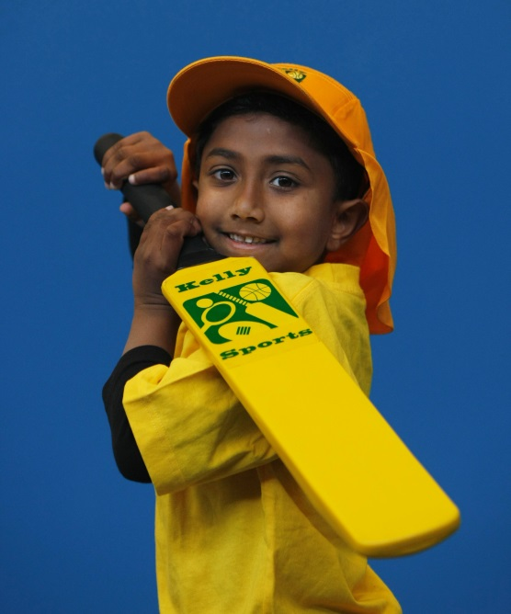

**BASKETBALL**

Have fun learning how to play Basketball with your friends in the Kelly Sports 7 week Basketball Clinic. Learn all the basic skills required to play the game in a safe and challenging environment.

Learn how to play like your heroes and have lots of fun learning all the skills in the game of Basketball.

**WHEN:** Wednesday

**COMMENCING:** 10/2/16

**CONCLUDING:** 23/3/16

**TIME:** 3.40pm – 4.40pm

**YEAR LEVELS:** P – 4

**COST:** $70



**DANCE**



**WHEN:** Thursday

**COMMENCING:** 11/2/16

**CONCLUDING:** 24/3/16

**TIME:** 1.30pm – 2.30pm

**YEAR LEVELS:** P – 4

**COST:** $70

Children have the opportunity to learn a variety of modern and traditional Dance steps culminating in a routine performed in front of the class. Come and learn fun dance routines and have fun and laughter with your friends. Easy for all ages and experience to pick up from trained Kelly Sports instructors.



**GET IN QUICK FOR TERM 1 AS PLACES FILLING FAST**

**It’s here online enrolments !**

**To enrol**, please visit [www.kellysports.com.au](http://www.kellysports.com.au) or

fill out the enrolment form & **send** with a cheque or credit card details to:

Kelly Sports PO BOX 71, Moonee Vale, VIC, 3055.

Payment options available!

Do **not** leave enrolment forms at the school office

**­**

NEW IMPROVED ONLINE BOOKING SYSTEM!!!

SIMPLY GO TO [WWW.KELLYSPORTS.COM.AU](http://WWW.KELLYSPORTS.COM.AU) ENTER YOUR POST CODE AND ENROL FROM THERE. OR

FILL OUT THE BELOW ENROLMENT FORM & SEND WITH A CHEQUE OR CREDIT CARDS DETAILS TO:

**PO BOX 5185, PINEWOOD, 3149**

PAYMENT OPTIONS AVAILABLE!

**It’s here online enrolments !**

**To enrol**, please visit [www.kellysports.com.au](http://www.kellysports.com.au) or

fill out the enrolment form & **send** with a cheque or credit card details to:

Kelly Sports PO BOX 71, Moonee Vale, VIC, 3055.

Payment options available!

Do **not** leave enrolment forms at the school office

**ENROLMENT FORM**

□ **Super Summer Sports** □ **End of Year Cheer**

School: Year Level:

Name: Room No:

Address: Post Code:

Phone: Mobile/Work:

Email: Medical Conditions:

At the completion of after school clinics, does your child? □ Go to after care □ Get collected

**Parents’ consent: I hereby authorise Kelly Sports to act on my behalf should my child require medical attention, and release   
Kelly Sports Blackburn from any liability for injury incurred by my child at Kelly Sports programs.**

Parent/Caregiver name: Signature:

Amount Paid: $ Credit card payment: □ **Visa** □ **Master card**

Card Number: □□□□ □□□□ □□□□ □□□□Expiry Date: □□/□□CVV:□□□

**THINGS TO KNOW**

Kelly Sports is a Registered Child Care provider

Don’t leave forms at the School Office

Spaces are limited so please make sure you enrol online or return form to Kelly Sports.

**It’s here online enrolments !**

**To enrol**, please visit [www.kellysports.com.au](http://www.kellysports.com.au) or

fill out the enrolment form & **send** with a cheque or credit card details to:

Kelly Sports PO BOX 71, Moonee Vale, VIC, 3055.

Payment options available!

Do **not** leave enrolment forms at the school office

**It’s here online enrolments !**

**To enrol**, please visit [www.kellysports.com.au](http://www.kellysports.com.au) or

fill out the enrolment form & **send** with a cheque or credit card details to:

Kelly Sports PO BOX 71, Moonee Vale, VIC, 3055.

Payment options available!

Do **not** leave enrolment forms at the school office

**It’s here online enrolments !**

**To enrol**, please visit [www.kellysports.com.au](http://www.kellysports.com.au) or

fill out the enrolment form & **send** with a cheque or credit card details to:

Kelly Sports PO BOX 71, Moonee Vale, VIC, 3055.

Payment options available!

Do **not** leave enrolment forms at the school office