 PO BOX 5185, Pinewood, 3149

**Special Offer   
$9.50/week   
for 7 weeks   
when you enrol  
on-line!**

**T** 0437 076 897

**E** gary@kellysports.com.au

**ANTONIO PARK PS**

**SUPER SUMMER SPORT**

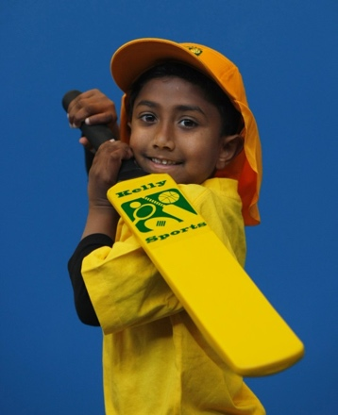

**Soccer – Cricket – Basketball**

Have fun in the sun this term! Super Summer Sports dynamic and active programs run over 7 weeks; these include: Soccer, Basketball,and Cricket.. This Program will not only provide an essential base for your child's motor skills but help build awareness, co-ordination and friendship all in an enjoyable environment.

**WHEN:** Wednesday

**COMMENCING:** 10/2/16

**CONCLUDING:** 23/3/16

**TIME:** 3.30-4.30pm

**YEAR LEVELS:** P – 4



**COST: $70** (enrol online for $66.50 – go to [**www.kellysports.com.au**](http://www.kellysports.com.au) and search for your school)

**It’s here online enrolments !**

**To enrol**, please visit [www.kellysports.com.au](http://www.kellysports.com.au) or

fill out the enrolment form & **send** with a cheque or credit card details to:

Kelly Sports PO BOX 71, Moonee Vale, VIC, 3055.

Payment options available!

Do **not** leave enrolment forms at the school office

**VENUE:** Antonio Park PS

**­**

**It’s here online enrolments !**

**To enrol**, please visit [www.kellysports.com.au](http://www.kellysports.com.au) or

fill out the enrolment form & **send** with a cheque or credit card details to:

Kelly Sports PO BOX 71, Moonee Vale, VIC, 3055.

Payment options available!

Do **not** leave enrolment forms at the school office

**ENROLMENT FORM**

School: Year Level:

Name: Room No:

Address: Post Code:

Phone: Mobile/Work:

Email: Medical Conditions:

At the completion of after school clinics, does your child? □ Go to after care □ Get collected

**Parents’ consent**

**I hereby authorise Kelly Sports to act on my behalf should my child require medical attention, and release Kelly Sports Templestowe from   
any liability for injury incurred by my child at Kelly Sports programmes.**

□ **I authorise the use by Kelly Sports of any photographs or video image of my child or legal charge for any reasonable purpose.**

Parent/Caregiver name: Signature:

Amount Paid: $ Credit card payment: □ **Visa** □ **Mastercard**

Card Number: □□□□ □□□□ □□□□ □□□□ Expiry Date: □□/□□

To enrol, please visit [**www.kellysports.com.au**](http://www.kellysports.com.au)or fill out the   
below enrolment form & sendwith a cheque or credit card details to:   
**PO BOX 5185, Pinewood 3149** Payment options available!   
**Do not** leave enrolment forms at the school office.

**ONLINE ENROLMENT**

**www.kellysports.com.au**

**It’s here online enrolments !**

**To enrol**, please visit [www.kellysports.com.au](http://www.kellysports.com.au) or

fill out the enrolment form & **send** with a cheque or credit card details to:

Kelly Sports PO BOX 71, Moonee Vale, VIC, 3055.

Payment options available!

Do **not** leave enrolment forms at the school office

**It’s here online enrolments !**

**To enrol**, please visit [www.kellysports.com.au](http://www.kellysports.com.au) or

fill out the enrolment form & **send** with a cheque or credit card details to:

Kelly Sports PO BOX 71, Moonee Vale, VIC, 3055.

Payment options available!

Do **not** leave enrolment forms at the school office

**It’s here online enrolments !**

**To enrol**, please visit [www.kellysports.com.au](http://www.kellysports.com.au) or

fill out the enrolment form & **send** with a cheque or credit card details to:

Kelly Sports PO BOX 71, Moonee Vale, VIC, 3055.

Payment options available!

Do **not** leave enrolment forms at the school office