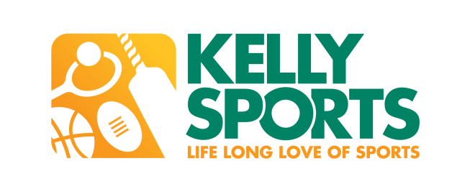

**ABN** 67606901919

P.O. Box 5185, Pinewood VIC 3149

**T** 0437 076 897

**www.kellysports.com.au**

**SPORTING SCHOOLS PROGRAM**

Dear Maria,

My name is Gary Hoskin and I am the Franchisee of the local Kelly Sports Area. Since 1994 Kelly Sports has been conducting programs encouraging physical activity both during school and out of school hours in over a 1500 primary schools throughout Australia.

Kelly Sports and the Sporting schools program (SSP) have been working together since the inception of the Term 2 2015 pilot program.

Kelly Sports has been involved with the old Active After school care program which now is called SSP.

Nationally recognized as the leading and largest provider of sports programs and clinics for school aged children, Kelly Sports delivers programs to young children from toddlers to teenagers within local schools.

We have developed a strong relationship with the Australian Sports Commission (ASC) and National Sporting Organizations (NSO) conducting over 1200 sessions across Australia, since the Term 2 Pilot program. It is a requirement that Kelly Sports staff are accredited and endorsed through each NSO to deliver the programs for SSP at your school. Kelly Sports with our team of accredited staff have the ability to provide a wide range of sports from;

**Hockey, Softball, AFL, Tennis, Badminton, Volleyball, Baseball, Golf, Netball, Squash, Table Tennis & Triathlon**

We are still adding sports to our program list, so please inform us if there are any other sports you are interested in.

SSP provides a great opportunity for children to participate in sports programs at NO COST to the school or parents.

The program can be run at a time that best suits the school, be it before, during or after school. Kelly Sports prides itself on offering quality sports clinics that focuses on development, participation and enjoyment for all children.

**Why choose Kelly Sports as your Sporting Schools provider?**

* Since 1994 have been conducting after school sports clinics.
* Kelly Sports engage and interact with over 55,000 children on a weekly basis before, during and after school. Both in and out of term time.
* $10 million public liability & $2 million professional indemnity insurance.
* Infrastructure to safely & efficiently deliver sports programs.
* All staff have Working With Children Checks



* Provide quality, skilled, trained & screened coaches in line with each NSO.

* Provide all equipment if required.
* Ongoing Quality Assurance structure in place through zone managers.
* Consistency, Reliable staff
* Proven record working with Children within Primary schools since 1994
* Kelly Sports pricing is dependent on the sport you select and your approved funding

Kelly Sports can facilitate a variety of sports, and this is beneficial to your school, as you will only have one contact to liaise with in regard to your sporting schools programs.

Kelly Sports offers on the ground trained personnel through all of Australia to deliver exceptionally high quality programs. Operating via a locally based franchise system, Kelly Sports understands the requirements of a specific regional area and can tailor the programs to the individual schools requirements.

The Sporting Schools Program is a great opportunity for all primary schools to assist their students in learning the joy that being active brings.

Should you have any queries please do not hesitate to call me.

Regards,

GARY HOSKIN, MANAGER, KELLY SPORTS BLACKBURN

