
T 0422 286 642


E michelle@kellysports.com.au

Kelly Sports Mornington Peninsula Region

MT ELIZA NORTH PRIMARY SCHOOL
SIZZLING SUMMER SPORTS

Kelly Sports is back in Term 1 for SIZZLING SUMMER SPORTS!! Over 7 weeks your child will participate in a range of lively and energetic programs including CRICKET, TENNIS, ATHLETICS AND CRAZY GAMES . This program will not only improve key sporting skills but also increase crucial motor skills in a fun, friendly and exciting environment. Enrol them now and let Kelly Sports give them a Life Long Love of Sports.

Sign up before the 4/2 and get one session for free. 7 weeks = $66,

It’s here online enrolments!
To enrol, please visit www.kellysports.com.au or
fill out the enrolment form & send with a cheque or credit card details to:
Kelly Sports PO BOX 71, Moonee Vale, VIC, 3055.
Payment options available!
Do not leave enrolment forms at the school office

It’s here online enrolments !
To enrol, please visit www.kellysports.com.au or
fill out the enrolment form & send with a cheque or credit card details to:
Kelly Sports PO BOX 71, Moonee Vale, VIC, 3055.
Payment options available!
Do not leave enrolment forms at the school office

It’s here online enrolments!
To enrol, please visit www.kellysports.com.au or
fill out the enrolment form & send with a cheque or credit card details to:
Kelly Sports PO BOX 71, Moonee Vale, VIC, 3055.
Payment options available!
Do not leave enrolment forms at the school office

It’s here online enrolments!
To enrol, please visit www.kellysports.com.au or
fill out the enrolment form & send with a cheque or credit card details to:
Kelly Sports PO BOX 71, Moonee Vale, VIC, 3055.
Payment options available!
Do not leave enrolment forms at the school office

It’s here online enrolments!
To enrol, please visit www.kellysports.com.au or
fill out the enrolment form & send with a cheque or credit card details to:
Kelly Sports PO BOX 71, Moonee Vale, VIC, 3055.
Payment options available!
Do not leave enrolment forms at the school office

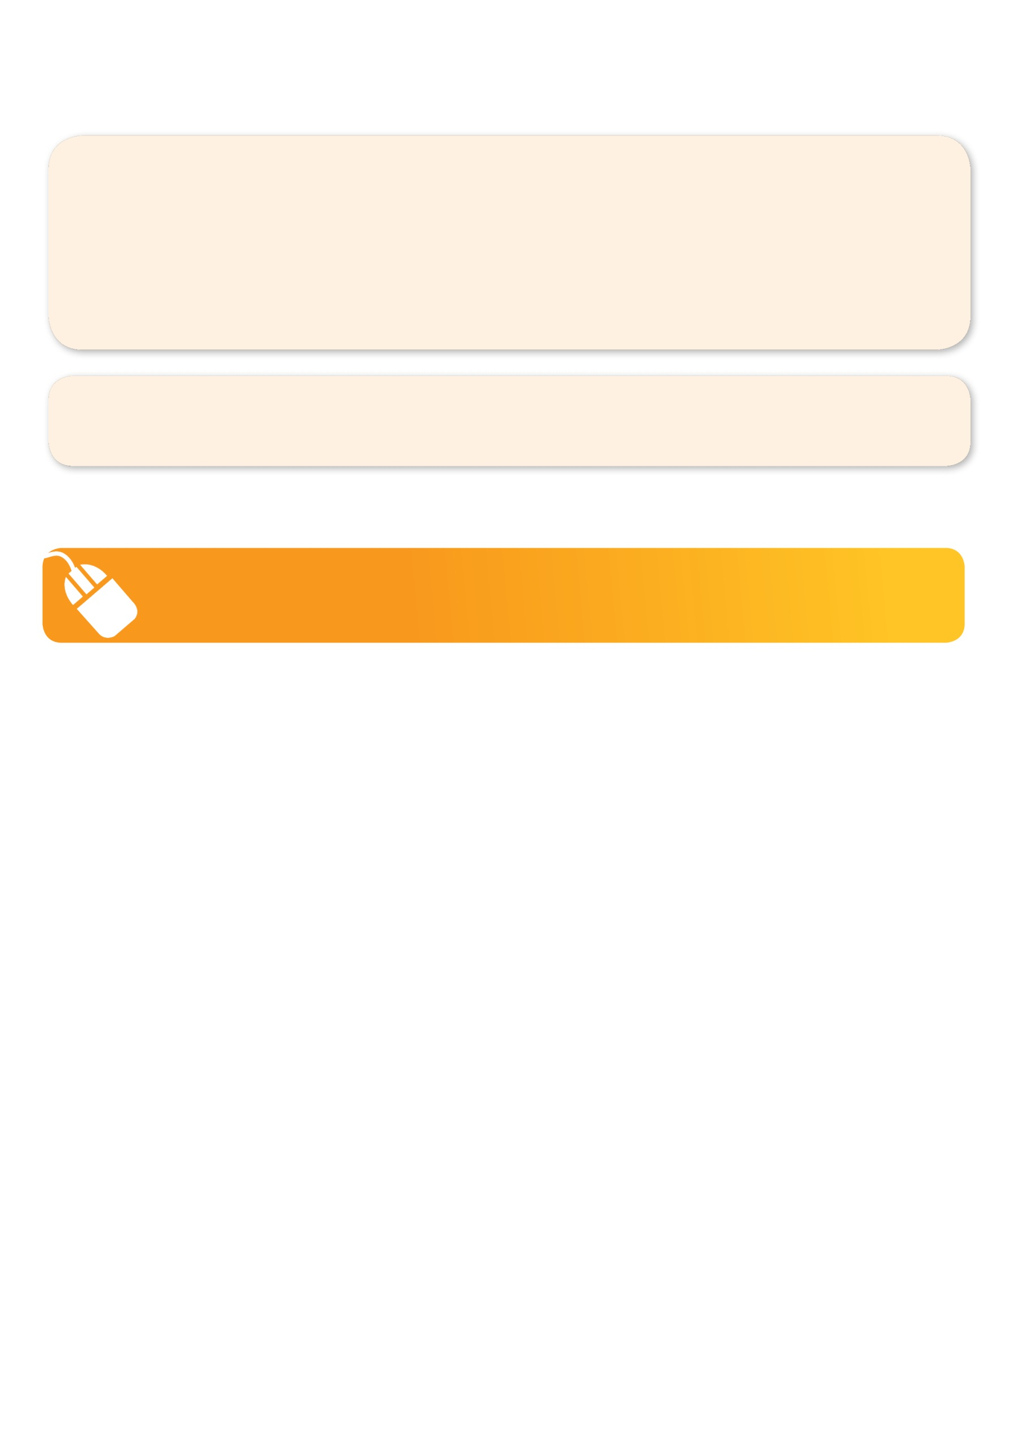
GET IN QUICK FOR TERM 1 AS PLACES ARE LIMITED AND WILL FILL FAST
$77 FOR THE 7 WEEK PROGRAM
WHEN: TUESDAYS
WHERE: On School Grounds
COMMENCING: 6/2/18
CONCLUDING: 20/3/18
TIME: 3.40pm – 4.40pm
YEAR LEVELS: P – GRADE 4
COST: $77

FEES MUST BE PAID BY WEEK 3

NEW IMPROVED ONLINE BOOKING SYSTEM!!!
SIMPLY GO TO WWW.KELLYSPORTS.COM.AU ENTER IN YOUR POSTCODE AND CLICK ON MT ELIZA NORTH PRIMARY SCHOOL’S PROGRAM

WHEN: THURSDAYS
WHERE: On School Grounds
COMMENCING: 8/2/18
CONCLUDING: 22/3/18
TIME: 3.40pm – 4.40pm
YEAR LEVELS: P – Grade 4
COST: $77

FEES MUST BE PAID BY WEEK 3
OR

KELLY SPORTS ALSO DOES SCHOOL HOLIDAY PROGRAMS & BIRTHDAY PARTIES.
Like us on Facebook, Kelly Sports Mornington Peninsula Region to keep up to date with what is happening in your area.

