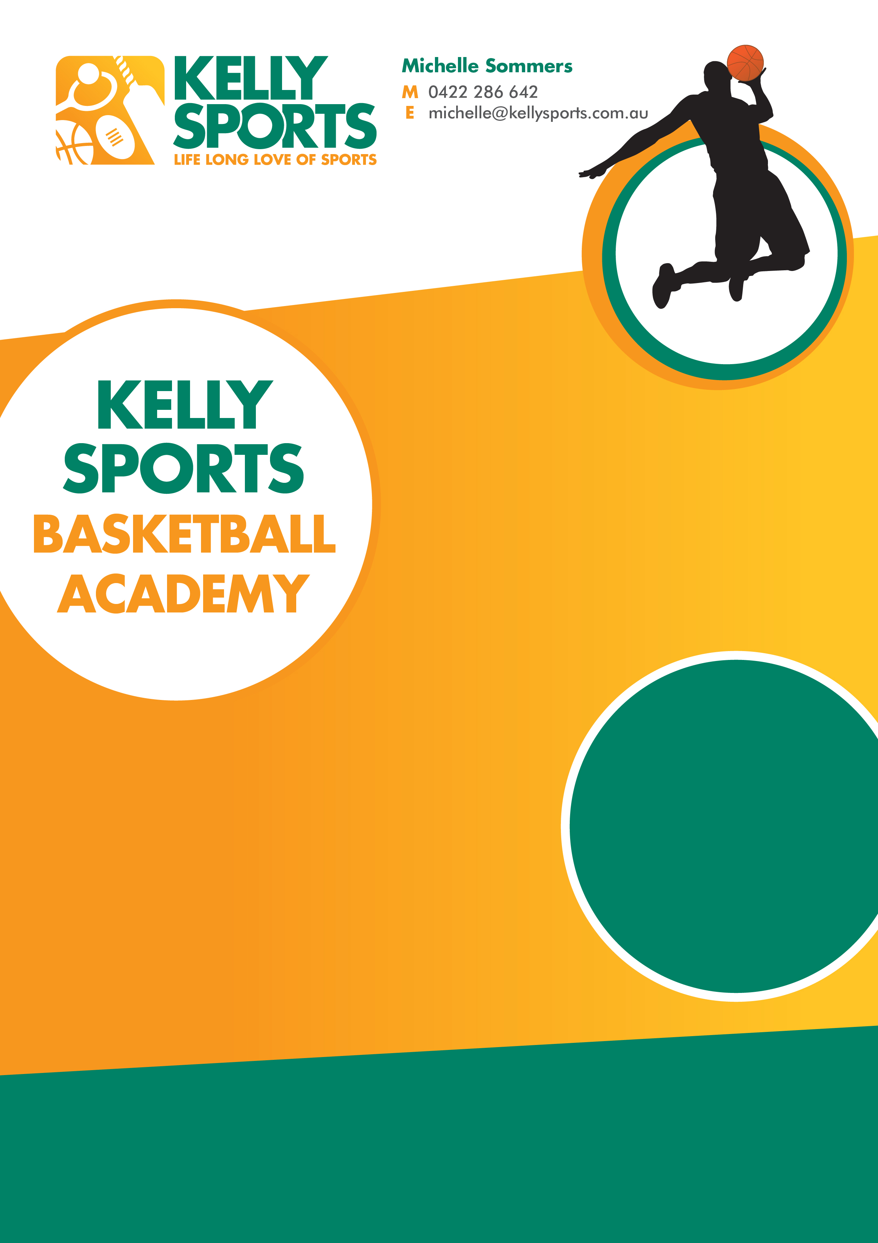

Kelly Sports is here in term 4 with a NEW program.

Over 9 weeks your child will participate in a number of Basketball skills and drills in a positive and inclusive environment.

Run at the school straight after the bell. This program will get your child active and ready to play against other schools in a round robin competition run in the last week of term.

Enrol them now and let Kelly Sports give them a Life Long Love of Sports.

**WHEN:**  Wednesdays

**WHERE:** On School Grounds

**COMMENCING:** 18th October

**CONCLUDING:** 13th December

**TIME:** 3.25pm to 4.25pm

**YEAR LEVELS:** Grade 3 to 6

**COST:** $99

**FEES TO BE PAID BY WEEK 3**

**GET IN QUICK FOR TERM 4 AS PLACES ARE LIMITED AND WILL FILL FAST**

**$99 FOR THE 9 WEEK PROGRAM.**

NEW IMPROVED ONLINE BOOKING SYSTEM!!!

SIMPLY GO TO WWW.K[ELLYSPORTS.COM.AU](http://WWW.KELLYSPORTS.COM.AU) ENTER IN YOUR POSTCODE AND CLICK ON

KINGSLEY PARK PRIMARY SCHOOL’S BASKETBALLPROGRAM

**KINGSLEY PARK PRIMARY SCHOOL**