
T Chris Hoegel: 0401 841 878


E chrishoegel@kellysports.com.au

Kelly Sports Mornington Peninsula Region

MT ELIZA NORTH PRIMARY SCHOOL
MIGHTY MULTI SPORTS

Kelly Sports is back in Term 3 for MIGHTY MULTI SPORTS!! Over 10 weeks your child will participate in a range of lively and energetic programs including AFL, HOCKEY, SOCCER, NETBALL AND FUN GAMES.This program will not only improve key sporting skills but also increase crucial motor skills in a fun, friendly and exciting environment. Enrol them now and let Kelly Sports give them a Life Long Love of Sports.

GET IN QUICK!
It’s here online enrolments!
To enrol, please visit www.kellysports.com.au or
fill out the enrolment form & send with a cheque or credit card details to:
Kelly Sports PO BOX 71, Moonee Vale, VIC, 3055.
Payment options available!
Do not leave enrolment forms at the school office

It’s here online enrolments !
To enrol, please visit www.kellysports.com.au or
fill out the enrolment form & send with a cheque or credit card details to:
Kelly Sports PO BOX 71, Moonee Vale, VIC, 3055.
Payment options available!
Do not leave enrolment forms at the school office

It’s here online enrolments!
To enrol, please visit www.kellysports.com.au or
fill out the enrolment form & send with a cheque or credit card details to:
Kelly Sports PO BOX 71, Moonee Vale, VIC, 3055.
Payment options available!
Do not leave enrolment forms at the school office

It’s here online enrolments!
To enrol, please visit www.kellysports.com.au or
fill out the enrolment form & send with a cheque or credit card details to:
Kelly Sports PO BOX 71, Moonee Vale, VIC, 3055.
Payment options available!
Do not leave enrolment forms at the school office

It’s here online enrolments!
To enrol, please visit www.kellysports.com.au or
fill out the enrolment form & send with a cheque or credit card details to:
Kelly Sports PO BOX 71, Moonee Vale, VIC, 3055.
Payment options available!
Do not leave enrolment forms at the school office

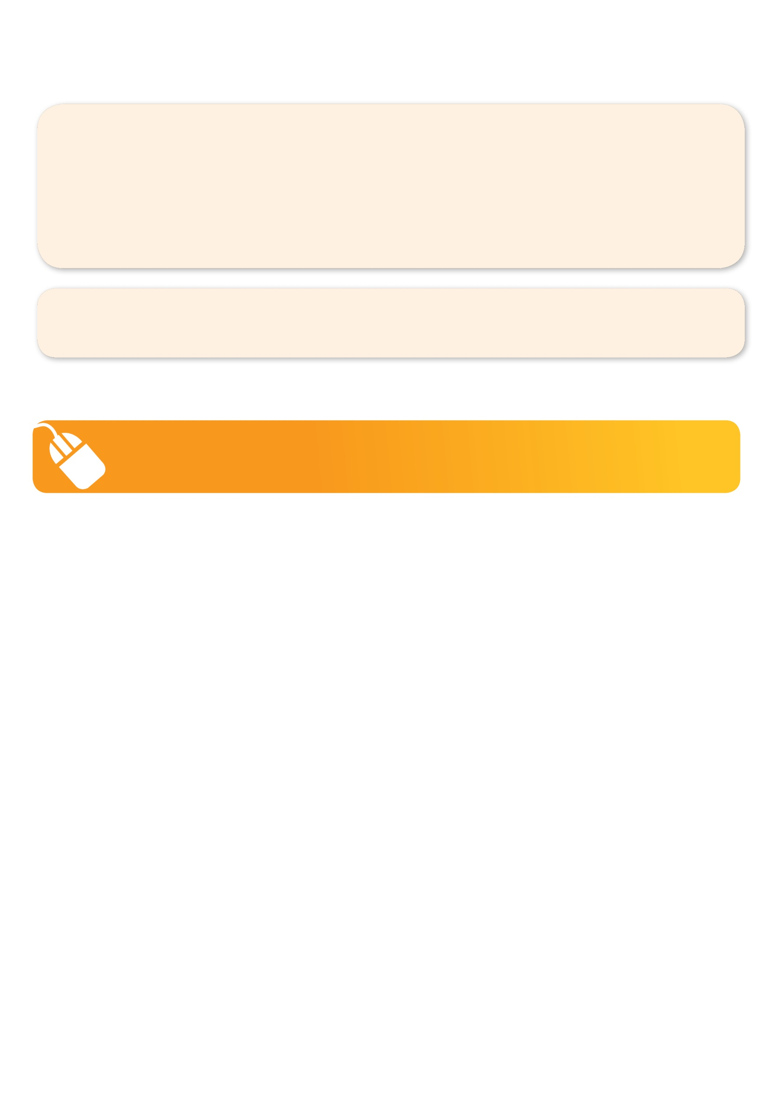
GET IN QUICK FOR TERM 3 AS PLACES ARE LIMITED AND WILL FILL FAST
$132 FOR THE 10 WEEK PROGRAM
WHEN: TUESDAYS
WHERE: On School Grounds
COMMENCING: 17/7/18
CONCLUDING: 18/9/18
TIME: 3.40pm – 4.40pm
YEAR LEVELS: P – GRADE 4
COST: $132 inc GST

NEW IMPROVED ONLINE BOOKING SYSTEM!!!
SIMPLY GO TO WWW.KELLYSPORTS.COM.AU ENTER IN YOUR POSTCODE AND CLICK ON MT ELIZA NORTH PRIMARY SCHOOL’S PROGRAM

WHEN: THURSDAYS
WHERE: On School Grounds
COMMENCING: 19/7/18
CONCLUDING: 20/9/18
TIME: 3.40pm – 4.40pm
YEAR LEVELS: P – Grade 4
COST: $132 inc GST

OR

KELLY SPORTS ALSO DOES SCHOOL HOLIDAY PROGRAMS & BIRTHDAY PARTIES.
Like us on Facebook, Kelly Sports Mornington Peninsula Region to keep up to date with what is happening in your area.

