
T Chris Hoegel: 0401 841 878


E chrishoegel@kellysports.com.au

Kelly Sports Mornington Peninsula Region

LANGWARRIN PRIMARY SCHOOL
SPRING INTO SPORTS

Start the new School term by enrolling in this fantastic Kelly sports program. Join up with your friends and develop your skills in a fun, safe and exciting sporting environment. With a new sport every 2 weeks the kids will love the variety and will be able to work on a range wide of sporting skills.

Hockey – Soccer – Basketball - AFL

It’s here online enrolments!
To enrol, please visit www.kellysports.com.au or
fill out the enrolment form & send with a cheque or credit card details to:
Kelly Sports PO BOX 71, Moonee Vale, VIC, 3055.
Payment options available!
Do not leave enrolment forms at the school office

It’s here online enrolments !
To enrol, please visit www.kellysports.com.au or
fill out the enrolment form & send with a cheque or credit card details to:
Kelly Sports PO BOX 71, Moonee Vale, VIC, 3055.
Payment options available!
Do not leave enrolment forms at the school office

WHEN: TUESDAYS
COMMENCING: 9/ 10/18
CONCLUDING: 11/10/18
TIME: 3.40pm – 4.40pm
YEAR LEVELS: P – GRADE 4
COST: $118.80 inc GST
*No program Melbourne cup Weekend (Tuesday 6th November)

It’s here online enrolments!
To enrol, please visit www.kellysports.com.au or
fill out the enrolment form & send with a cheque or credit card details to:
Kelly Sports PO BOX 71, Moonee Vale, VIC, 3055.
Payment options available!
Do not leave enrolment forms at the school office

It’s here online enrolments!
To enrol, please visit www.kellysports.com.au or
fill out the enrolment form & send with a cheque or credit card details to:
Kelly Sports PO BOX 71, Moonee Vale, VIC, 3055.
Payment options available!
Do not leave enrolment forms at the school office

It’s here online enrolments!
To enrol, please visit www.kellysports.com.au or
fill out the enrolment form & send with a cheque or credit card details to:
Kelly Sports PO BOX 71, Moonee Vale, VIC, 3055.
Payment options available!
Do not leave enrolment forms at the school office

SIGN UP FAST FOR TERM 4
SPORTS

GET IN QUICK FOR TERM 4 AS PLACES ARE LIMITED AND WILL FILL FAST
$118.80 FOR THE 9 WEEK PROGRAM
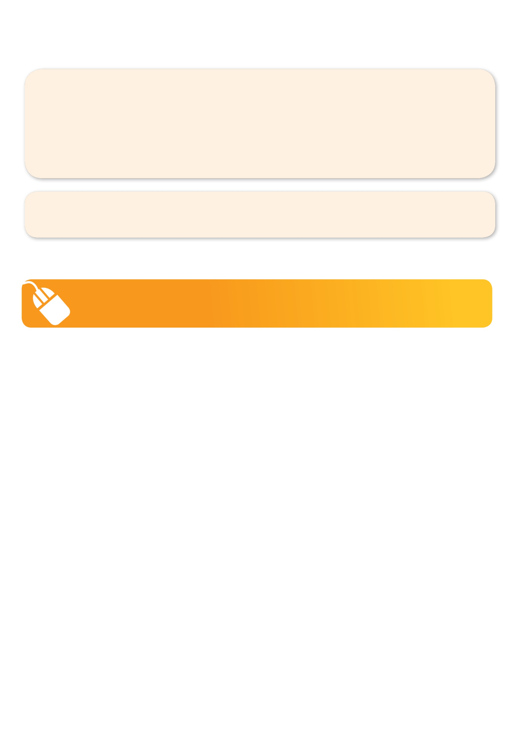
NEW IMPROVED ONLINE BOOKING SYSTEM!!!
SIMPLY GO TO WWW.KELLYSPORTS.COM.AU ENTER IN YOUR POSTCODE AND CLICK ON LANGWARRIN PRIMARY SCHOOL’S PROGRAM

KELLY SPORTS ALSO DOES SCHOOL HOLIDAY PROGRAMS & BIRTHDAY PARTIES.
Like our Facebook page, Kelly Sports Mornington Peninsula Region to keep up to date with what is happening in your area.

