

**MT ELIZA NORTH**

**PRIMARY SCHOOL P** (03) 9384 2204

**M** 0466 501 822

** E** [ann@kellysports.com.au](mailto:ann@kellysports.com.au)

**SPRING MULTI SPORTS – Thursday**Come and experience all the fun in our 9 week Kelly Sports

Spring Multi Sport program.

Our Kelly Sports classes are all inclusive, fun & interactive with a key focus on maximum participation. Each week children will be introduced to new sports & activities in a positive environment. It’s a fantastic way to get your child active while having fun as well as building confidence and social skills!

**BASKETBALL – Tuesday**

**Speed! Precision! Athleticism! Fun!**

Vibrant 9 week Basketball program we have on offer. This Basketball Program includes all the skill and activities required to help enhance your child’s skills and get them on the way to being the next basketball superstar. Hop on board and shoot a goal this term.





**How To Enrol?**Please visit [www.kellysports.com.au/events](http://www.kellysports.com.au/events) and search for your school.  
**Our new booking system requires upfront payments to secure your position. For more information, please call the head office.**



**"The Kelly Sports Programs offer our students opportunities for physical activities; including dance & multi-sports. Conveniently located on our school grounds, they are popular with students and their families. Staff are skilled in working with young people to love active participation.”**



***Amanda Hay, Principal – Newtown Primary School***

**CLASS INFORMATION**

Only 30 spots available for each program so sign up fast to secure your position

Mighty Multi Sports include **Soccer, Hockey, Basketball, Cricket & Crazy games**, plus we will incorporate our Kelly Sports Modified games children love.

**Come and join us every Tuesday and Thursday afterschool**

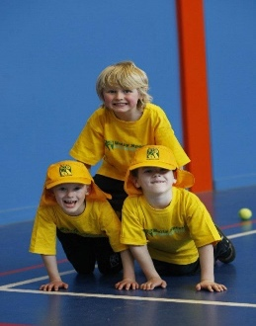

**When: Tuesdays & Thursdays**  
**Starts: 16th October & 18th October**   
**Finishes: 18th Dec & 13th Dec**  
**Sports: 3:40pm – 4:40pm  
Basketball: 3:40pm – 4:40pm**  
**Year Levels: Prep – 4  
Cost: $118.80 (Inc GST)  
Tuesday Make up session on the 18th Dec for Melbourne Cup Public Holiday**

