

P.O. Box 71, Moonee Vale 3055
FOLLOW US
ONLINE


MICHELLE SOMMERS
T 0422 286 642

E michelle@kellysports.com.au


ST JUDES PRIMARY SCHOOL
SUPER SPRING SPORTS (AFTER SCHOOL)
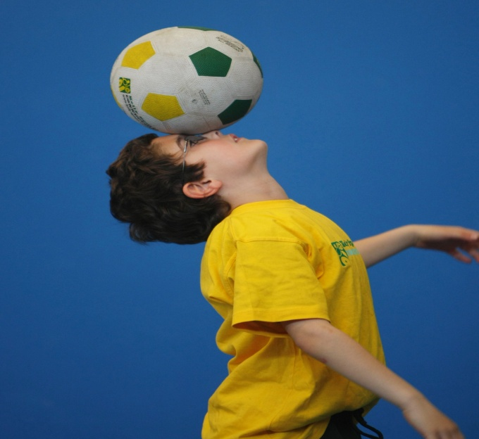
WHEN: Wednesday
COMMENCING: 12/10/16
CONCLUDING: 07/12/16
TIME: 3.20pm – 4.20pm
YEAR LEVELS: P – 4
COST: $90

Kelly Sports is here in Term 4 for SUPER SPRING SPORTS!! Over 9 weeks your child will participate in range of lively and energetic programs including T-BALL, CRAZY GAMES and ATHLETICS. This program will not only improve key sporting skills but also increase crucial motor skills, all in a fun, friendly and exciting environment. Enrol them now and let Kelly Sports give them a Life Long Love of Sports.


DANCE (LUNCH TIME)

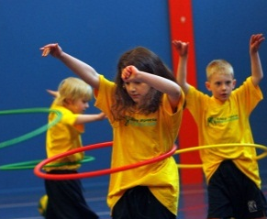
GET MOVING WITH KELLY DANCE THIS SPRING!
Over 9 weeks students will have the opportunity to move and groove. It helps build confidence and co-ordination, in an enjoyable environment. Our Hip Hop classes are high energy, rhythmic and electric. The dance is based on sharp strong movements and the class helps build rhythm, confidence and social skills in a friendly environment.

WHEN: Wednesday
COMMENCING: 12/10/16
CONCLUDING: 07/12/16
TIME: 11.05am – 11.45am
YEAR LEVELS: P – 6
COST: $90

GET IN QUICK FOR TERM 4 AS PLACES FILL FAST
It’s here online enrolments!
To enrol, please visit www.kellysports.com.au or
fill out the enrolment form & send with a cheque or credit card details to:
Kelly Sports PO BOX 71, Moonee Vale, VIC, 3055.
Payment options available!
Do not leave enrolment forms at the school office

$90 FOR THE 9 WEEK PROGRAM (PRICE IS PER PROGRAM, YOU CAN DO ONE OR DO BOTH ☺)
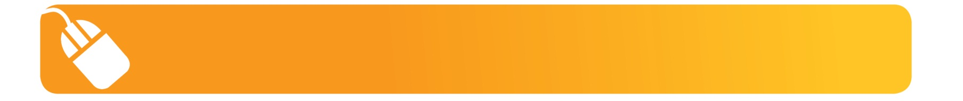
It’s here online enrolments!
To enrol, please visit www.kellysports.com.au or
fill out the enrolment form & send with a cheque or credit card details to:
Kelly Sports PO BOX 71, Moonee Vale, VIC, 3055.
Payment options available!
Do not leave enrolment forms at the school office

NEW IMPROVED ONLINE BOOKING SYSTEM!!!

SIMPLY GO TO WWW.KELLYSPORTS.COM.AU ENTER YOUR POST CODE AND ENROL
FROM THERE

Enrol before 09/10/16 and get the 9 weeks for the price of 8 that’s $80 for the 9 weeks.

It’s here online enrolments !
To enrol, please visit www.kellysports.com.au or
fill out the enrolment form & send with a cheque or credit card details to:
Kelly Sports PO BOX 71, Moonee Vale, VIC, 3055.
Payment options available!
Do not leave enrolment forms at the school office

It’s here online enrolments !
To enrol, please visit www.kellysports.com.au or
fill out the enrolment form & send with a cheque or credit card details to:
Kelly Sports PO BOX 71, Moonee Vale, VIC, 3055.
Payment options available!
Do not leave enrolment forms at the school office

It’s here online enrolments!
To enrol, please visit www.kellysports.com.au or
fill out the enrolment form & send with a cheque or credit card details to:
Kelly Sports PO BOX 71, Moonee Vale, VIC, 3055.
Payment options available!
Do not leave enrolment forms at the school office

ENROLMENT FORM – St Judes P.S
 Super Spring Sports  Dance
School: Year Level:
Name: BirthDate:
Address: Post Code:
Phone: Mobile/Work:
Email: Medical Conditions:

At the completion of after school clinics, does your child?  Go to after care  Get collected
Parents’ consent: I hereby authorise Kelly Sports to act on my behalf should my child require medical attention, and release
Kelly Sports Mornington Peninsula Region from any liability for injury incurred by my child at Kelly Sports programs.
Parent/Caregiver name: Signature:
Amount Paid: $ Credit card payment:  Visa  Master card (Surcharge applies)
Card Number:    Expiry Date: /CVV:
THINGS TO KNOW
Kelly Sports is a Registered Child Care provider
Don’t leave forms at the School Office
Spaces are limited so please make sure you enrol online or return form to Kelly Sports.

