
T 0422 286 642


E michelle@kellysports.com.a

Kelly Sports Mornington Peninsula Region

GOODSTART EARLY LEARNING - LANGWARRIN
AWESOME AUTUMN SPORTS

Kelly Sports runs a half an hour program to teach children the fundamentals of sport. This 8 WEEK program is all inclusive with high participation. Our aim is to develop and enhance the following skills – running, jumping, catching, throwing, passing, kicking and striking:
The Fundamental Skills Program includes:
- Motor Skill Development
- Balance and Hand- Eye Coordination
- Introduction to a variety of Sports

It’s here online enrolments!
To enrol, please visit www.kellysports.com.au or
fill out the enrolment form & send with a cheque or credit card details to:
Kelly Sports PO BOX 71, Moonee Vale, VIC, 3055.
Payment options available!
Do not leave enrolment forms at the school office

It’s here online enrolments !
To enrol, please visit www.kellysports.com.au or
fill out the enrolment form & send with a cheque or credit card details to:
Kelly Sports PO BOX 71, Moonee Vale, VIC, 3055.
Payment options available!
Do not leave enrolment forms at the school office

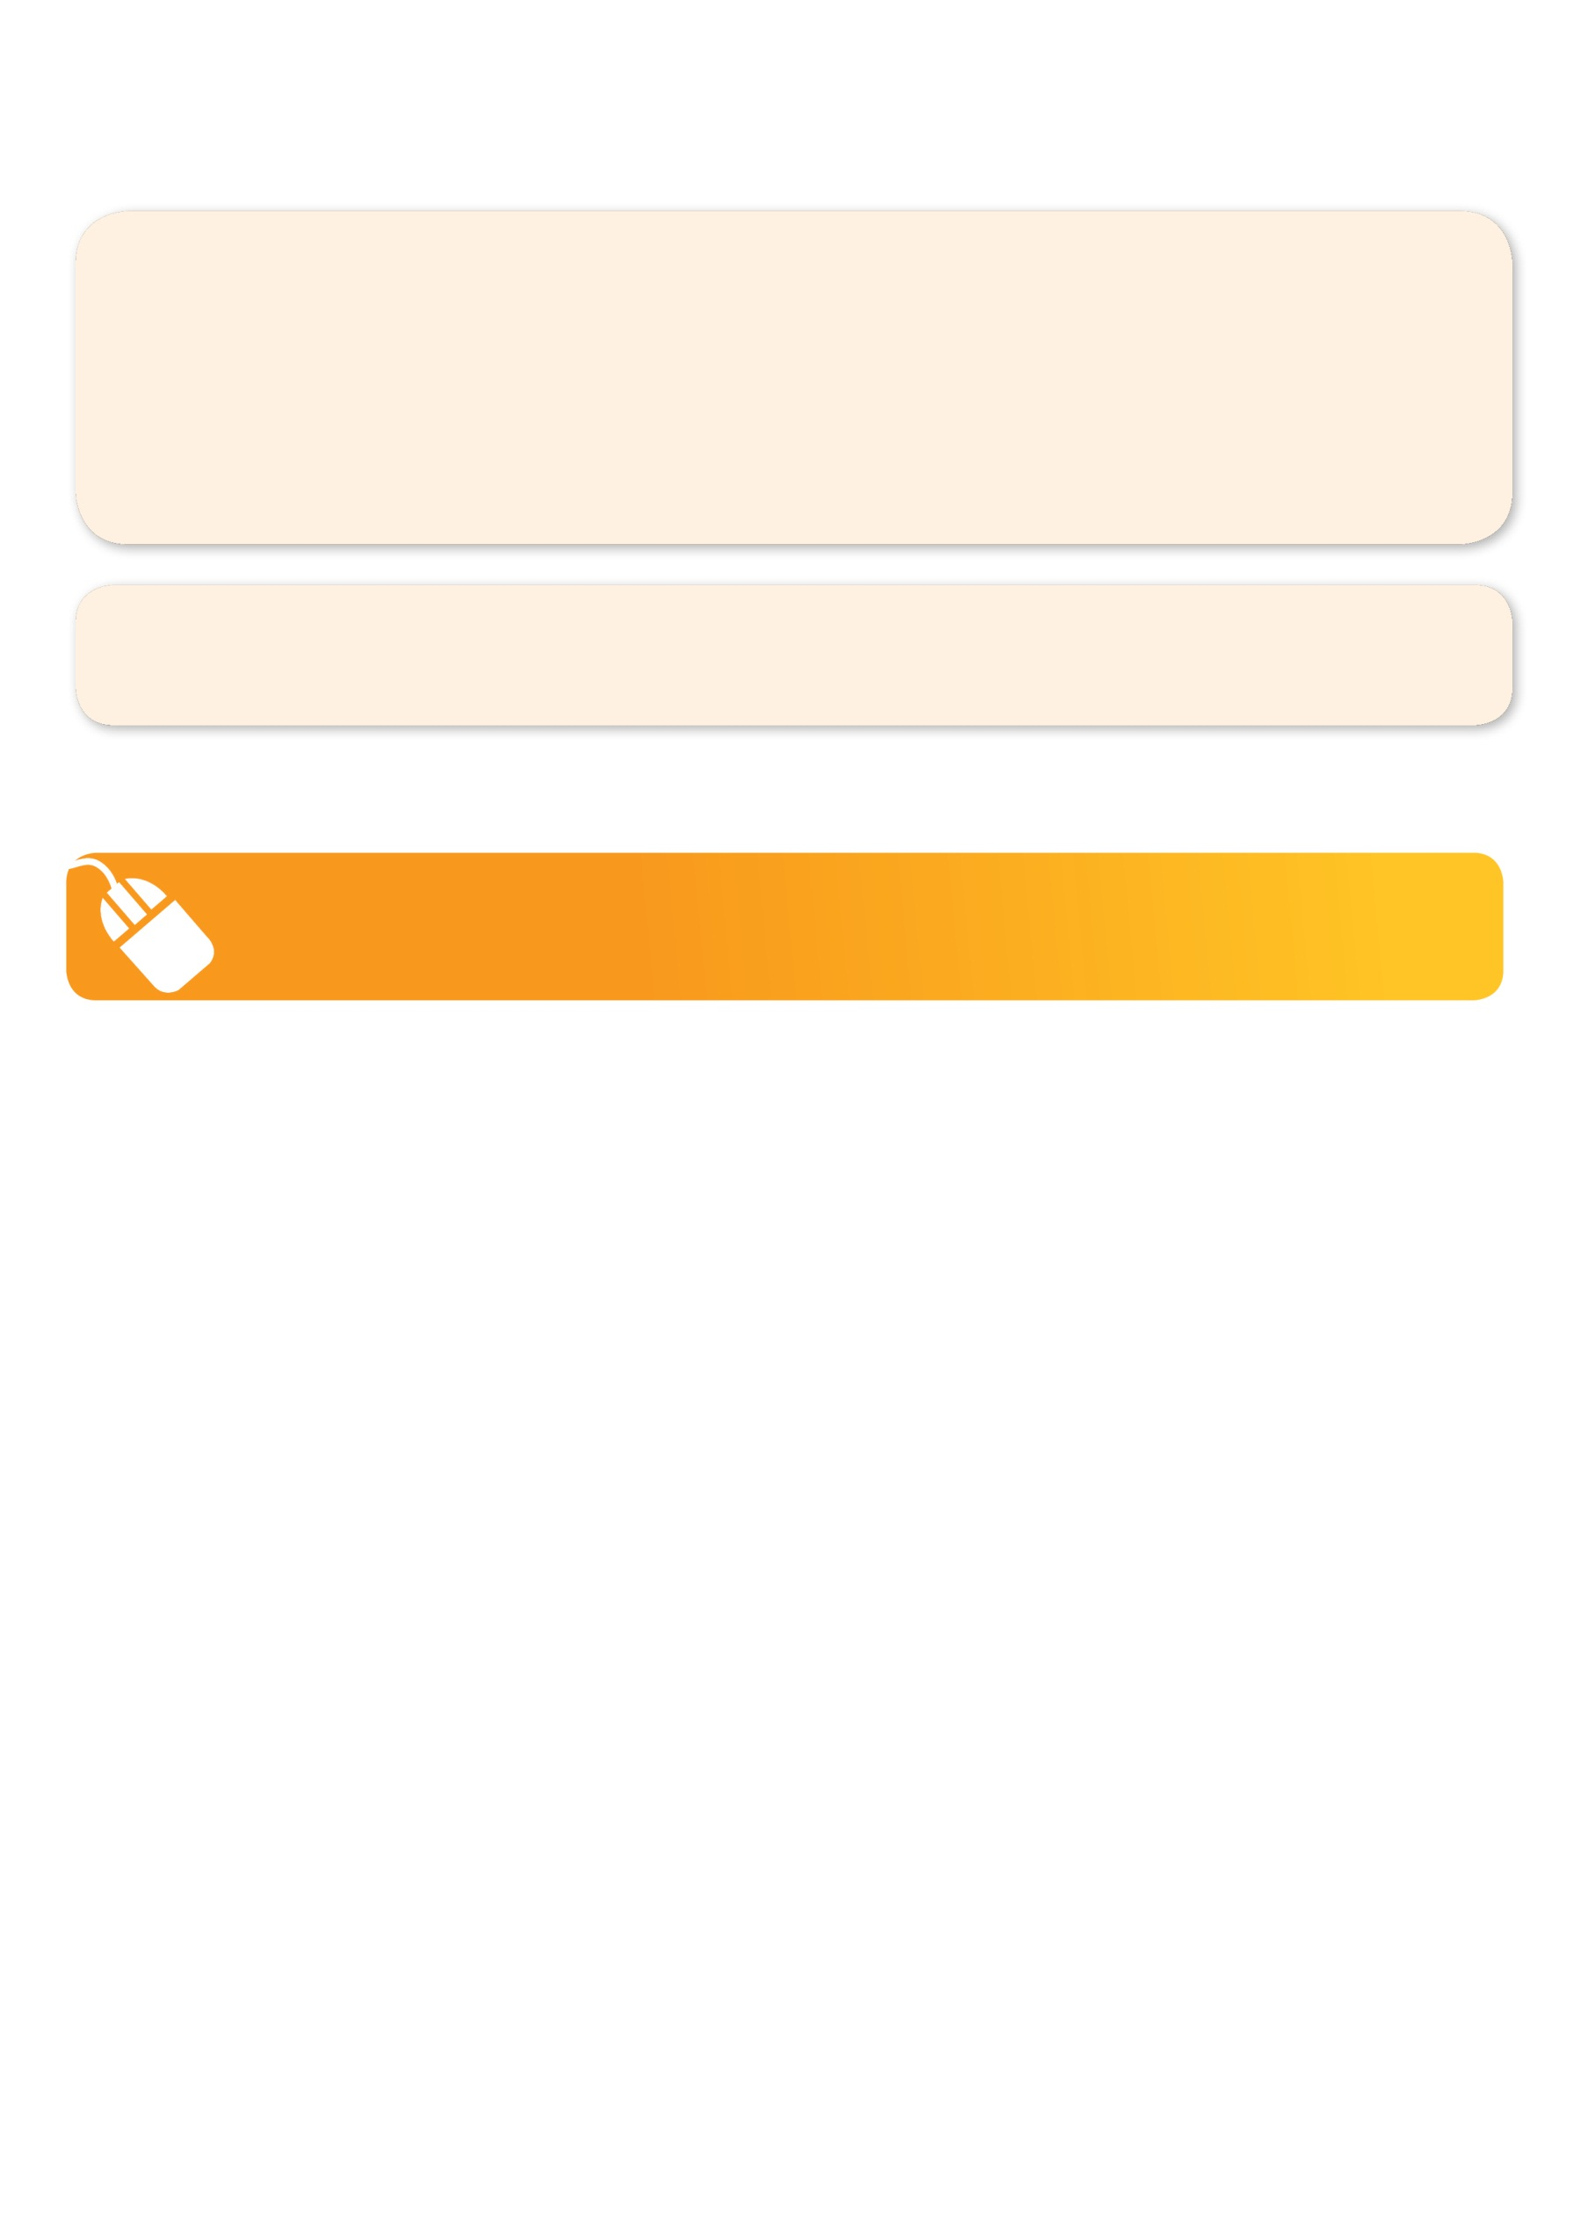
GET IN QUICK FOR TERM 2 AS PLACES ARE LIMITED AND WILL FILL FAST
$56 FOR THE 8 WEEK PROGRAM
WHEN: MONDAYS
COMMENCING: 01/05/17
CONCLUDING: 26/06/17
TIME: 11.30am – 12.00pm
YEAR LEVELS: PRE -KINDER
COST: $56
FEES MUST BE PAID BY WEEK 3
NOT RUNNING QUEENS BIRTHDAY

It’s here online enrolments!
To enrol, please visit www.kellysports.com.au or
fill out the enrolment form & send with a cheque or credit card details to:
Kelly Sports PO BOX 71, Moonee Vale, VIC, 3055.
Payment options available!
Do not leave enrolment forms at the school office

It’s here online enrolments!
To enrol, please visit www.kellysports.com.au or
fill out the enrolment form & send with a cheque or credit card details to:
Kelly Sports PO BOX 71, Moonee Vale, VIC, 3055.
Payment options available!
Do not leave enrolment forms at the school office

It’s here online enrolments!
To enrol, please visit www.kellysports.com.au or
fill out the enrolment form & send with a cheque or credit card details to:
Kelly Sports PO BOX 71, Moonee Vale, VIC, 3055.
Payment options available!
Do not leave enrolment forms at the school office

NEW IMPROVED ONLINE BOOKING SYSTEM!!!
SIMPLY GO TO WWW.KELLYSPORTS.COM.AU ENTER IN YOUR POSTCODE AND CLICK ON GOODSTART LANGWARRINS PROGRAM

Enrol before 30/04/17 and get the 8 weeks for the price of 7 that’s $49 for the 8 weeks.

