


P.O. Box 71, Moonee Vale 3055
FOLLOW US
ONLINE

T 0422 286 642

E michelle@kellysports.com.au



LANGWARRIN CURRICULUM DAY
THURSDAY JULY 30TH



DETAILS: Keep the kids entertained this upcoming curriculum day.
The day will be filled with sports mixed with quieter craft activities and
alternatives.
Children will be required to bring a packed lunch and drink bottle.

SPORTS: Soccer, footy, basketball, netball & hockey.

COST: $40
($35 if enrolled in Kelly Sports program on Thursdays after school)

TIME: 8.30am – 4.30pm

VENUE: LANGWARRIN PRIMARY SCHOOL

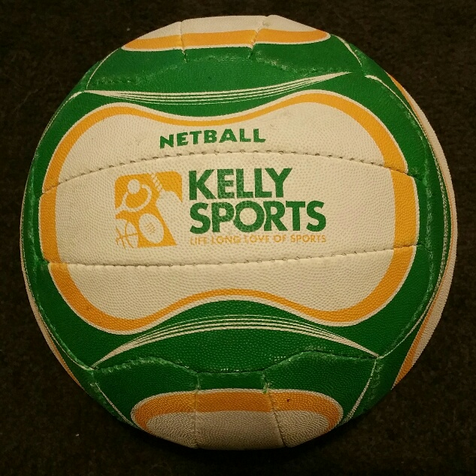


GET IN QUICK AS PLACES ARE LIMITED AND WILL FILL FAST
It’s here online enrolments!
To enrol, please visit www.kellysports.com.au or
fill out the enrolment form & send with a cheque or credit card details to:
Kelly Sports PO BOX 71, Moonee Vale, VIC, 3055.
Payment options available!
Do not leave enrolment forms at the school office

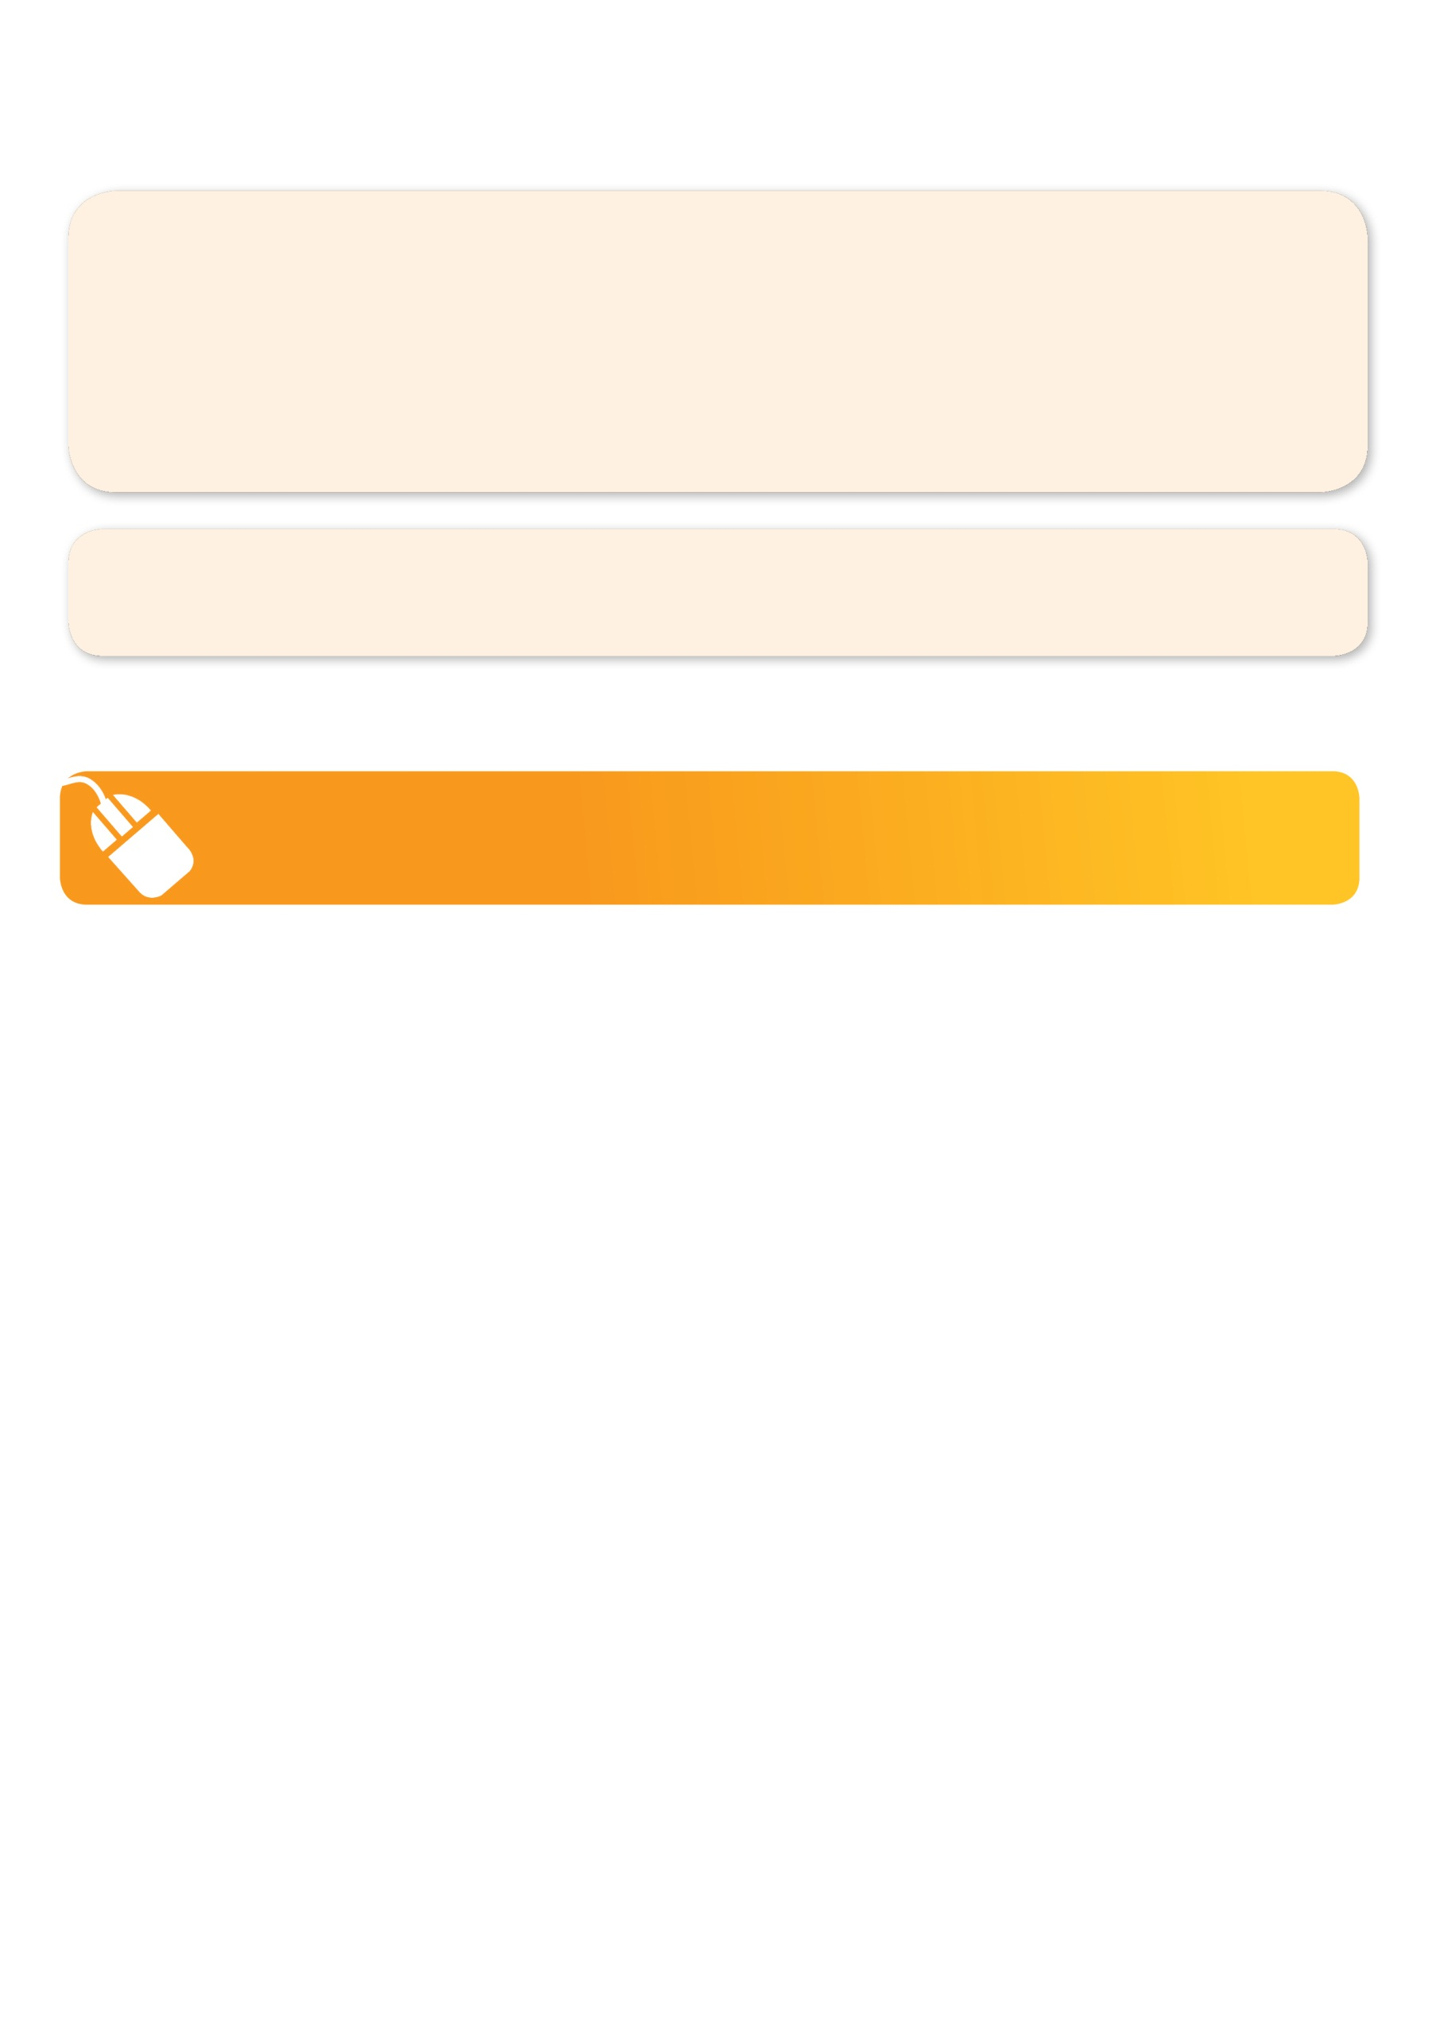
It’s here online enrolments !
To enrol, please visit www.kellysports.com.au or
fill out the enrolment form & send with a cheque or credit card details to:
Kelly Sports PO BOX 71, Moonee Vale, VIC, 3055.
Payment options available!
Do not leave enrolment forms at the school office

NEW IMPROVED ONLINE BOOKING SYSTEM!!!
SIMPLY GO TO WWW.KELLYSPORTS.COM.AU OR SCAN AND SEND TO MICHELLE@KELLYSPORTS.COM.AU
OR FILL OUT THE BELOW ENROLMENT FORM & SEND WITH A CHEQUE OR CREDIT CARD DETAILS TO:
PO BOX 71, MOONEE VALE, 3055

It’s here online enrolments!
To enrol, please visit www.kellysports.com.au or
fill out the enrolment form & send with a cheque or credit card details to:
Kelly Sports PO BOX 71, Moonee Vale, VIC, 3055.
Payment options available!
Do not leave enrolment forms at the school office

It’s here online enrolments!
To enrol, please visit www.kellysports.com.au or
fill out the enrolment form & send with a cheque or credit card details to:
Kelly Sports PO BOX 71, Moonee Vale, VIC, 3055.
Payment options available!
Do not leave enrolment forms at the school office

It’s here online enrolments!
To enrol, please visit www.kellysports.com.au or
fill out the enrolment form & send with a cheque or credit card details to:
Kelly Sports PO BOX 71, Moonee Vale, VIC, 3055.
Payment options available!
Do not leave enrolment forms at the school office

ENROLMENT FORM – Langwarrin P.S
 Curriculum Day July 30th
School: _______________________________________________________________________________ Year Level/room number: _____________
Name: Birth date:
Address: Post Code:
Phone: Mobile/Work:
Email: Medical Conditions:

Parents’ consent: I hereby authorise Kelly Sports to act on my behalf should my child require medical attention, and release
Kelly Sports Mornington Peninsula Region from any liability for injury incurred by my child at Kelly Sports programs.
Parent/Caregiver name: Signature:
Amount Paid: $ Credit card payment: (Surcharge applies)  Visa  Master card
Card Number:    Expiry Date: /CVV:

THINGS TO KNOW
Kelly Sports is a Registered Child Care provider
Don’t leave forms at the School Office
Spaces are limited so please make sure you enrol online or return form to Kelly Sports.

