 P.O. Box 71 Monee Vale 3055

**Enrol before 20/07/16 and get the 9 weeks for the price of 8 that’s $56 for 9 weeks.**

**T** 0422 286 642

**E** [Michelle@kellysports.com.au](mailto:Michelle@kellysports.com.au)

**W** www.kellysports.com.au

**GOODSTART EARLY LEARNING LANGWARRIN**

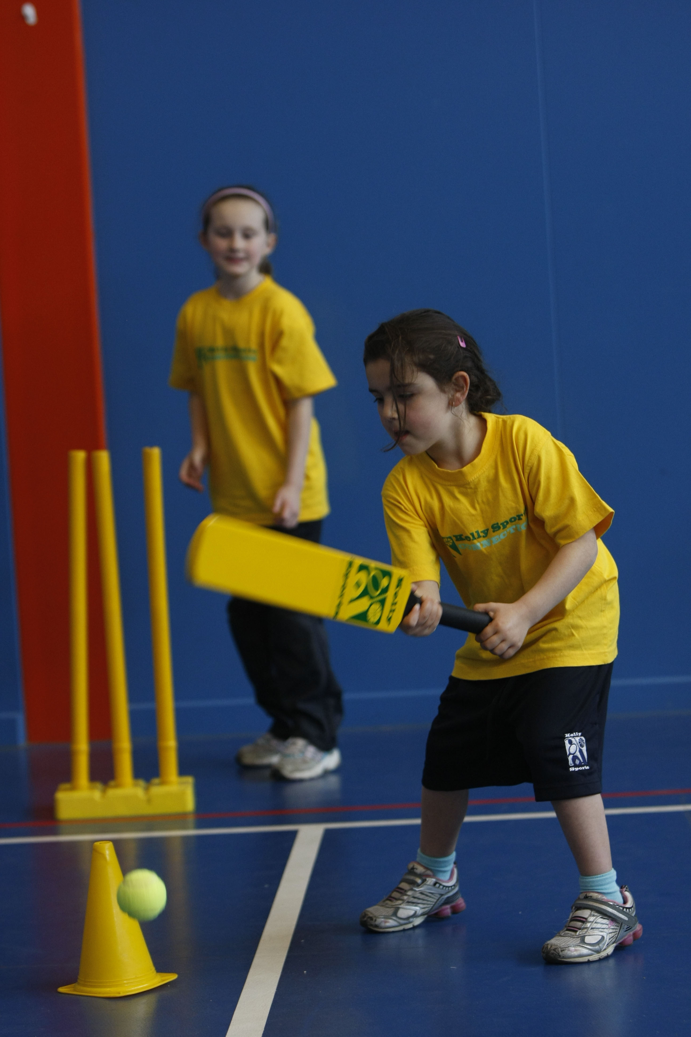

**FUNDAMENTAL**

**SKILLS PROGRAM**

Kelly Sports runs a half an hour program to teach children the fundamentals of sport. This **9** **WEEK** program is all inclusive with high participation. Our aim is to develop and enhance the following skills – **running, jumping, catching, throwing, passing, kicking and striking:**

The Fundamental Skills Program includes:  
**- Motor Skill Development  
- Balance and Hand- Eye Coordination  
- Introduction to a variety of Sports**

**WHEN: Thursday**

**COMMENCING:** **21/07/2016**

**CONCLUDING: 15/09/2016**

**TIME: 9:30am – 10:00am – (3 to 5 Yrs)**



**COST: $63**

**It’s here online enrolments !**

**To enrol**, please visit [www.kellysports.com.au](http://www.kellysports.com.au) or

fill out the enrolment form & **send** with a cheque or credit card details to:

Kelly Sports PO BOX 71, Moonee Vale, VIC, 3055.

Payment options available!

Do **not** leave enrolment forms at the school office

**VENUE: Goodstart Early Learning Langwarrin**

**It’s here online enrolments !**

**To enrol**, please visit [www.kellysports.com.au](http://www.kellysports.com.au) or

fill out the enrolment form & **send** with a cheque or credit card details to:

Kelly Sports PO BOX 71, Moonee Vale, VIC, 3055.

Payment options available!

Do **not** leave enrolment forms at the school office

**ONLINE ENROLMENT**

**www.kellysports.com.au**

To enrol, please visit [**www.kellysports.com.au**](http://www.kellysports.com.au)and search for yourcentre or fill out the enrolment form below & scan/ send **it to** [**michelle@kellysports.com.au**](mailto:michelle@kellysports.com.au)

**ENROLMENT FORM – Goodstart Langwarrin**

Name: Birth Date: _____

Address: Post Code:

Phone: Mobile/Work:

Email: Medical Conditions:

**Parents’ consent: I hereby authorise Kelly Sports to act on my behalf should my child require medical attention, and release   
Kelly Sports from any liability for injury incurred by my child at Kelly Sports programmes.**

Parent/Caregiver name: Signature:

Amount Paid: $ Credit card payment: □ **Visa** □ **Mastercard**  (surcharge applies)

Card Number: □□□□ □□□□ □□□□ □□□□ Expiry Date: □□/□□

CVV:□□□

**THINGS TO KNOW**

Kelly Sports is a Registered Child Care provider

Don’t leave forms at the centre

Spaces are limited so please make sure you enrol online or return form to Kelly Sports.

**It’s here online enrolments !**

**To enrol**, please visit [www.kellysports.com.au](http://www.kellysports.com.au) or

fill out the enrolment form & **send** with a cheque or credit card details to:

Kelly Sports PO BOX 71, Moonee Vale, VIC, 3055.

Payment options available!

Do **not** leave enrolment forms at the school office

**It’s here online enrolments !**

**To enrol**, please visit [www.kellysports.com.au](http://www.kellysports.com.au) or

fill out the enrolment form & **send** with a cheque or credit card details to:

Kelly Sports PO BOX 71, Moonee Vale, VIC, 3055.

Payment options available!

Do **not** leave enrolment forms at the school office

**It’s here online enrolments !**

**To enrol**, please visit [www.kellysports.com.au](http://www.kellysports.com.au) or

fill out the enrolment form & **send** with a cheque or credit card details to:

Kelly Sports PO BOX 71, Moonee Vale, VIC, 3055.

Payment options available!

Do **not** leave enrolment forms at the school office