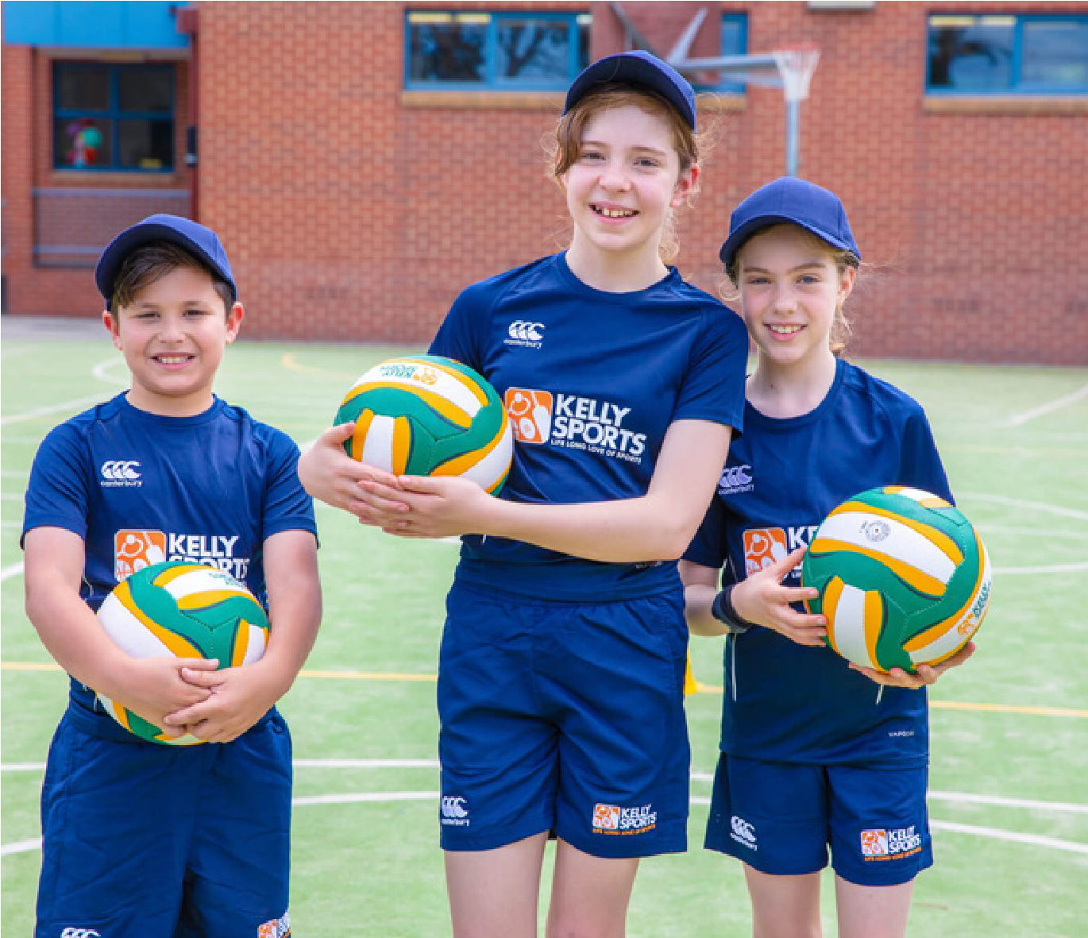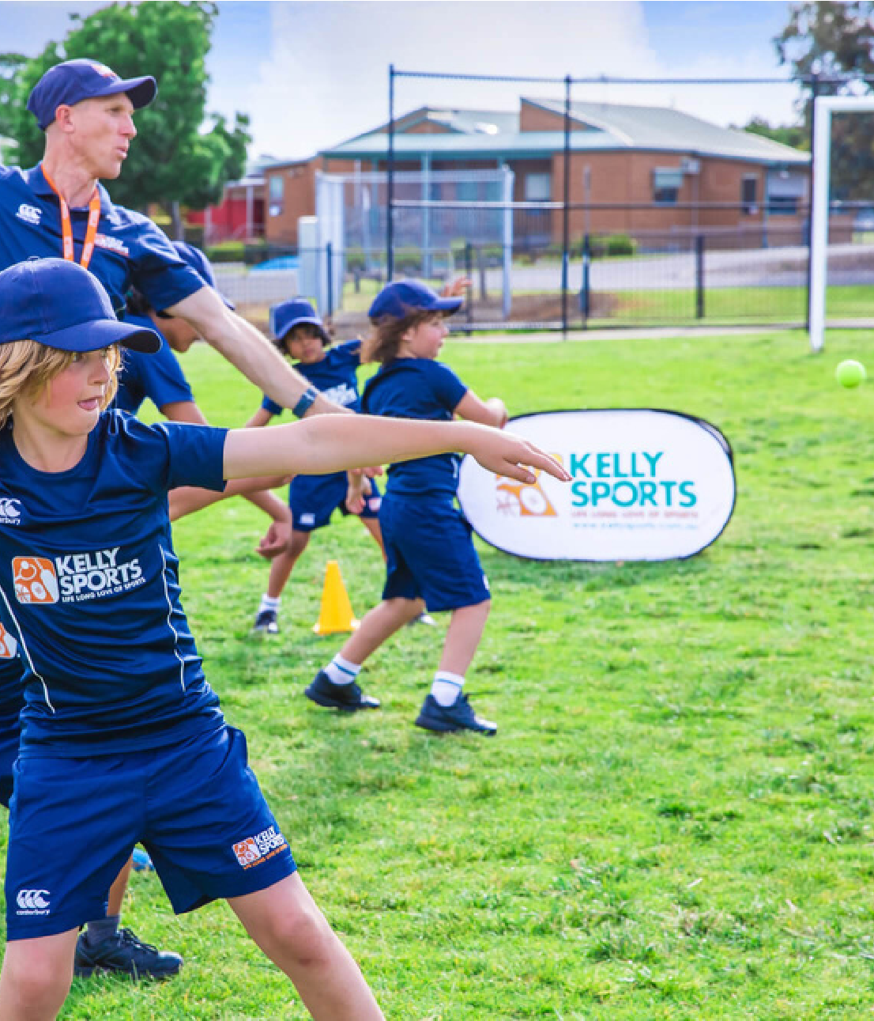

SIZZLING SUMMER

SPORTS

MULTI SPORTS PROGRAM - AFTER

SCHOOL

NETBALL, SOCCER &

HOCKEY PROGRAM

AFTER SCHOOL

THE KNOX SCHOOL



Teamwork



MULTI-SPORT

PROGRAMME

TERM 1 2024 INFORMATION

$126

FOR 7 WEEKS

For Prep – Year 4 students.

This term we will focus on the following sports:

Soccer

Programme runs 7 afternoons for one hour after school.

Basketball

Cricket

This weekly programme gives children skills and confidence in a fun

and enjoyable environment. It also encourages their enthusiasm for

sport and the life skills that such involvement brings – giving them

confidence to join sports clubs and teams in the future.

southeast@kellysports.com.au

www.kellysports.com.au

TERM 1 2024 INFORMATION

$144 FOR 8 WEEKS

For Prep – Year 4 students.

This

program will include the following:

Skills Practice

Game Rules

Modified Games

Match Play

Our Netball, soccer & hockey

program focuses on fundamental

skills such as passing, dribbling, offense, defence and shooting

whilst using a mixture of skill related activities and modified games

to do so. This program is designed to improve overall motor skills

and coordination, and is sure to bring out the little sports star in

everyone!

Sign up anytime and only pay for the remaining weeks left in

the term. $18 per week.

Sign up anytime and only pay for the remaining weeks left in

the term. $18 per week.

No session 11th March ( Labour Day )

School: The Knox School

Day: Monday's

Start Date: 5th February

End Date: 25th March

Time: 3: 30pm - 4.30pm

School: The Knox School

Day: Wednesday's

Start Date: 7th February

End Date: 27th March

Time: 3:30pm - 4:30pm

T-Ball

Programme runs 8 afternoons for one hour after school.

Book before 22nd January to receive one week free!

NETBALL, SOCCER &

HOCKEY PROGRAM