
T Chris Hoegel: 0401 841 878


E chrishoegel@kellysports.com.au

Kelly Sports Mornington Peninsula Region

KUNYUNG PRIMARY SCHOOL
MIGHTY MULTI SPORTS

Kelly Sports is back in Term 3 for MIGHTY MULTI SPORTS!! Over 9 weeks your child will participate in a range of lively and energetic programs including AFL, SOCCER, BASKETBALL, AND NETBALL. This program will not only improve key sporting skills but also increase crucial motor skills in a fun, friendly and exciting environment. Enrol them now and let Kelly Sports give them a Life Long Love of Sports.

It’s here online enrolments!
To enrol, please visit www.kellysports.com.au or
fill out the enrolment form & send with a cheque or credit card details to:
Kelly Sports PO BOX 71, Moonee Vale, VIC, 3055.
Payment options available!
Do not leave enrolment forms at the school office

It’s here online enrolments !
To enrol, please visit www.kellysports.com.au or
fill out the enrolment form & send with a cheque or credit card details to:
Kelly Sports PO BOX 71, Moonee Vale, VIC, 3055.
Payment options available!
Do not leave enrolment forms at the school office

WHEN: MONDAY
COMMENCING: 23/ 7/18
CONCLUDING: 17/9/18
TIME: 3.40pm – 4.40pm
YEAR LEVELS: P – GRADE 4
COST: $118.8 inc GST

It’s here online enrolments!
To enrol, please visit www.kellysports.com.au or
fill out the enrolment form & send with a cheque or credit card details to:
Kelly Sports PO BOX 71, Moonee Vale, VIC, 3055.
Payment options available!
Do not leave enrolment forms at the school office

It’s here online enrolments!
To enrol, please visit www.kellysports.com.au or
fill out the enrolment form & send with a cheque or credit card details to:
Kelly Sports PO BOX 71, Moonee Vale, VIC, 3055.
Payment options available!
Do not leave enrolment forms at the school office

It’s here online enrolments!
To enrol, please visit www.kellysports.com.au or
fill out the enrolment form & send with a cheque or credit card details to:
Kelly Sports PO BOX 71, Moonee Vale, VIC, 3055.
Payment options available!
Do not leave enrolment forms at the school office

SIGN UP FAST FOR TERM 3
SPORTS

GET IN QUICK FOR TERM 3 AS PLACES ARE LIMITED AND WILL FILL FAST
$118.8 FOR THE 9 WEEK PROGRAM
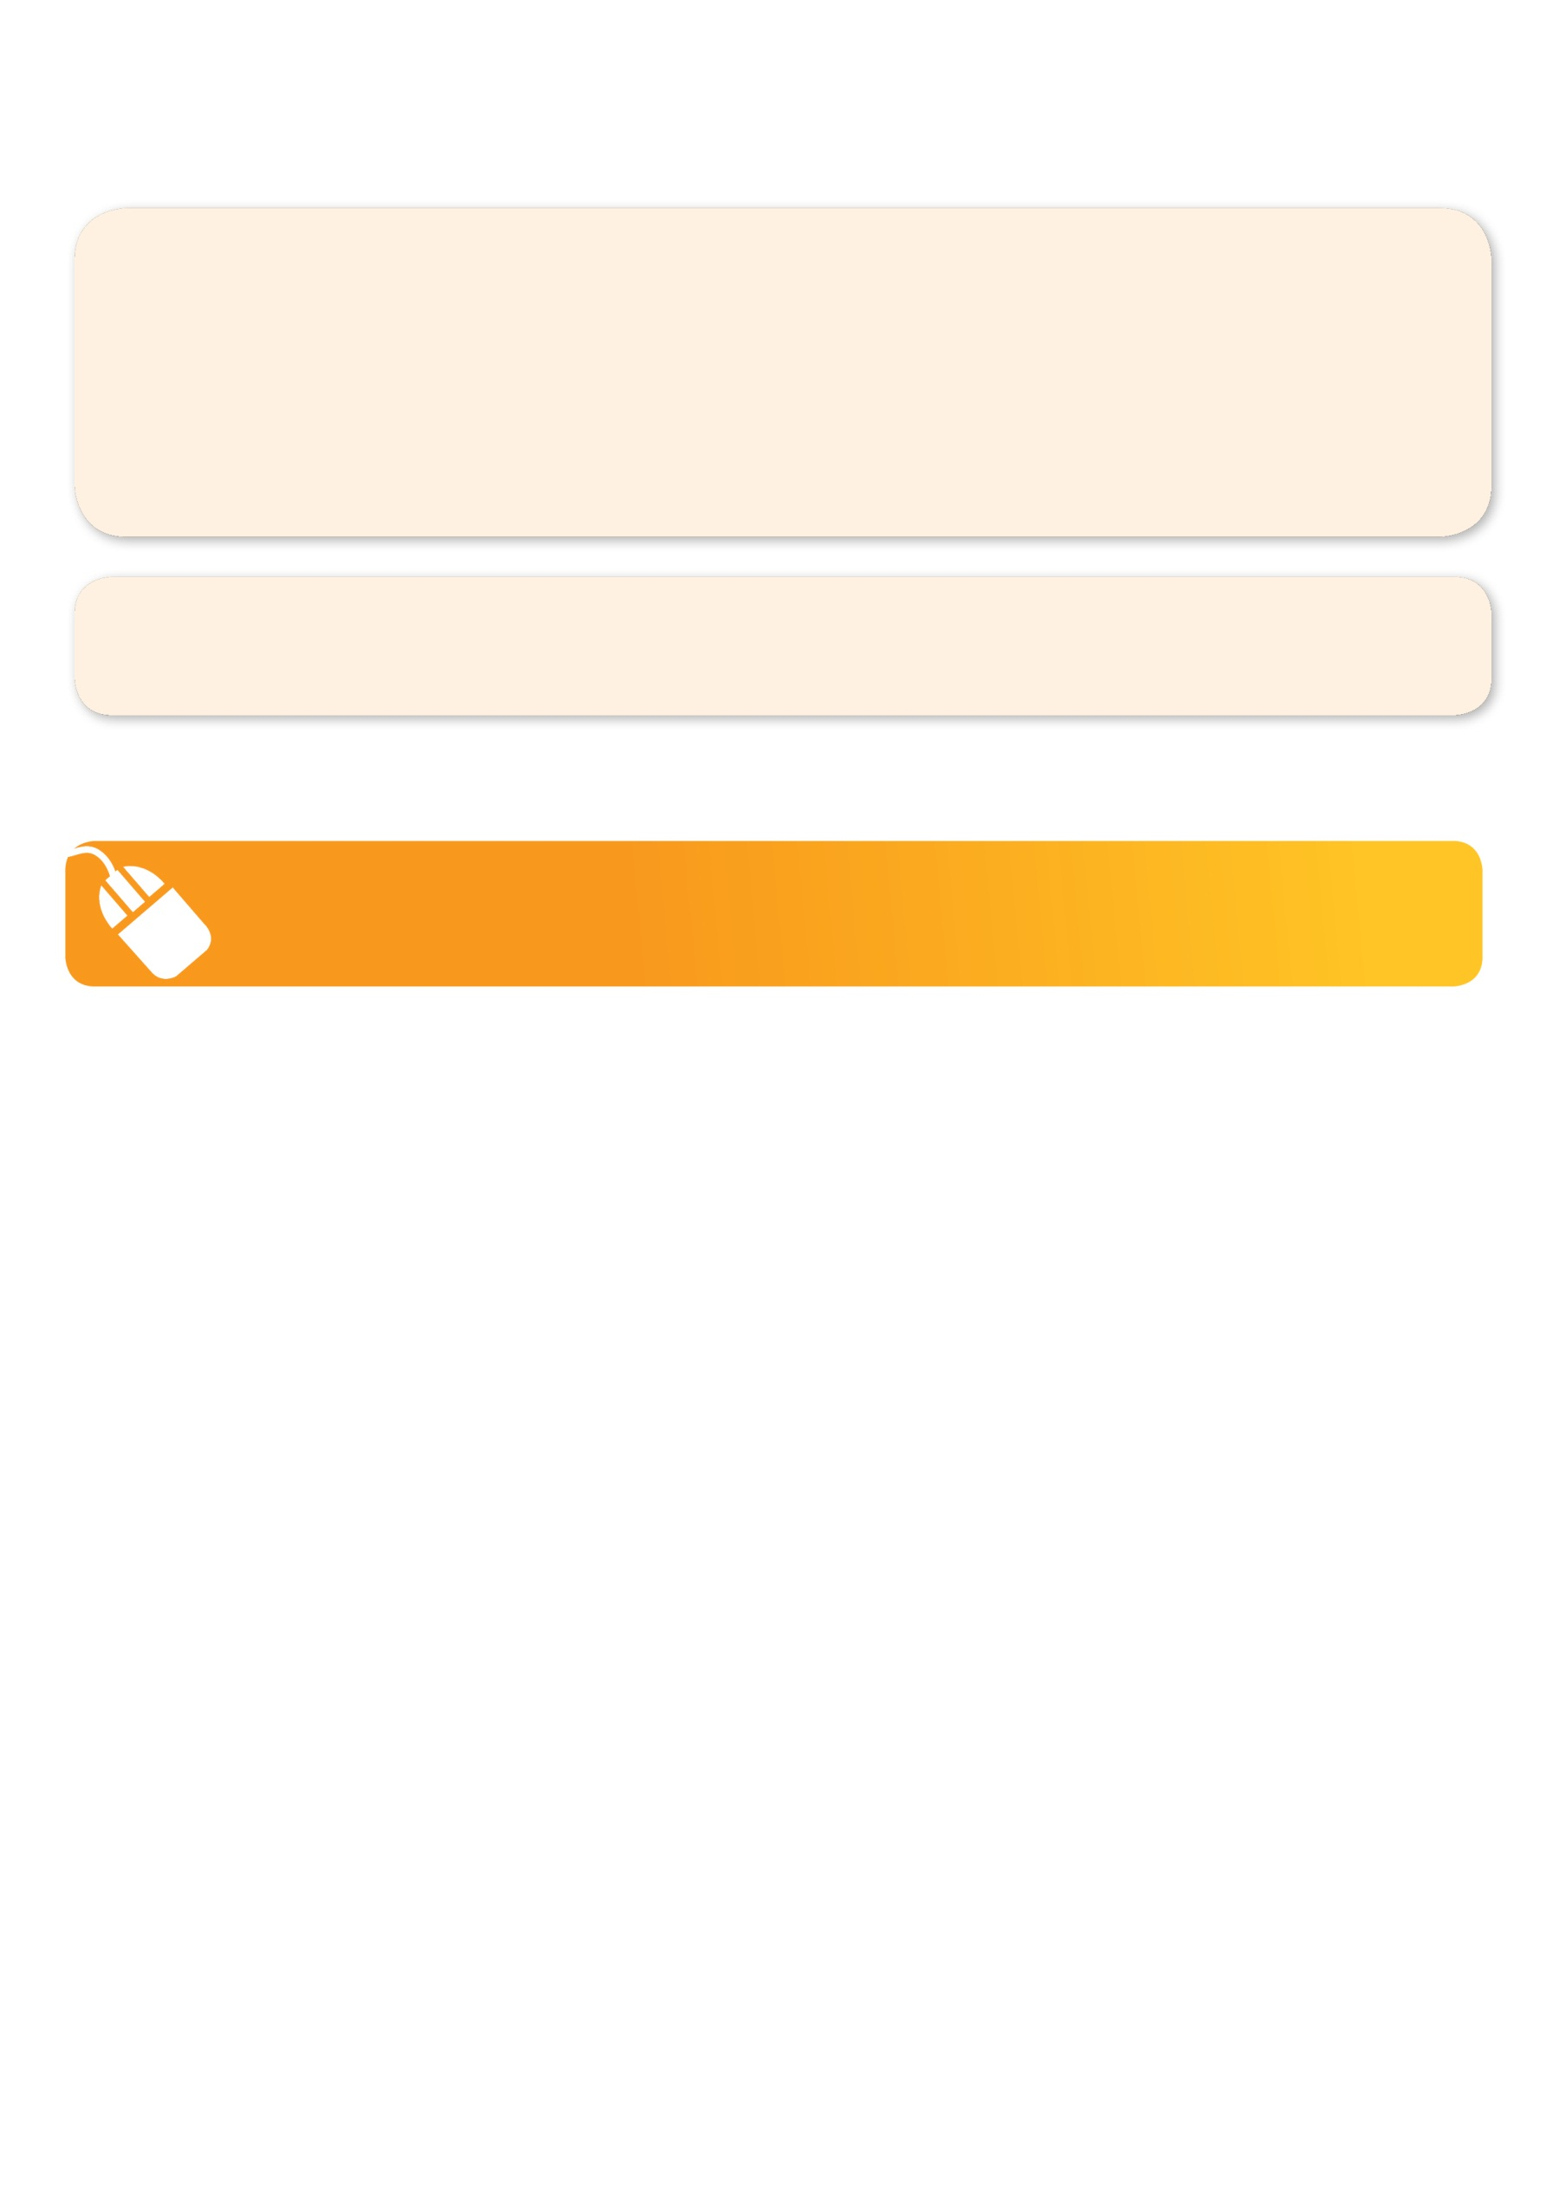
NEW IMPROVED ONLINE BOOKING SYSTEM!!!
SIMPLY GO TO WWW.KELLYSPORTS.COM.AU ENTER IN YOUR POSTCODE AND CLICK ON KUNYUNG PRIMARY SCHOOL’S PROGRAM

KELLY SPORTS ALSO DOES SCHOOL HOLIDAY PROGRAMS & BIRTHDAY PARTIES.
Like our Facebook page, Kelly Sports Mornington Peninsula Region to keep up to date with what is happening in your area.

