
T 0422 286 642


E michelle@kellysports.com.a

Kelly Sports Mornington Peninsula Region

MT ELIZA PRIMARY SCHOOL
WILD WINTER SPORTS

Kelly Sports is back in Term 3 for WILD WINTER SPORTS!! Over 8 weeks your child will participate in a range of lively and energetic programs including HOCKEY, SOCCER, CRAZY GAMES AND ATHLETICS. This program will not only improve key sporting skills but also increase crucial motor skills in a fun, friendly and exciting environment. Enrol them now and let Kelly Sports give them a Life Long Love of Sports.

It’s here online enrolments!
To enrol, please visit www.kellysports.com.au or
fill out the enrolment form & send with a cheque or credit card details to:
Kelly Sports PO BOX 71, Moonee Vale, VIC, 3055.
Payment options available!
Do not leave enrolment forms at the school office

It’s here online enrolments !
To enrol, please visit www.kellysports.com.au or
fill out the enrolment form & send with a cheque or credit card details to:
Kelly Sports PO BOX 71, Moonee Vale, VIC, 3055.
Payment options available!
Do not leave enrolment forms at the school office

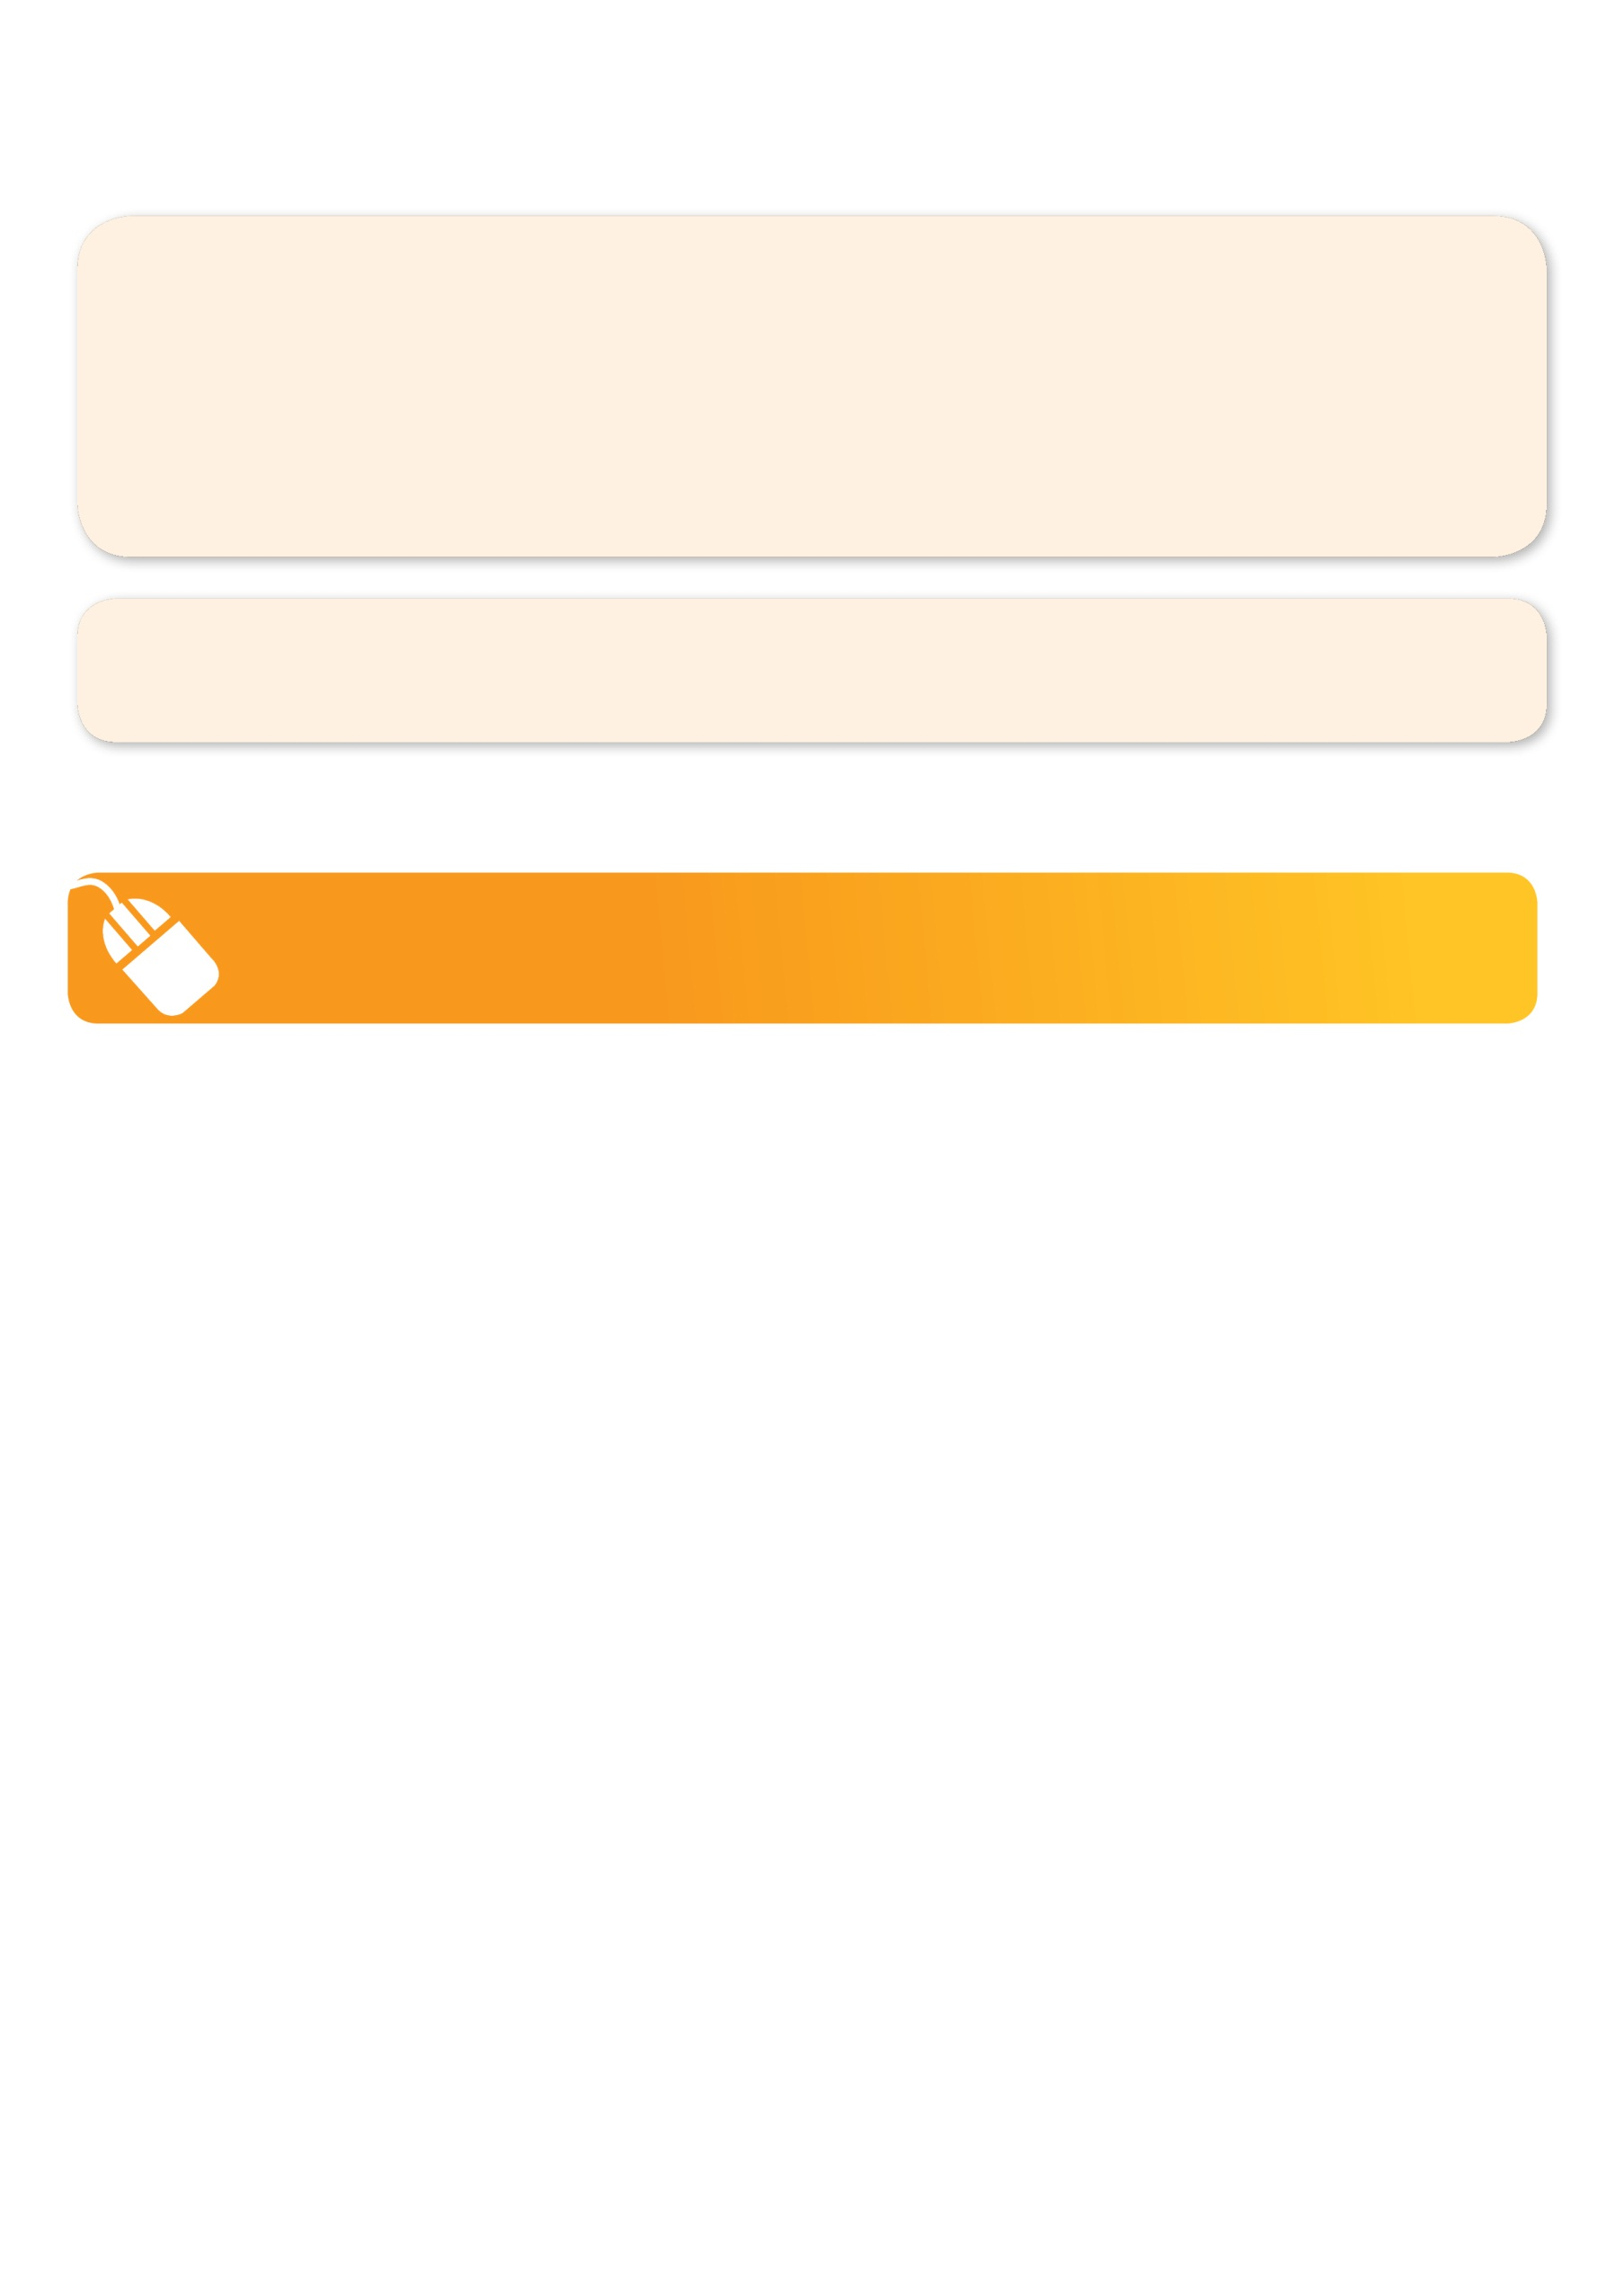
GET IN QUICK FOR TERM 3 AS PLACES ARE LIMITED AND WILL FILL FAST
$80 FOR THE 8 WEEK PROGRAM
It’s here online enrolments!
To enrol, please visit www.kellysports.com.au or
fill out the enrolment form & send with a cheque or credit card details to:
Kelly Sports PO BOX 71, Moonee Vale, VIC, 3055.
Payment options available!
Do not leave enrolment forms at the school office

It’s here online enrolments!
To enrol, please visit www.kellysports.com.au or
fill out the enrolment form & send with a cheque or credit card details to:
Kelly Sports PO BOX 71, Moonee Vale, VIC, 3055.
Payment options available!
Do not leave enrolment forms at the school office

It’s here online enrolments!
To enrol, please visit www.kellysports.com.au or
fill out the enrolment form & send with a cheque or credit card details to:
Kelly Sports PO BOX 71, Moonee Vale, VIC, 3055.
Payment options available!
Do not leave enrolment forms at the school office

NEW IMPROVED ONLINE BOOKING SYSTEM!!!
SIMPLY GO TO WWW.KELLYSPORTS.COM.AU ENTER IN YOUR POSTCODE AND CLICK ON MT ELIZA’S PRIMARY SCHOOL’S PROGRAM

WHEN: TUESDAYS
COMMENCING: 25/07/17
CONCLUDING: 12/09/17
TIME: 3.25pm – 4.25pm
YEAR LEVELS: P – GRADE 4
COST: $80

FEES MUST BE PAID BY WEEK 3

Enrol before 23/07/17 and get the 8 weeks for the price of 7 that’s $70 for the 8 weeks.

