 P.O. 4004, Keilor Downs 3038

**T** 0433 530 316

**F** (03) 9384 2205

**Special O**

**E** belinda@kellysports.com.au

 **COMMUNITY KIDS MELTON**

**FUNDAMENTAL**

**SKILLS PROGRAM**

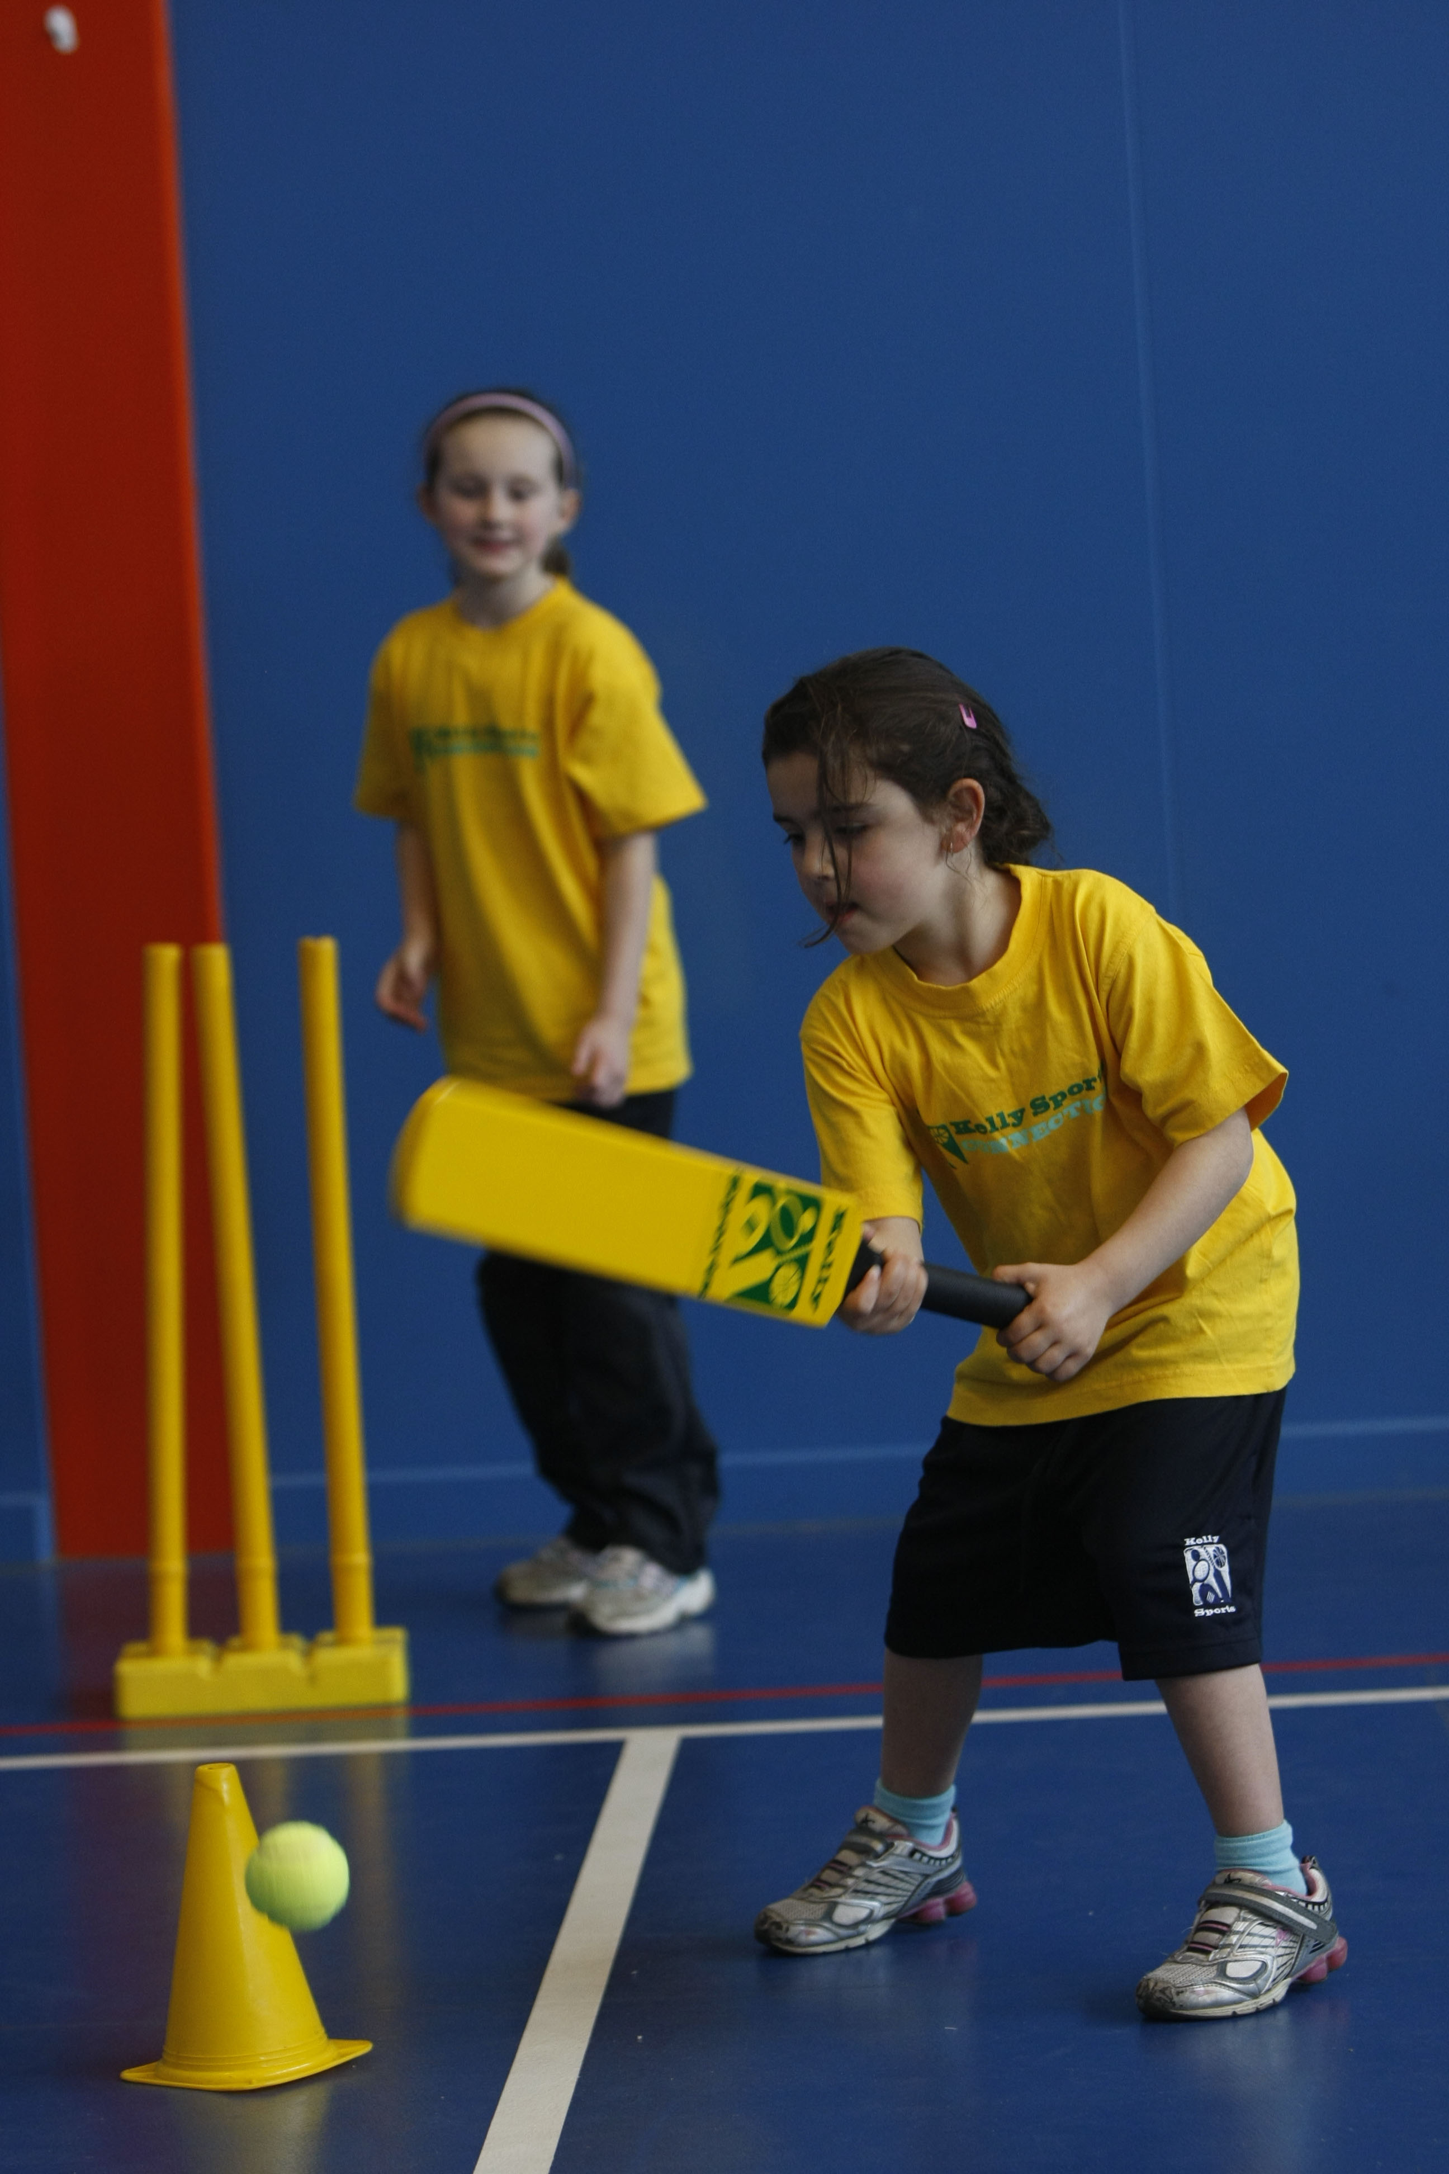

Kelly Sports runs programs to teach children the fundamentals of sport. This **10 WEEK** program is all inclusive with high participation. Our key aims are to develop and enhance the following skills – **running, jumping, catching, throwing, passing, kicking and striking:**

The Fundamental Skills Program includes:

**- Motor Skill Development  
- Balance and Hand- Eye Coordination  
- Introduction to a variety of sports -Soccer, Basketball, Handball, Hockey, Football and more.**

**WHEN:** Friday

**COMMENCING:** 17/07/2015

**CONCLUDING:** 18/09/2015

**TIME:** 10:00am – 10:30am - Pre School

10:30am – 11:00am – Kinder



**COST: $35** (enrol online go to **www.kellysports.com.au**)

**It’s here online enrolments !**

**To enrol**, please visit [www.kellysports.com.au](http://www.kellysports.com.au) or

fill out the enrolment form & **send** with a cheque or credit card details to:

Kelly Sports PO BOX 71, Moonee Vale, VIC, 3055.

Payment options available!

Do **not** leave enrolment forms at the school office

**VENUE: Community Kids Melton**

**It’s here online enrolments !**

**To enrol**, please visit [www.kellysports.com.au](http://www.kellysports.com.au) or

fill out the enrolment form & **send** with a cheque or credit card details to:

Kelly Sports PO BOX 71, Moonee Vale, VIC, 3055.

Payment options available!

Do **not** leave enrolment forms at the school office

**ENROLMENT FORM**

**🞏 Pre School 🞏 Kinder**

Centre: Community Kids Melton Age:

Name: Class:

Address: Post Code:

Phone: Mobile/Work:

Email: Medical Conditions:

At the completion of after school clinics, does your child? □ Go to after care □ Get collected

**Parents’ consent: I hereby authorise Kelly Sports to act on my behalf should my child require medical attention, and release   
Kelly Sports from any liability for injury incurred by my child at Kelly Sports programmes.**

Parent/Caregiver name: Signature:

Amount Paid: $ Credit card payment: □ **Visa** □ **Mastercard**

Card Number: □□□□ □□□□ □□□□ □□□□ Expiry Date: □□/□□

**ONLINE ENROLMENT**

**www.kellysports.com.au**

To enrol, please visit [**www.kellysports.com.au**](http://www.kellysports.com.au)or fill out the   
below enrolment form & sendwith a cheque or credit card details to:   
**PO BOX 4004, Keilor Downs 3138**. Payment options available!   
**Do not** leave enrolment forms at the school office.

**It’s here online enrolments !**

**To enrol**, please visit [www.kellysports.com.au](http://www.kellysports.com.au) or

fill out the enrolment form & **send** with a cheque or credit card details to:

Kelly Sports PO BOX 71, Moonee Vale, VIC, 3055.

Payment options available!

Do **not** leave enrolment forms at the school office

**It’s here online enrolments !**

**To enrol**, please visit [www.kellysports.com.au](http://www.kellysports.com.au) or

fill out the enrolment form & **send** with a cheque or credit card details to:

Kelly Sports PO BOX 71, Moonee Vale, VIC, 3055.

Payment options available!

Do **not** leave enrolment forms at the school office

**It’s here online enrolments !**

**To enrol**, please visit [www.kellysports.com.au](http://www.kellysports.com.au) or

fill out the enrolment form & **send** with a cheque or credit card details to:

Kelly Sports PO BOX 71, Moonee Vale, VIC, 3055.

Payment options available!

Do **not** leave enrolment forms at the school office