

**WARRANWOOD**

**PRIMARY SCHOOL P** (03) 9384 2204

**M** 0403 149 391

** E** [mitch@kellysports.com.au](mailto:mitch@kellysports.com.au)

**GROOVY JAZZ – Lunch time Monday**Groovy Jazz is a new and exciting jazz based routine for term 3. Students will have a fantastic time learning the new moves in our high intensity, excitement-filled dance environment. Our experienced coaches will work through the steps each week, while also incorporating lots of fun dance related games and activities. Sign up fast for this popular program.

**MIGHTY MULTI SPORTS – After School Wednesday**Come and experience all the fun in our 10 week Kelly Sports

Mighty Multi Sport program.

Our Kelly Sports classes are all inclusive, fun & interactive with a key focus on maximum participation. Each week children will be introduced to new sports & activities in a positive environment. It’s a fantastic way to get your child active while having fun as well as building confidence and social skills!





**How To Enrol?**Please visit [www.kellysports.com.au/events](http://www.kellysports.com.au/events) and search for your school.  
**Our new booking system requires upfront payments to secure your position. For more information, please call the head office.**



**"The Kelly Sports Programs offer our students opportunities for physical activities; including dance & multi-sports. Conveniently located on our school grounds, they are popular with students and their families. Staff are skilled in working with young people to love active participation.”**



***Amanda Hay, Principal – Newtown Primary School***

**CLASS INFORMATION**

Only 14 spots available for each program so sign up fast to secure your position

Mighty Multi Sports include **AFL, Soccer, Tee ball, Basketball/Netball** plus we will incorporate our Kelly Sports Modified games children love.

Come & join us every Monday at Lunch & Wednesday straight after school

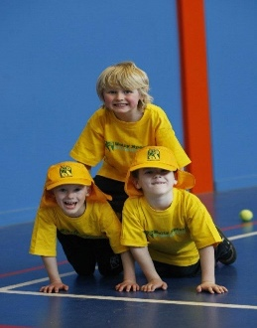

**When: Mondays & Wednesdays**   
**Starts: 23rd July & 18th July**   
**Finishes: 17th Sep & 19th Sep**   
**Jazz: 1:30pm to 2:30pm   
Sports: 3:40pm – 4:40pm**  
**Year Levels: Prep – 4  
Cost Jazz: $118.80 (Inc GST)  
Cost Sports: $132 (Inc GST)**

