 P.O. Box 71, Moonee Vale 3055

**T** (03) 9384 2204

**F** (03) 9384 2205

**E** mitch@kellysports.com.au

**SERPELL PRIMARY SCHOOL**

**WHEN:** Monday’s

**COMMENCING:** 15/10/2018

**CONCLUDING:** 17/12/2018

**TIME:** 3.40pm – 4.40pm

**YEAR LEVELS:** P – 4

**COST:** $118.80 (Inc Gst)

No session 5th NOV

**SPRING MULTI SPORTS – CRICET -SOCCER-BASKETBALL – HOCKEY – FUN GAMES**

Start the new school term by enrolling in this fantastic Kelly sports program. Join up with your friends and develop your skills in a fun, safe an exciting sporting environment. Our experienced coaches aim to develop and enhance the wide range of sporting skills of your child including kicking catching & throwing while also improving strength, flexibility, hand-eye co-ordination, Spatial awareness, co-operative and teamwork



**WHEN:** Tuesday’s

**COMMENCING:** 16/10/2018

**CONCLUDING:** 18/12/2018

**TIME:** 12.30pm – 1.30pm

**YEAR LEVELS:** P – 4

**COST:** $118.80 (Inc Gst)  
No sessions 6th Nov (Melb Cup)

**END OF YEAR CHEER**

**IT’S THE END OF THE YEAR AND IT’S TIME TO CHEER!**   
Join us in Term 4 for our Cheerleading program for boys and girls. This program will combine both Hip Hop and Cheerleading to create a new and fresh routine. You will have a fantastic time learning the new moves in our high intensity, excitement-filled dance environment. Book early for this incredibly fun program!



**WHEN:** Thursday’s

**COMMENCING:** 18/10/2018

**CONCLUDING:** 13/12/2018

**TIME:** 12.30pm – 1.30pm

**YEAR LEVEL** P – 4

**COST:** $118.80 (Inc Gst)

**GYM FUN**

This fun fast paced, highly active and non-stop program is an introduction for your child to the world of gymnastics. Colourful ribbons, Entertaining Hula Hoops, Incredible Rhythmical Routines and Group Dynamics. Allow your child to build their gymnastics skills and their thirst   
for exciting energetic activities.



**How To Enrol?**Please visit [www.kellysports.com.au/events](http://www.kellysports.com.au/events) and search for your school.  
Our new booking system requires upfront payments to secure your position. For more information, please call the head office.

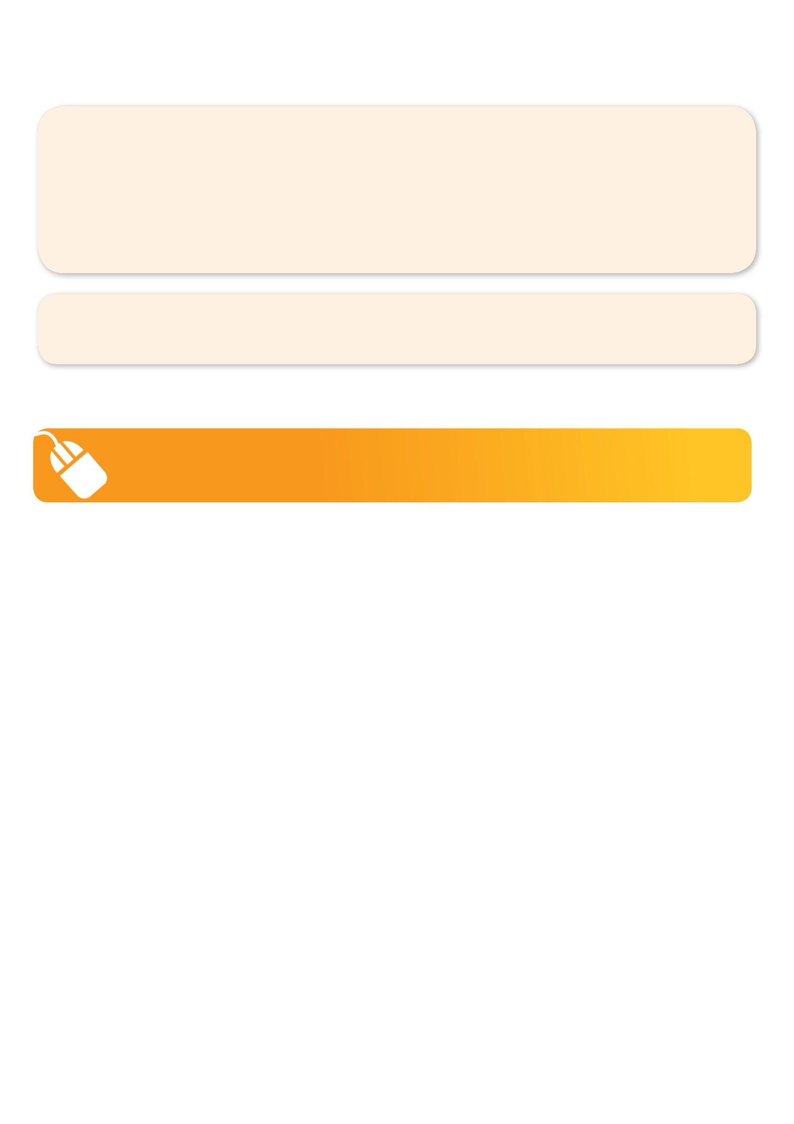**­**

**It’s here online enrolments !**

**To enrol**, please visit [www.kellysports.com.au](http://www.kellysports.com.au) or

fill out the enrolment form & **send** with a cheque or credit card details to:

Kelly Sports PO BOX 71, Moonee Vale, VIC, 3055.

Payment options available!

Do **not** leave enrolment forms at the school office

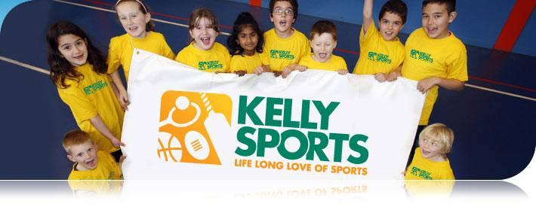

**"The Kelly Sports Programs offer our students opportunities for physical activities; including dance & multi-sports. Conveniently located on our school grounds, they are popular with students and their families. Staff are skilled in working with young people to love active participation.”**

***Amanda Hay, Principal – Newtown Primary School***

**It’s here online enrolments !**

**To enrol**, please visit [www.kellysports.com.au](http://www.kellysports.com.au) or

fill out the enrolment form & **send** with a cheque or credit card details to:

Kelly Sports PO BOX 71, Moonee Vale, VIC, 3055.

Payment options available!

Do **not** leave enrolment forms at the school office

**It’s here online enrolments !**

**To enrol**, please visit [www.kellysports.com.au](http://www.kellysports.com.au) or

fill out the enrolment form & **send** with a cheque or credit card details to:

Kelly Sports PO BOX 71, Moonee Vale, VIC, 3055.

Payment options available!

Do **not** leave enrolment forms at the school office

**It’s here online enrolments !**

**To enrol**, please visit [www.kellysports.com.au](http://www.kellysports.com.au) or

fill out the enrolment form & **send** with a cheque or credit card details to:

Kelly Sports PO BOX 71, Moonee Vale, VIC, 3055.

Payment options available!

Do **not** leave enrolment forms at the school office