

**P** (03) 9384 2204  
**E** [mitch@kellysports.com.au](mailto:mitch@kellysports.com.au)

**DONCASTER ELC**



**FUNDAMENTAL MOTOR SKILLS**

**Kelly Sports is offering our fundamental motor skills program again in Term 2 2019.   
  
Our program consists of fun-filled sports activities including Soccer, Basketball and AFL while also using bean bags, tennis balls, hula hoops, and more! Our focus as always with kinder aged children is fun, excitement, maximum participation and of course fundamental motor skill development including jumping, bouncing, striking, catching, throwing, balance and hand-eye coordination.**

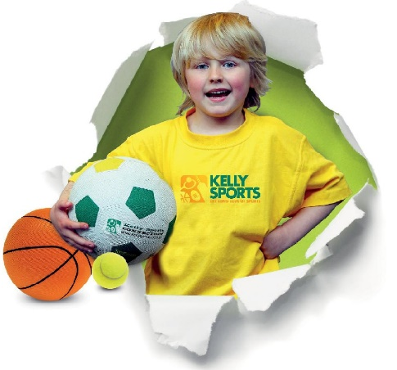



**How To Enrol?**Please visit [www.kellysports.com.au/events](http://www.kellysports.com.au/events) and search for your school.  
Our new booking system requires upfront payments to secure your position. For more information, please call the head office.

**"The Kelly Sports Programs offer our students opportunities for physical activities; including dance & multi-sports. Conveniently located on our school grounds, they are popular with students and their families. Staff are skilled in working with young people to love active participation.”**



***Amanda Hay, Principal – Newtown Primary School***

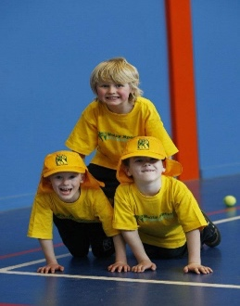

**CLASS INFORMATION**

Sign up at any time of the term and only pay for the sessions your child can attend.

Fundamental Motor Skills include Locomotive skills, Catch & Throw, Ball skills and of a range of sports the kids will love.

**When: Wednesday**   
**Starts: 1st May**   
**Finishes: 26th June**   
**Time: 2.30pm to 3pm  
Cost: $108 (Inc GST) or $12 per week**

