 P.O. Box 71, Moonee Vale 3055

**T** (03) 9384 2204

**F** (03) 9384 2205

**E** mitch@kellysports.com.au

**SERPELL PRIMARY SCHOOL**

**DYNAMIC DANCE**

**WHEN:** Tuesday

**COMMENCING:** 2/5/2017

**CONCLUDING:** 27/6/2017

**TIME:** 12.30pm – 1.30pm

**YEAR LEVELS:** P – 4

Shake, move and let the beat enter your feet with Kelly Sports. Our trained dance coaches can get your child’s **hips swinging, heads bumping, feet rocking and bodies shaking** to all of modern contemporary music’s classics. Sign up fast as places are limited and let our coaches beat ignite your child’s dancing feet.

* Kelly Sports are excited to announce we are now running our programs every week of term 3 due to popular demand!



**GYM FUN**

This fun fast paced, highly active and non-stop program is an introduction for your child to the world of gymnastics. **Colorful ribbons, Entertaining Hula Hoops, Incredible** **Rhythmical Routines and Group Dynamics**. Allow your child to build their gymnastics skills and their thirst   
for exciting energetic activities.

**WHEN:** Thursday

**COMMENCING:** 4/5/2017

**CONCLUDING:** 29/6/2017

**TIME:** 12.30pm – 1.30pm

**YEAR LEVELS:** P – 4



**AWESOME AUTUMN SPORTS**

Don’t miss out on this brilliant catch! Super Summer Sports allows your child to experience a fun, energetic and highly active multi-sport program over **10 weeks** these include; **Soccer, Football, Basketball, Netball and Tee-Ball!** This program will not only provide an essential base for your child’s motor skills but help build awareness and co-ordination all in an enjoyable environment.

**WHEN:** Monday

**COMMENCING:** 24/4/2017

**CONCLUDING:** 26/6/2017

**TIME:** 3.40pm – 4.40pm

**YEAR LEVEL** P – 4



**COST: $120-EARLY BIRD RATE JUST $108 WHEN YOU ENROL BY FRIDAY 14TH APRIL** (go to [**www.kellysports.com.au**](http://www.kellysports.com.au) and search for your school)

**It’s here online enrolments !**

**To enrol**, please visit [www.kellysports.com.au](http://www.kellysports.com.au) or

fill out the enrolment form & **send** with a cheque or credit card details to:

Kelly Sports PO BOX 71, Moonee Vale, VIC, 3055.

Payment options available!

Do **not** leave enrolment forms at the school office

**VENUE: Serpell Primary School**

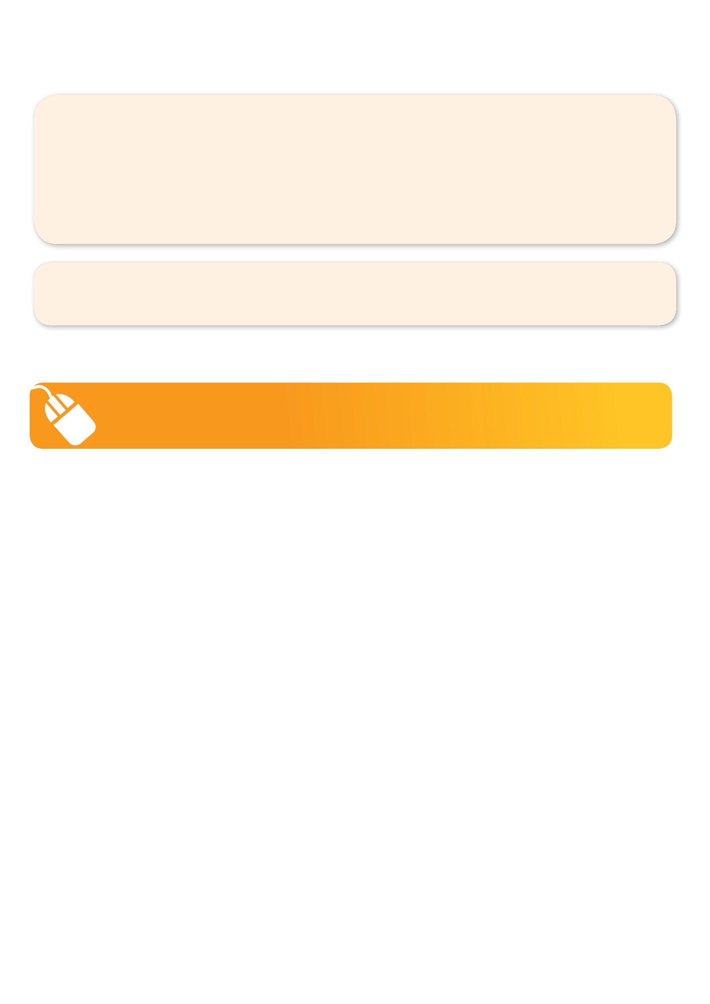**­**

NEW IMPROVED ONLINE BOOKING SYSTEM!!!

SIMPLY GO TO [WWW.KELLYSPORTS.COM.AU](http://WWW.KELLYSPORTS.COM.AU) ENTER YOUR POST CODE AND ENROL FROM THERE. OR

FILL OUT THE BELOW ENROLMENT FORM & SEND WITH A CHEQUE OR CREDIT CARDS DETAILS TO:

**PO BOX 71, MOONEE VALE, 3055**

PAYMENT OPTIONS AVAILABLE!

**It’s here online enrolments !**

**To enrol**, please visit [www.kellysports.com.au](http://www.kellysports.com.au) or

fill out the enrolment form & **send** with a cheque or credit card details to:

Kelly Sports PO BOX 71, Moonee Vale, VIC, 3055.

Payment options available!

Do **not** leave enrolment forms at the school office

**ENROLMENT FORM**

□  **Dynamic Dance** (lunchtime) □ **Gym Fun** (Lunchtime) □ **Awesome Autumn Sports** (After school)

School: Year Level:

Name: Room No:

Address: Post Code:

Phone: Mobile/Work:

Email: Medical Conditions:

At the completion of after school clinics, does your child? □ Go to after care □ Get collected

**Parents’ consent**

**I hereby authorise Kelly Sports to act on my behalf should my child require medical attention, and release Kelly Sports Templestowe from   
any liability for injury incurred by my child at Kelly Sports programmes.**

□ **I authorise the use by Kelly Sports of any photographs or video image of my child or legal charge for any reasonable purpose.**

Parent/Caregiver name: Signature:

Amount Paid: $

**It’s here online enrolments !**

**To enrol**, please visit [www.kellysports.com.au](http://www.kellysports.com.au) or

fill out the enrolment form & **send** with a cheque or credit card details to:

Kelly Sports PO BOX 71, Moonee Vale, VIC, 3055.

Payment options available!

Do **not** leave enrolment forms at the school office

**It’s here online enrolments !**

**To enrol**, please visit [www.kellysports.com.au](http://www.kellysports.com.au) or

fill out the enrolment form & **send** with a cheque or credit card details to:

Kelly Sports PO BOX 71, Moonee Vale, VIC, 3055.

Payment options available!

Do **not** leave enrolment forms at the school office

**It’s here online enrolments !**

**To enrol**, please visit [www.kellysports.com.au](http://www.kellysports.com.au) or

fill out the enrolment form & **send** with a cheque or credit card details to:

Kelly Sports PO BOX 71, Moonee Vale, VIC, 3055.

Payment options available!

Do **not** leave enrolment forms at the school office