 P.O. Box 71, Moonee Vale 3055

**T** (03) 9384 2204

**F** (03) 9384 2205

**E** mitch@kellysports.com.au

**SERPELL PRIMARY SCHOOL**

**WHEN:** Monday

**COMMENCING:** 23/7/2018

**CONCLUDING:** 17/9/2018

**TIME:** 3.40pm – 4.40pm

**YEAR LEVELS:** P – 4

**COST:** $118.80 (Inc Gst)

**MIGHTY MULTI SPORTS - AFL-SOCCER-BASKETBALL/NETBALL – TEEBALL – FUN GAMES**

Start the new school term by enrolling in this fantastic Kelly sports program. Join up with your friends and develop your skills in a fun, safe an exciting sporting environment. Our experienced coaches aim to develop and enhance the wide range of sporting skills of your child including kicking catching & throwing while also improving strength, flexibility, hand-eye co-ordination, Spatial awareness, co-operative and teamwork



**GROOVY JAZZ**

**WHEN:** Tuesday

**COMMENCING:** 24/7/2018

**CONCLUDING:** 18/9/2018

**TIME:** 12.30pm – 1.30pm

**YEAR LEVELS:** P – 4

**COST:** $118.80 (Inc Gst)

Groovy Jazz is a new and exciting jazz based routine for term 3. Students will have a fantastic time learning the new moves in our high intensity, excitement-filled dance environment. Our experienced coaches will work through the steps each week, while also incorporating lots of fun dance related games and activities. Sign up fast for this popular program.



**WHEN:** Thursday

**COMMENCING:** 26/7/2018

**CONCLUDING:** 20/9/2018

**TIME:** 12.30pm – 1.30pm

**YEAR LEVEL** P – 4

**COST:** $118.80 (Inc Gst)

**GYM FUN**

This fun fast paced, highly active and non-stop program is an introduction for your child to the world of gymnastics. Colourful ribbons, Entertaining Hula Hoops, Incredible Rhythmical Routines and Group Dynamics. Allow your child to build their gymnastics skills and their thirst   
for exciting energetic activities.



**How To Enrol?**Please visit [www.kellysports.com.au/events](http://www.kellysports.com.au/events) and search for your school.  
Our new booking system requires upfront payments to secure your position. For more information, please call the head office.

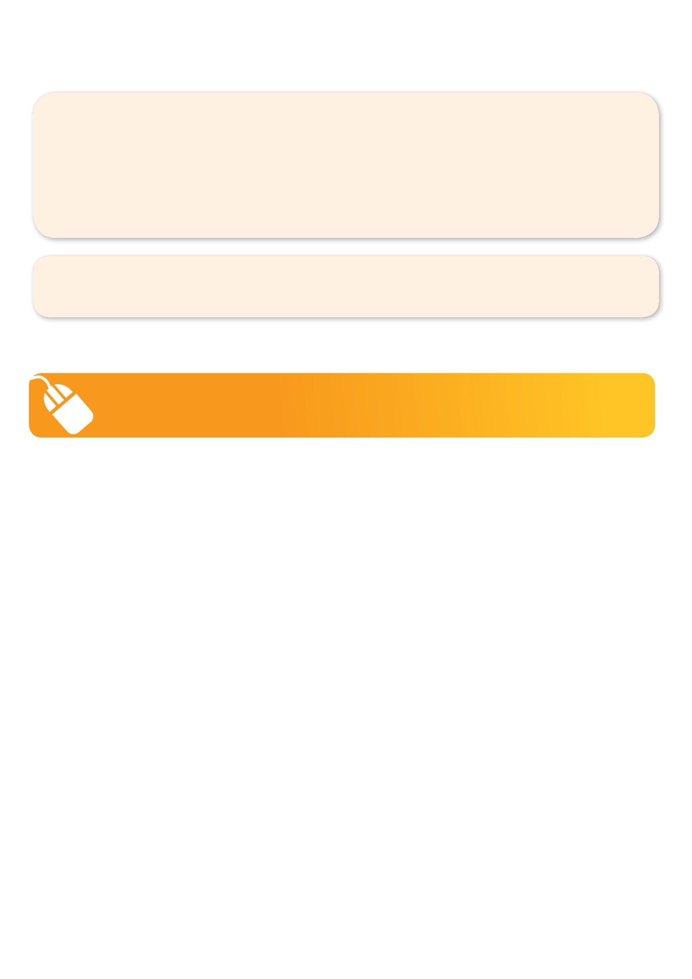**­**

**It’s here online enrolments !**

**To enrol**, please visit [www.kellysports.com.au](http://www.kellysports.com.au) or

fill out the enrolment form & **send** with a cheque or credit card details to:

Kelly Sports PO BOX 71, Moonee Vale, VIC, 3055.

Payment options available!

Do **not** leave enrolment forms at the school office

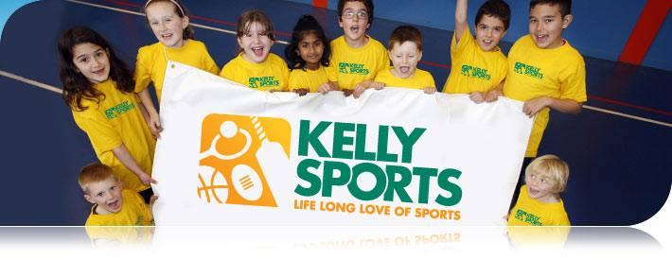

**"The Kelly Sports Programs offer our students opportunities for physical activities; including dance & multi-sports. Conveniently located on our school grounds, they are popular with students and their families. Staff are skilled in working with young people to love active participation.”**

***Amanda Hay, Principal – Newtown Primary School***

**It’s here online enrolments !**

**To enrol**, please visit [www.kellysports.com.au](http://www.kellysports.com.au) or

fill out the enrolment form & **send** with a cheque or credit card details to:

Kelly Sports PO BOX 71, Moonee Vale, VIC, 3055.

Payment options available!

Do **not** leave enrolment forms at the school office

**It’s here online enrolments !**

**To enrol**, please visit [www.kellysports.com.au](http://www.kellysports.com.au) or

fill out the enrolment form & **send** with a cheque or credit card details to:

Kelly Sports PO BOX 71, Moonee Vale, VIC, 3055.

Payment options available!

Do **not** leave enrolment forms at the school office

**It’s here online enrolments !**

**To enrol**, please visit [www.kellysports.com.au](http://www.kellysports.com.au) or

fill out the enrolment form & **send** with a cheque or credit card details to:

Kelly Sports PO BOX 71, Moonee Vale, VIC, 3055.

Payment options available!

Do **not** leave enrolment forms at the school office