

P.O. Box 71, Moonee Vale 3055

**T** (03) 9384 2204

**F** (03) 9384 2205

**E** mitch@kellysports.com.au

**SERPELL PRIMARY SCHOOL**

**WHEN:** Monday’s

**COMMENCING:** 29th April

**CONCLUDING:** 24th June

**TIME:** 3.40pm – 4.40pm

**YEAR LEVELS:** P – 4

**COST:** $105.60 (Inc Gst)

No session 10th June Queen’s Birthday

**AWESOME AUTUMN SPORTS – AFL – SOCCER – BASKETBALL - HOCKEY**

Kelly Sports is back in Term 2 for a **AWESOME AUTUMN OF SPORTS!!**   
Our Kelly Sports classes are all inclusive, fun & interactive with a key focus on maximum participation. Each week children will be introduced to new sports & activities in a positive environment. It’s a fantastic way to get your child active while having fun as well as building confidence and social skills!



**WHEN:** Tuesday’s

**COMMENCING:** 30th April

**CONCLUDING:** 225th June

**TIME:** 12.30pm – 1.30pm

**YEAR LEVELS:** P – 4

**COST:** $118.80 (Inc Gst)

**JAZZ FUNK**

Jazz – Funk takes elements of both Hip Hop and Jazz, combined into one dance style that gives students a chance to release energy and dance with power and passion. Our experience staff will work on a brand new routine through out the term to showcase to parents and friends. Sign up fast as students will have a fantastic time learning the new moves in our high intensity, excitement-filled dance environment.



**WHEN:** Thursday’s

**COMMENCING:** 2nd May

**CONCLUDING:** 27th June

**TIME:** 12.30pm – 1.30pm

**YEAR LEVEL** P – 4

**COST:** $118.80 (Inc Gst)

**GYM FUN**

This fun fast paced, highly active and non-stop program is an introduction for your child to the world of gymnastics. Colourful ribbons, Entertaining Hula Hoops, Incredible Rhythmical Routines and Group Dynamics. Allow your child to build their gymnastics skills and their thirst   
for exciting energetic activities.



**How To Enrol?**Please visit [www.kellysports.com.au/events](http://www.kellysports.com.au/events) and search for your school.  
Our new booking system requires upfront payments to secure your position. For more information, please call the head office.

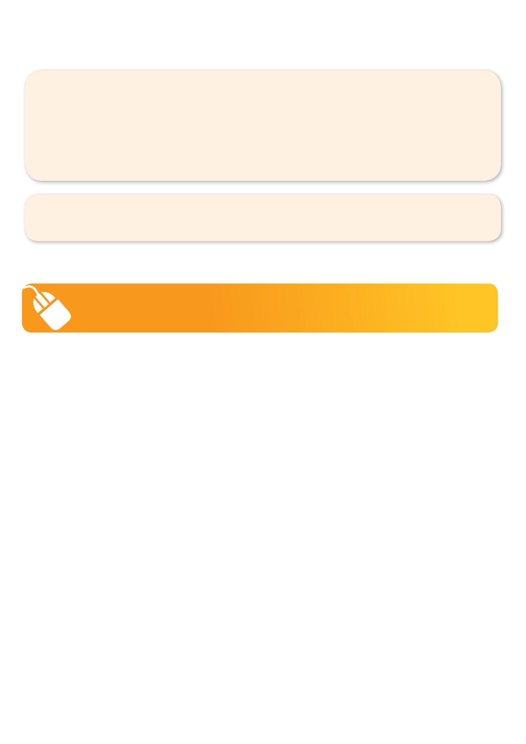**­**

**It’s here online enrolments !**

**To enrol**, please visit [www.kellysports.com.au](http://www.kellysports.com.au) or

fill out the enrolment form & **send** with a cheque or credit card details to:

Kelly Sports PO BOX 71, Moonee Vale, VIC, 3055.

Payment options available!

Do **not** leave enrolment forms at the school office

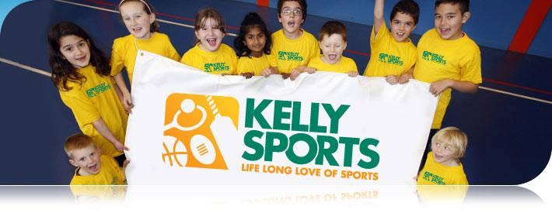

**"The Kelly Sports Programs offer our students opportunities for physical activities; including dance & multi-sports. Conveniently located on our school grounds, they are popular with students and their families. Staff are skilled in working with young people to love active participation.”**

***Amanda Hay, Principal – Newtown Primary School***

**It’s here online enrolments !**

**To enrol**, please visit [www.kellysports.com.au](http://www.kellysports.com.au) or

fill out the enrolment form & **send** with a cheque or credit card details to:

Kelly Sports PO BOX 71, Moonee Vale, VIC, 3055.

Payment options available!

Do **not** leave enrolment forms at the school office

**It’s here online enrolments !**

**To enrol**, please visit [www.kellysports.com.au](http://www.kellysports.com.au) or

fill out the enrolment form & **send** with a cheque or credit card details to:

Kelly Sports PO BOX 71, Moonee Vale, VIC, 3055.

Payment options available!

Do **not** leave enrolment forms at the school office

**It’s here online enrolments !**

**To enrol**, please visit [www.kellysports.com.au](http://www.kellysports.com.au) or

fill out the enrolment form & **send** with a cheque or credit card details to:

Kelly Sports PO BOX 71, Moonee Vale, VIC, 3055.

Payment options available!

Do **not** leave enrolment forms at the school office