 P.O. Box 71, Moonee Vale 3055

**T** (03) 9384 2204

**F** (03) 9384 2205

**E** mitch@kellysports.com.au

**SERPELL PRIMARY SCHOOL**

**SUPER SUMMER SPORTS - CRICKET-SOCCER-BASKETBALL-ULTIMATE FRISBEE**

Start the new school term by enrolling in this fantastic Kelly sports program. Join up with your friends and develop your skills in a fun, safe an exciting sporting environment. Our experienced coaches aim to develop and enhance the wide range of sporting skills of your child including kicking catching & throwing while also improving strength, flexibility, hand-eye co-ordination, Spatial awareness, co-operative and teamwork

**WHEN:** Monday

**COMMENCING:** 05/2/2018

**CONCLUDING:** 26/3/2018

**TIME:** 3.40pm – 4.40pm

**YEAR LEVELS:** P – 4



**HIP HOP**

**Kelly sports Hip Hop is back in term 1!**Throughout the term students will have the opportunity to move, groove, spin and bop to the sound of some hip hop favourite tunes, alongside our very experience dance instructor. You will have a fantastic time learning the new moves in our high intensity excitement-filled environment.

**WHEN:** Tuesday

**COMMENCING:** 6/2/2018

**CONCLUDING:** 27/3/2018

**TIME:** 12.30pm – 1.30pm

**YEAR LEVELS:** P – 4



**GYM FUN**

This fun fast paced, highly active and non-stop program is an introduction for your child to the world of gymnastics. **Colourful ribbons, Entertaining Hula Hoops, Incredible** **Rhythmical Routines and Group Dynamics**. Allow your child to build their gymnastics skills and their thirst   
for exciting energetic activities.

**WHEN:** Thursday

**COMMENCING:** 8/2/2018

**CONCLUDING:** 22/3/2018

**TIME:** 12.30pm – 1.30pm

**YEAR LEVEL** P – 4



**COST: Monday & Thursday $84 for 7 weeks – Tuesday $96 for 8 weeks**

**It’s here online enrolments !**

**To enrol**, please visit [www.kellysports.com.au](http://www.kellysports.com.au) or

fill out the enrolment form & **send** with a cheque or credit card details to:

Kelly Sports PO BOX 71, Moonee Vale, VIC, 3055.

Payment options available!

Do **not** leave enrolment forms at the school office

**VENUE: Serpell Primary School**

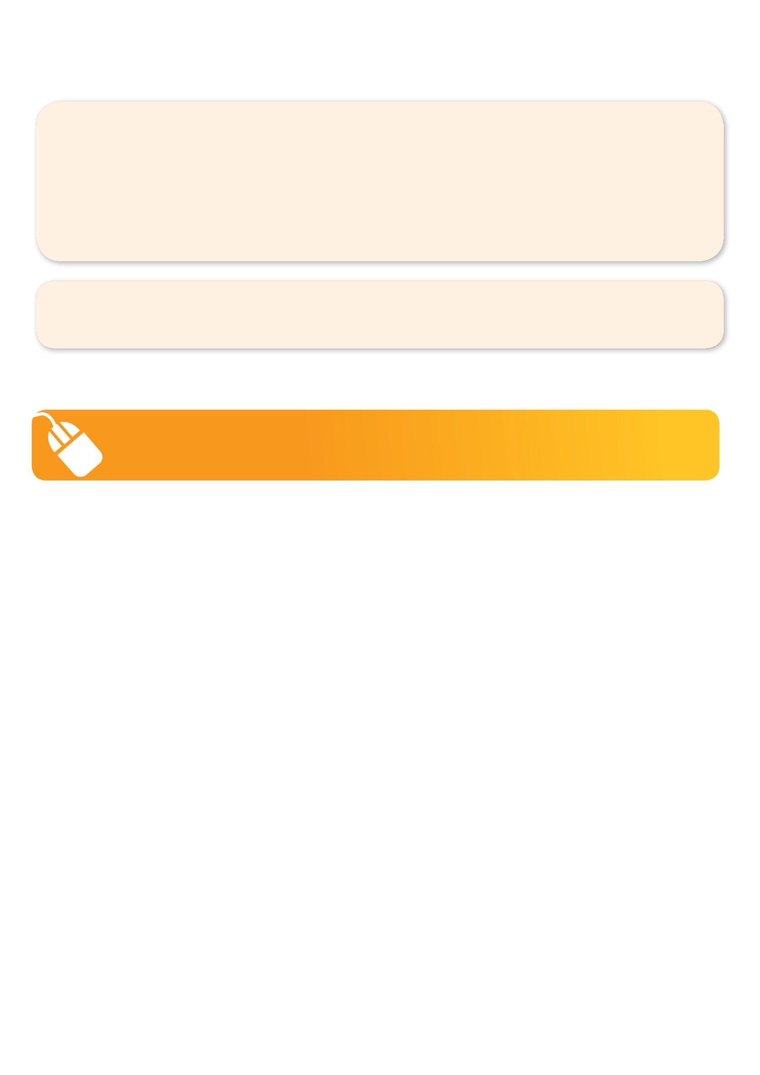**­**

NEW IMPROVED ONLINE BOOKING SYSTEM!!!

SIMPLY GO TO [WWW.KELLYSPORTS.COM.AU](http://WWW.KELLYSPORTS.COM.AU) ENTER YOUR POST CODE AND ENROL FROM THERE. OR

FILL OUT THE BELOW ENROLMENT FORM & SEND WITH A CHEQUE OR CREDIT CARDS DETAILS TO:

**PO BOX 71, MOONEE VALE, 3055**

PAYMENT OPTIONS AVAILABLE!

**It’s here online enrolments !**

**To enrol**, please visit [www.kellysports.com.au](http://www.kellysports.com.au) or

fill out the enrolment form & **send** with a cheque or credit card details to:

Kelly Sports PO BOX 71, Moonee Vale, VIC, 3055.

Payment options available!

Do **not** leave enrolment forms at the school office

**ENROLMENT FORM**

□  **Super Summer Sport** (After school)□ **Hip Hop** (Lunchtime) □ **Gym Fun** (Lunchtime)

School: Year Level:

Name: Room No:

Address: Post Code:

Phone: Mobile/Work:

Email: Medical Conditions:

At the completion of after school clinics, does your child? □ Go to after care □ Get collected

**Parents’ consent**

**I hereby authorise Kelly Sports to act on my behalf should my child require medical attention, and release Kelly Sports Templestowe from   
any liability for injury incurred by my child at Kelly Sports programmes.**

□ **I authorise the use by Kelly Sports of any photographs or video image of my child or legal charge for any reasonable purpose.**

Parent/Caregiver name: Signature:

Amount Paid: $

**It’s here online enrolments !**

**To enrol**, please visit [www.kellysports.com.au](http://www.kellysports.com.au) or

fill out the enrolment form & **send** with a cheque or credit card details to:

Kelly Sports PO BOX 71, Moonee Vale, VIC, 3055.

Payment options available!

Do **not** leave enrolment forms at the school office

**It’s here online enrolments !**

**To enrol**, please visit [www.kellysports.com.au](http://www.kellysports.com.au) or

fill out the enrolment form & **send** with a cheque or credit card details to:

Kelly Sports PO BOX 71, Moonee Vale, VIC, 3055.

Payment options available!

Do **not** leave enrolment forms at the school office

**It’s here online enrolments !**

**To enrol**, please visit [www.kellysports.com.au](http://www.kellysports.com.au) or

fill out the enrolment form & **send** with a cheque or credit card details to:

Kelly Sports PO BOX 71, Moonee Vale, VIC, 3055.

Payment options available!

Do **not** leave enrolment forms at the school office