

**WARRANWOOD**

**PRIMARY SCHOOL P** (03) 9384 2204

**M** 0403 149 391

** E** templestowe@kellysports.com.au

**BASKETBALL CLUB**

Come and join us for our first ever Lunch Time Basketball program. This Basketball Program includes all the skill and activities required to help enhance your child's skills, and get them on the way to being the next Basketball Superstar. This program is run by ex Maroondah Magic and Warrandyte Venom players





**How To Enrol?**Please visit [www.kellysports.com.au/events](http://www.kellysports.com.au/events) and search for your school.  
**Our new booking system requires upfront payments to secure your position. For more information, please call the head office.**



**"The Kelly Sports Programs offer our students opportunities for physical activities; including dance & multi-sports. Conveniently located on our school grounds, they are popular with students and their families. Staff are skilled in working with young people to love active participation.”**



***Amanda Hay, Principal – Newtown Primary School***

**CLASS INFORMATION**

Only 14 spots available for each program so sign up fast to secure your position  
  
This program will focus on skill based and game sense activities.  
  
Come and join us every Monday at Lunchtime.

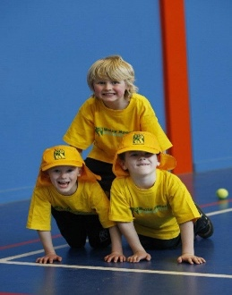

**When: Monday**  
**Continues: 13th May**   
**Finishes: 24th June**  
**Time: 1pm – 1:50pm**  
**Year Levels: Prep – 4  
Cost: $79.20 (Inc GST) or $13.20 per week left in the term.**

