 P.O. Box 3011, The Pines 3109

**T** 0414 381 368

**E** [davidkight@kellysports.com.au](mailto:davidkight@kellysports.com.au)

**MONTMORENCY PRIMARY SCHOOL**

**SIZZZLING SUMMER SPORTS**

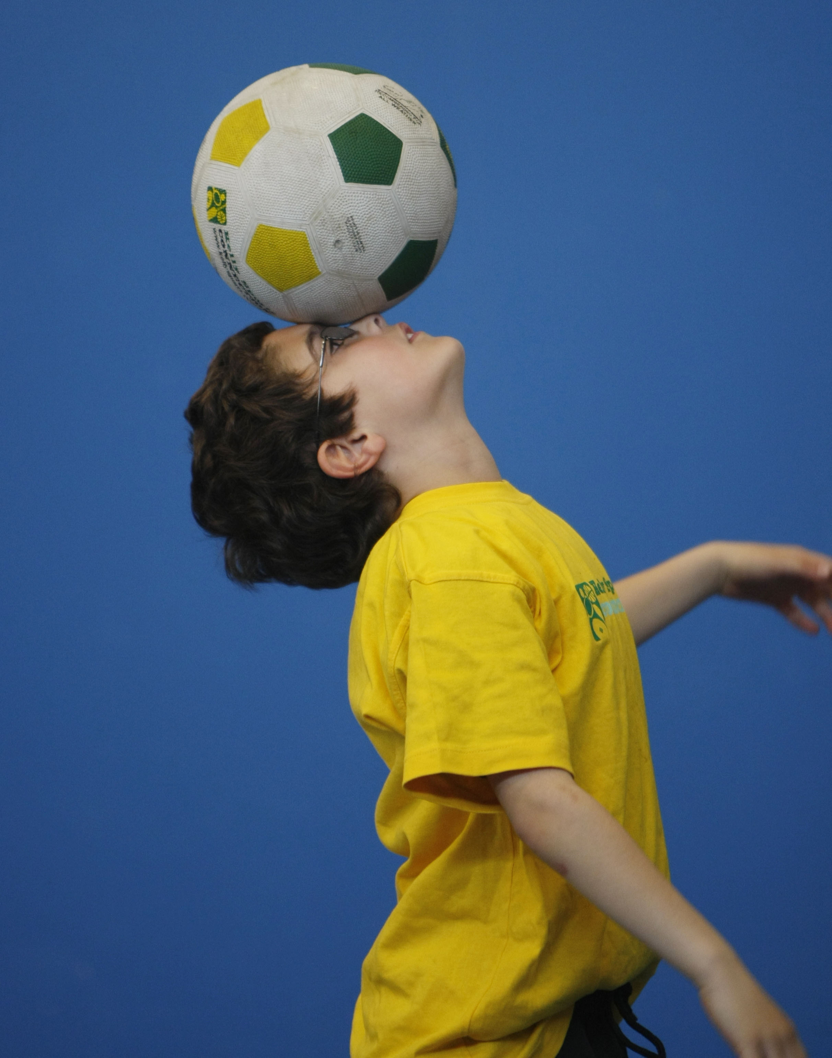

**WHEN:** Thursday

**COMMENCING:** 9/2/2017

**CONCLUDING:** 30/3/2017

**TIME:** 3.40pm – 4.40pm

**YEAR LEVELS:** P – 4

DONT MISS OUT ON SHOOTING A GOAL! SIZZLING SUMMER SPORTS allows your child to play a range of dynamic and active programs run over **8 weeks** these include; **Soccer, Cricket, Basketball and Hockey!** This Program will not only provide an essential base for your child's motor skills but help build awareness, co-ordination and friendship all in an enjoyable environment.

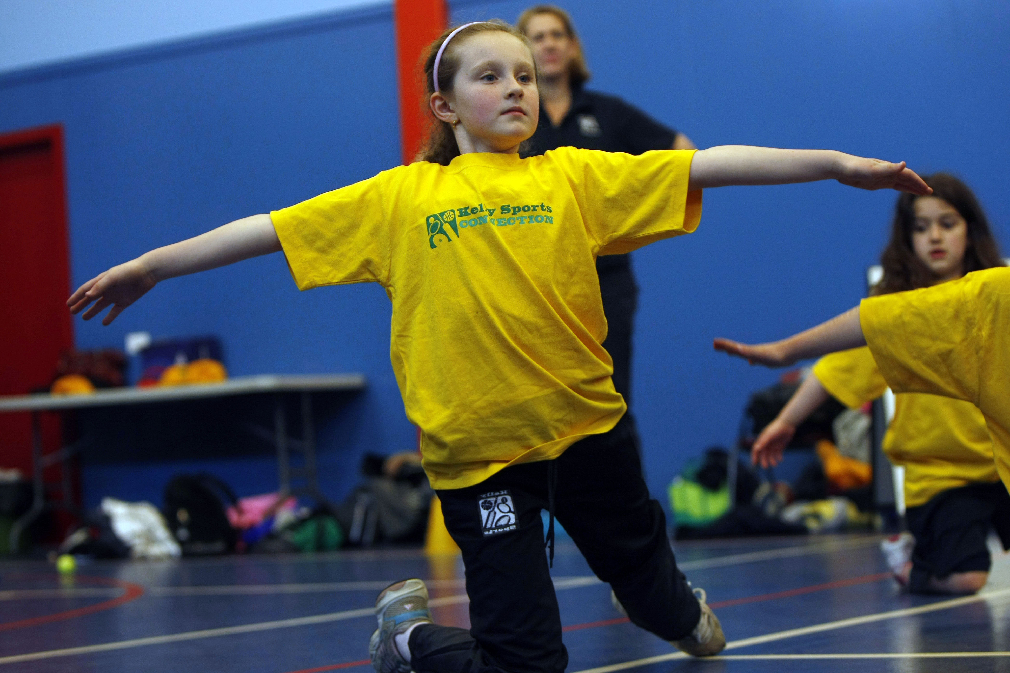

**DYNAMIC DANCE-NEW!**

**WHEN:** Wednesday

**COMMENCING:** 8/2/2017

**CONCLUDING:** 29/3/2017

**TIME:** 11.00am –11.40am

**YEAR LEVELS:** P – 4

LET THE BEAT ENTER YOUR FEET! Our specialized Dance coaches can get your child’s hips swinging, feet rocking and heads bumping to all of modern contemporary music’s classics. Sign up fast as places are limited and let our coaches beat ignite your child’s feet!



**COST: EARLY BIRD RATE-JUST $84 FOR 8 WEEKS IF YOU ENROL BY 27TH JANUARY (go to** [**www.kellysports.com.au**](http://www.kellysports.com.au) **and search for your school)**

**It’s here online enrolments !**

**To enrol**, please visit [www.kellysports.com.au](http://www.kellysports.com.au) or

fill out the enrolment form & **send** with a cheque or credit card details to:

Kelly Sports PO BOX 71, Moonee Vale, VIC, 3055.

Payment options available!

Do **not** leave enrolment forms at the school office

**VENUE: Montmorency Primary School**

**­**

To enrol, please visit [**www.kellysports.com.au**](http://www.kellysports.com.au)or fill

out the below enrolment form & sendwith a cheque to:

**PO BOX 3011, The Pines VIC 3109**. Payment options

available! **Do not** leave enrolment forms at the school office.

**ONLINE ENROLMENT**

**www.kellysports.com.au/zone/templestowe**

**It’s here online enrolments !**

**To enrol**, please visit [www.kellysports.com.au](http://www.kellysports.com.au) or

fill out the enrolment form & **send** with a cheque or credit card details to:

Kelly Sports PO BOX 71, Moonee Vale, VIC, 3055.

Payment options available!

Do **not** leave enrolment forms at the school office

**ENROLMENT FORM**

□ **Sizzling Summer Sports** (After School) □ **Dynamic Dance** (Lunchtime)

School: Year Level:

Name: Room No:

Address: Post Code:

Phone: Mobile/Work:

Email: Medical Conditions:

At the completion of after school clinics, does your child? □ Go to after care □ Get collected

**Parents’ consent: I hereby authorise Kelly Sports to act on my behalf should my child require medical attention, and release   
Kelly Sports Templestowe from any liability for injury incurred by my child at Kelly Sports programmes.**

**Payment Options: Go online and pay via Direct Deposit or credit card.**

Parent/Caregiver name: Signature:

Amount Paid: $

**It’s here online enrolments !**

**To enrol**, please visit [www.kellysports.com.au](http://www.kellysports.com.au) or

fill out the enrolment form & **send** with a cheque or credit card details to:

Kelly Sports PO BOX 71, Moonee Vale, VIC, 3055.

Payment options available!

Do **not** leave enrolment forms at the school office

**It’s here online enrolments !**

**To enrol**, please visit [www.kellysports.com.au](http://www.kellysports.com.au) or

fill out the enrolment form & **send** with a cheque or credit card details to:

Kelly Sports PO BOX 71, Moonee Vale, VIC, 3055.

Payment options available!

Do **not** leave enrolment forms at the school office

**It’s here online enrolments !**

**To enrol**, please visit [www.kellysports.com.au](http://www.kellysports.com.au) or

fill out the enrolment form & **send** with a cheque or credit card details to:

Kelly Sports PO BOX 71, Moonee Vale, VIC, 3055.

Payment options available!

Do **not** leave enrolment forms at the school office