 P.O. Box 71, Moonee Vale 3055

**T** (03) 9384 2204

**F** (03) 9384 2205

**E** mitch@kellysports.com.au

**SERPELL PRIMARY SCHOOL**

**WHEN:** Monday’s

**COMMENCING:** 4th February

**CONCLUDING:** 1st April

**TIME:** 3.40pm – 4.40pm

**YEAR LEVELS:** P – 4

**COST:** $105.60 (Inc Gst)

No session 11th March

**SIZZLING SUMMER SPORTS – CRICET -SOCCER-BASKETBALL – TENNIS – FUN GAMES**

Kelly Sports is back in Term 1 for a **SIZZLING SUMMER OF SPORTS!!**   
Our Kelly Sports classes are all inclusive, fun & interactive with a key focus on maximum participation. Each week children will be introduced to new sports & activities in a positive environment. It’s a fantastic way to get your child active while having fun as well as building confidence and social skills!



**WHEN:** Tuesday’s

**COMMENCING:** 5th February

**CONCLUDING:** 2nd April

**TIME:** 12.30pm – 1.30pm

**YEAR LEVELS:** P – 4

**COST:** $118.80 (Inc Gst)

**HIP HOP**

Kelly Sports welcomes HIP HOP back in Term 1! In this program Students will have the opportunity to move, groove, spin and bop to the sound of hip hop beats alongside our very experienced dance instructor. You will have a fantastic time learning the new moves in our high intensity, excitement-filled dance environment. At the end of the term the kids will have learnt a new performance to showcase to their parents.



**WHEN:** Thursday’s

**COMMENCING:** 7th February

**CONCLUDING:** 4th April

**TIME:** 12.30pm – 1.30pm

**YEAR LEVEL** P – 4

**COST:** $118.80 (Inc Gst)

**GYM FUN**

This fun fast paced, highly active and non-stop program is an introduction for your child to the world of gymnastics. Colourful ribbons, Entertaining Hula Hoops, Incredible Rhythmical Routines and Group Dynamics. Allow your child to build their gymnastics skills and their thirst   
for exciting energetic activities.



**How To Enrol?**Please visit [www.kellysports.com.au/events](http://www.kellysports.com.au/events) and search for your school.  
Our new booking system requires upfront payments to secure your position. For more information, please call the head office.

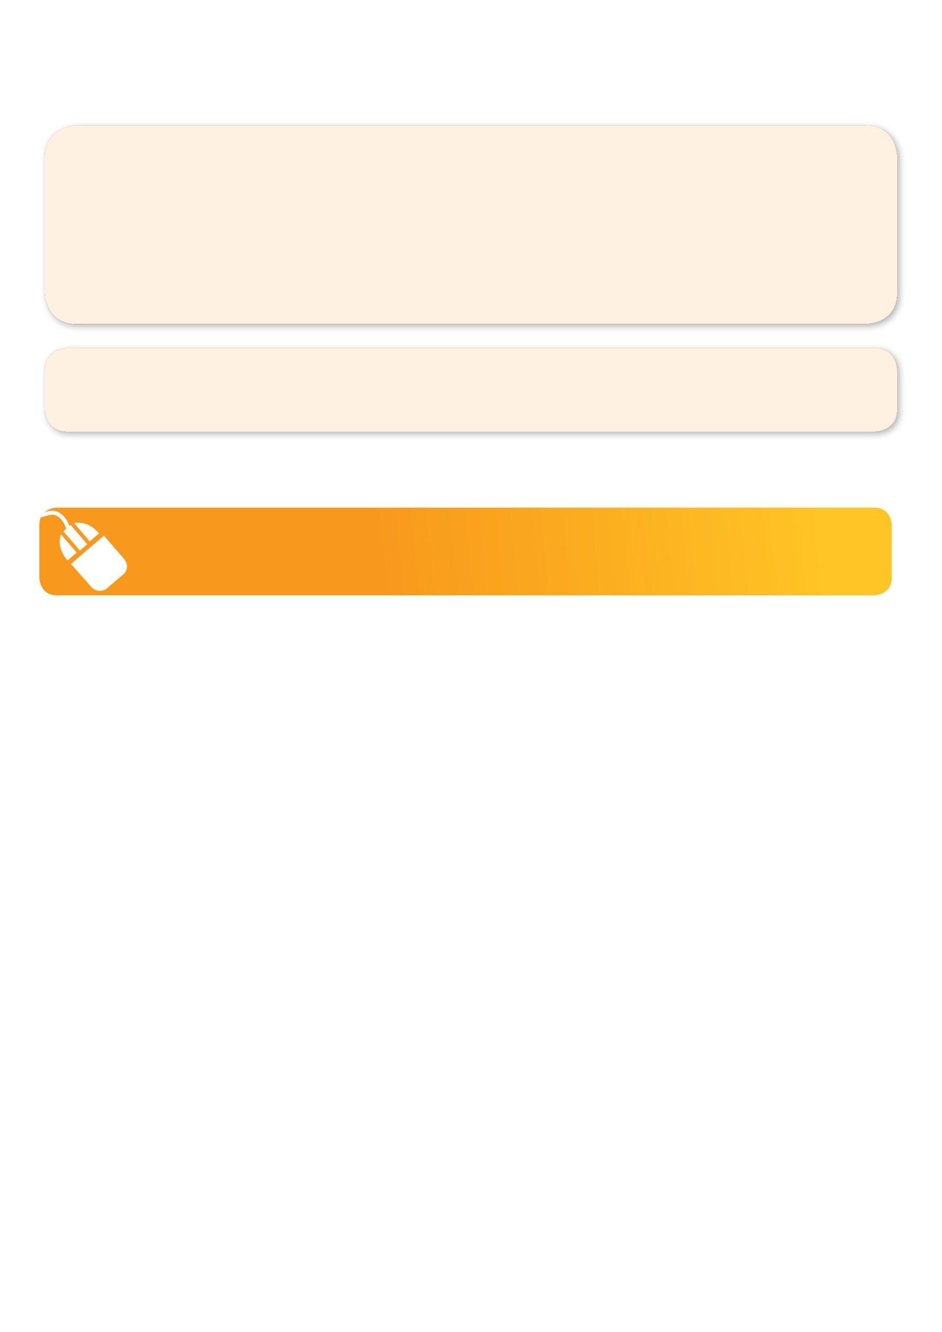**­**

**It’s here online enrolments !**

**To enrol**, please visit [www.kellysports.com.au](http://www.kellysports.com.au) or

fill out the enrolment form & **send** with a cheque or credit card details to:

Kelly Sports PO BOX 71, Moonee Vale, VIC, 3055.

Payment options available!

Do **not** leave enrolment forms at the school office

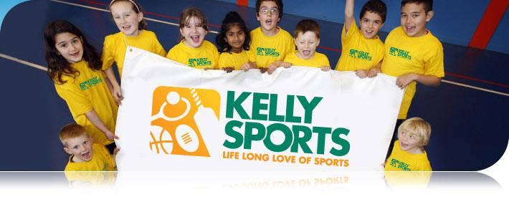

**"The Kelly Sports Programs offer our students opportunities for physical activities; including dance & multi-sports. Conveniently located on our school grounds, they are popular with students and their families. Staff are skilled in working with young people to love active participation.”**

***Amanda Hay, Principal – Newtown Primary School***

**It’s here online enrolments !**

**To enrol**, please visit [www.kellysports.com.au](http://www.kellysports.com.au) or

fill out the enrolment form & **send** with a cheque or credit card details to:

Kelly Sports PO BOX 71, Moonee Vale, VIC, 3055.

Payment options available!

Do **not** leave enrolment forms at the school office

**It’s here online enrolments !**

**To enrol**, please visit [www.kellysports.com.au](http://www.kellysports.com.au) or

fill out the enrolment form & **send** with a cheque or credit card details to:

Kelly Sports PO BOX 71, Moonee Vale, VIC, 3055.

Payment options available!

Do **not** leave enrolment forms at the school office

**It’s here online enrolments !**

**To enrol**, please visit [www.kellysports.com.au](http://www.kellysports.com.au) or

fill out the enrolment form & **send** with a cheque or credit card details to:

Kelly Sports PO BOX 71, Moonee Vale, VIC, 3055.

Payment options available!

Do **not** leave enrolment forms at the school office