 P.O. Box 3011, The Pines 3109

**T** 0414 381 368

**E** [davidkight@kellysports.com.au](mailto:davidkight@kellysports.com.au)

**TEMPLESTOWE HEIGHTS PRIMARY SCHOOL**

**SUPER SUMMER SPORTS**

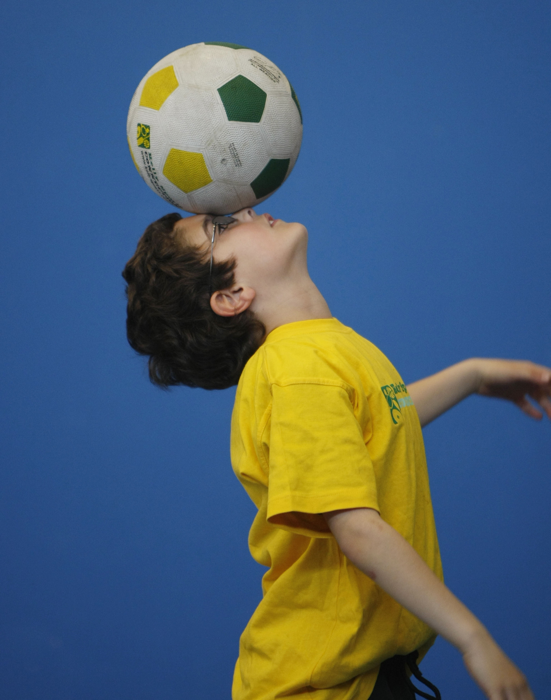

DONT MISS OUT ON HITTING A SIX! SUPER SUMMER SPORTS allows your child to play a range of dynamic and active programs run over **8 weeks**, these include; **Soccer, T-Ball, Cricket and Basketball!** This Program will not only provide an essential base for your child's motor skills but help build awareness, co-ordination and friendship all in an enjoyable environment.

**WHEN:** Wednesday

**COMMENCING:** 4/2/2015

**CONCLUDING:** 25/3/2015

**TIME:** 3.40pm – 4.40pm

**YEAR LEVELS:** P – 4



**COST: $80(**go to [www.kellysports.com.au](http://www.kellysports.com.au) and search for your school )

**It’s here online enrolments !**

**To enrol**, please visit [www.kellysports.com.au](http://www.kellysports.com.au) or

fill out the enrolment form & **send** with a cheque or credit card details to:

Kelly Sports PO BOX 71, Moonee Vale, VIC, 3055.

Payment options available!

Do **not** leave enrolment forms at the school office

**VENUE: Templestowe Heights Primary School**

**­**

To enrol, please visit [**www.kellysports.com.au**](http://www.kellysports.com.au)

or fill out the below enrolment form & sendwith a cheque

to: **PO BOX 3011, The Pines VIC 3109**. Payment options

available! **Do not** leave enrolment forms at the school office.

**ONLINE ENROLMENT**

**www.kellysports.com.au**

**It’s here online enrolments !**

**To enrol**, please visit [www.kellysports.com.au](http://www.kellysports.com.au) or

fill out the enrolment form & **send** with a cheque or credit card details to:

Kelly Sports PO BOX 71, Moonee Vale, VIC, 3055.

Payment options available!

Do **not** leave enrolment forms at the school office

**ENROLMENT FORM**

School: Year Level:

Name: Room No:

Address: Post Code:

Phone: Mobile/Work:

Email: Medical Conditions:

At the completion of after school clinics, does your child? □ Go to after care □ Get collected

**Parents’ consent: I hereby authorise Kelly Sports to act on my behalf should my child require medical attention, and release   
Kelly Sports Templestowe from any liability for injury incurred by my child at Kelly Sports programmes.**

**Payment Options: Go online and pay via Direct Deposit or credit card via Pay Pal.**

Parent/Caregiver name: Signature:

Amount Paid: $

**It’s here online enrolments !**

**To enrol**, please visit [www.kellysports.com.au](http://www.kellysports.com.au) or

fill out the enrolment form & **send** with a cheque or credit card details to:

Kelly Sports PO BOX 71, Moonee Vale, VIC, 3055.

Payment options available!

Do **not** leave enrolment forms at the school office

**It’s here online enrolments !**

**To enrol**, please visit [www.kellysports.com.au](http://www.kellysports.com.au) or

fill out the enrolment form & **send** with a cheque or credit card details to:

Kelly Sports PO BOX 71, Moonee Vale, VIC, 3055.

Payment options available!

Do **not** leave enrolment forms at the school office

**It’s here online enrolments !**

**To enrol**, please visit [www.kellysports.com.au](http://www.kellysports.com.au) or

fill out the enrolment form & **send** with a cheque or credit card details to:

Kelly Sports PO BOX 71, Moonee Vale, VIC, 3055.

Payment options available!

Do **not** leave enrolment forms at the school office