 P.O. Box 3011, The Pines 3109

**T 0414 381 368**

**E** [davidkight@kellysports.com.au](mailto:davidkight@kellysports.com.au)

**ST CHARLES BORROMEO**

**DANCE**

**WHEN:** Tuesday

**COMMENCING:** 2/2/2016

**CONCLUDING:** 22/3/2016

**TIME:** 1.30pm – 2.30pm

**YEAR LEVELS:** P – 4

Shake, move and let the beat enter your feet with Kelly Sports. Our trained dance coaches can get your child’s **hips swinging, heads bumping, feet rocking and bodies shaking** to all of modern contemporary music’s classics. Sign up fast as places are limited and let our coaches beat ignite your child’s dancing feet.



**GYM FUN**

This fun fast paced, highly active and non-stop program is an introduction for your child to the world of gymnastics. **Colorful ribbons, Entertaining Hula Hoops, Incredible** **Rhythmical Routines and Group Dynamics**. Allow your child to build their gymnastics skills and their thirst   
for exciting energetic activities.

**WHEN:** Thursday

**COMMENCING:** 4/2/2016

**CONCLUDING:** 24/3/2016

**TIME:** 1.30pm – 2.30pm

**YEAR LEVELS:** P – 4



**SUPER SPRING SPORTS**

DONT MISS OUT ON SHOOTING A GOAL! SUPER SPRING SPORTS allows your child to play a range of dynamic and active programs run over **8 weeks** these include; **Soccer, Cricket, Basketball and Hockey!** This program will not only provide an essential base for your child’s motor skills but help build awareness and co-ordination all in an enjoyable environment.

**WHEN:** Wednesday

**COMMENCING:** 3/2/2016

**CONCLUDING:** 23/3/2016

**TIME:** 3.40pm – 4.40pm

**YEAR LEVELS:** P – 4



**COST: $80** (go to [**www.kellysports.com.au**](http://www.kellysports.com.au) and search for your school)

**It’s here online enrolments !**

**To enrol**, please visit [www.kellysports.com.au](http://www.kellysports.com.au) or

fill out the enrolment form & **send** with a cheque or credit card details to:

Kelly Sports PO BOX 71, Moonee Vale, VIC, 3055.

Payment options available!

Do **not** leave enrolment forms at the school office

**VENUE: St Charles Borromeo Primary School**

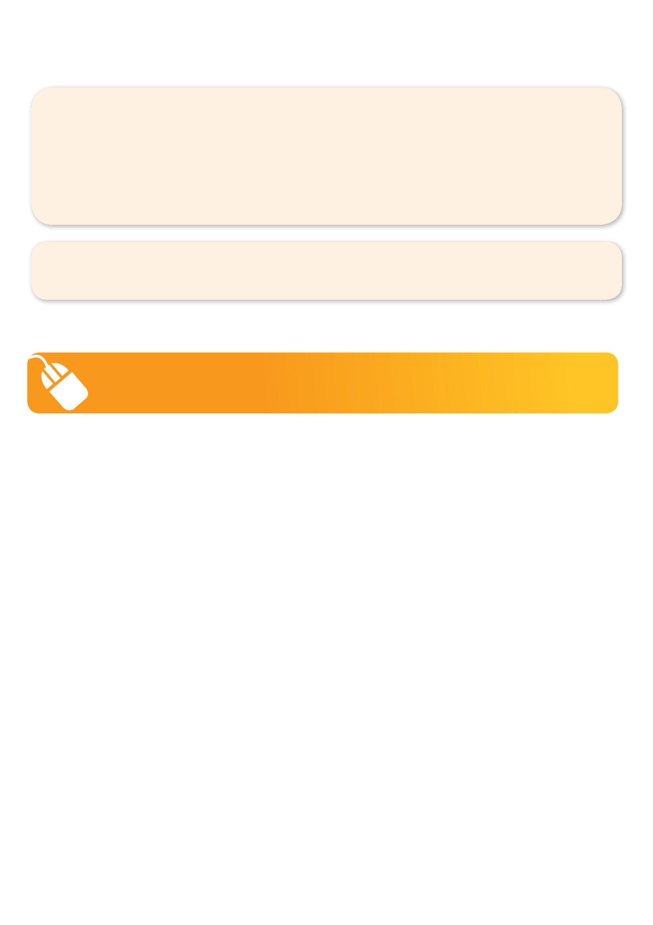**­**

To enrol, please visit [**www.kellysports.com.au**](http://www.kellysports.com.au)or fill out the   
below enrolment form & sendwith a cheque or credit card details to:   
**PO BOX 3011, The Pines VIC 3109**. Payment options available!   
**Do not** leave enrolment forms at the school office.

**ONLINE ENROLMENT**

**www.kellysports.com.au**

**It’s here online enrolments !**

**To enrol**, please visit [www.kellysports.com.au](http://www.kellysports.com.au) or

fill out the enrolment form & **send** with a cheque or credit card details to:

Kelly Sports PO BOX 71, Moonee Vale, VIC, 3055.

Payment options available!

Do **not** leave enrolment forms at the school office

**ENROLMENT FORM**

□  **Dance** (lunchtime) □ **Gym Fun** (Lunch time) □ **Super Summer Sports** (After school)

School: Year Level:

Name: Room No:

Address: Post Code:

Phone: Mobile/Work:

Email: Medical Conditions:

At the completion of after school clinics, does your child? □ Go to after care □ Get collected

**Parents’ consent**

**I hereby authorise Kelly Sports to act on my behalf should my child require medical attention, and release Kelly Sports Templestowe from   
any liability for injury incurred by my child at Kelly Sports programmes.**

□ **I authorise the use by Kelly Sports of any photographs or video image of my child or legal charge for any reasonable purpose.**

Parent/Caregiver name: Signature:

Amount Paid: $

**It’s here online enrolments !**

**To enrol**, please visit [www.kellysports.com.au](http://www.kellysports.com.au) or

fill out the enrolment form & **send** with a cheque or credit card details to:

Kelly Sports PO BOX 71, Moonee Vale, VIC, 3055.

Payment options available!

Do **not** leave enrolment forms at the school office

**It’s here online enrolments !**

**To enrol**, please visit [www.kellysports.com.au](http://www.kellysports.com.au) or

fill out the enrolment form & **send** with a cheque or credit card details to:

Kelly Sports PO BOX 71, Moonee Vale, VIC, 3055.

Payment options available!

Do **not** leave enrolment forms at the school office

**It’s here online enrolments !**

**To enrol**, please visit [www.kellysports.com.au](http://www.kellysports.com.au) or

fill out the enrolment form & **send** with a cheque or credit card details to:

Kelly Sports PO BOX 71, Moonee Vale, VIC, 3055.

Payment options available!

Do **not** leave enrolment forms at the school office