

 P.O. Box 3011, The Pines, 3109

**M** 0414 381 368

**E** [davidkight@kellysports.com.au](mailto:davidkight@kellysports.com.au)

**PARK ORCHARDS PRIMARY SCHOOL**

**WICKED WINTER SPORTS**

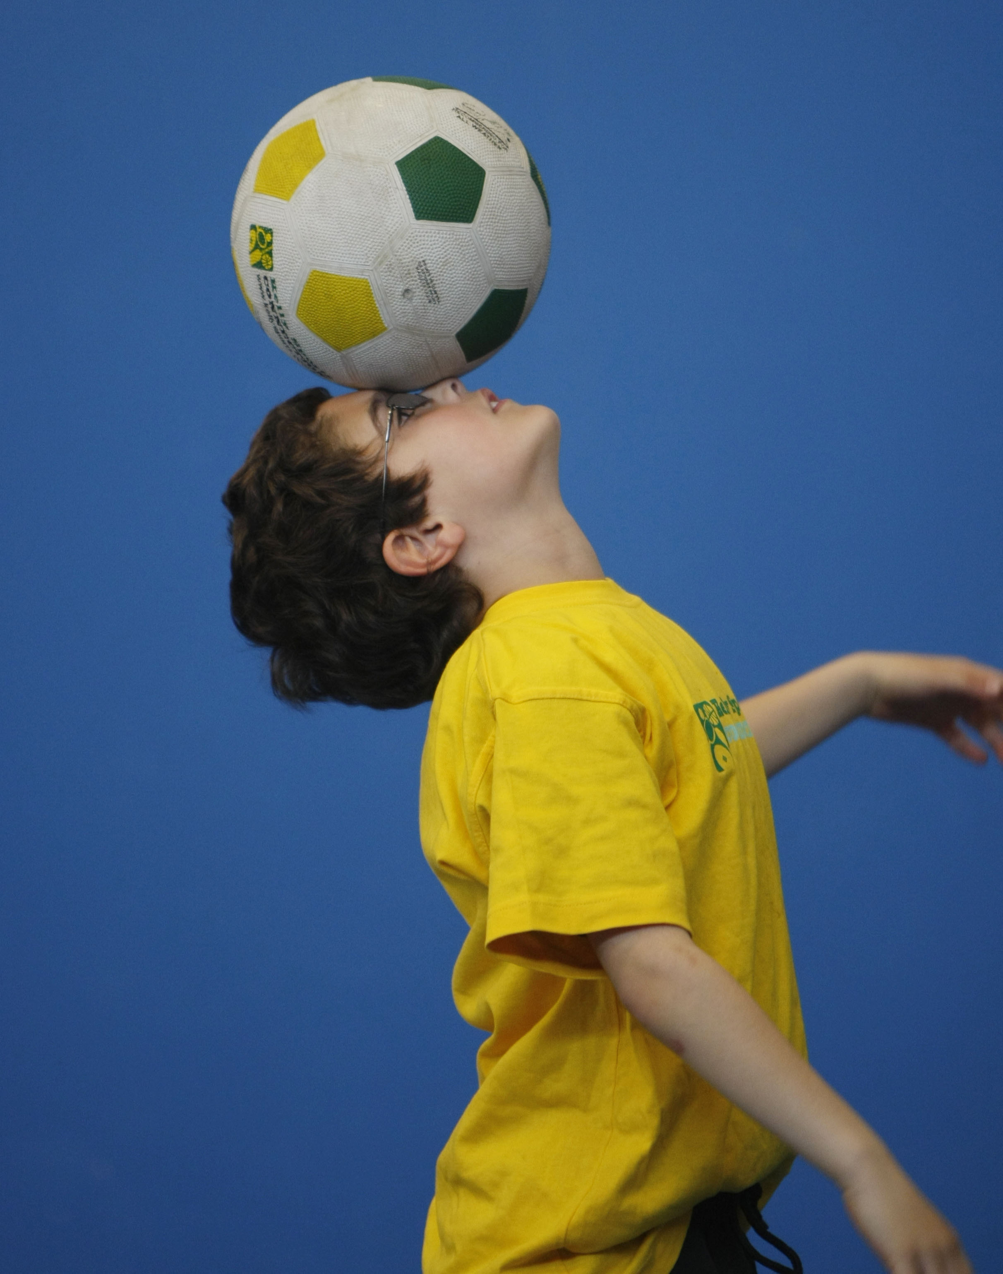

DONT MISS OUT ON KICKING A GOAL! WICKED WINTER SPORTS allows your child to play a range of dynamic and active programs run over **10 weeks**; these include; **Soccer, Football, Tee-Ball, Basketball and Netball!** This Program will not only provide an essential base for your child's motor skills but help build awareness, co-ordination and friendship all in an enjoyable environment.

**WHEN:** Thursday

**COMMENCING:** 17/7/2014

**CONCLUDING:** 18/9/2014

**TIME:** 3.40pm – 4.40pm

**YEAR LEVELS:** P – 4



**GYM FUN**

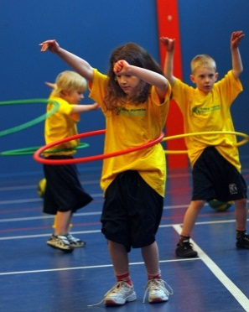

Leap into fun with the Kelly Sports Team. This fast paced, highly active and non-stop program is an introduction for your child to the world of gymnastic. Colourful Ribbons, Entertaining Hula Hoops, Fantastic Rhythmical Routines, Doing Cartwheels and Group Dynamics allow your child to build up their thirst for energetic activities!

**WHEN:** Monday

**COMMENCING:** 14/7/2014

**CONCLUDING:** 15/9/2014

**TIME:** 1.00pm – 1.50pm

**YEAR LEVELS:** P – 4



**COST: $100** (go to [www.kellysports.com.au](http://www.kellysports.com.au)/zone/templestoweand search for your school)

**It’s here online enrolments !**

**To enrol**, please visit [www.kellysports.com.au](http://www.kellysports.com.au) or

fill out the enrolment form & **send** with a cheque or credit card details to:

Kelly Sports PO BOX 71, Moonee Vale, VIC, 3055.

Payment options available!

Do **not** leave enrolment forms at the school office

**VENUE: Park Orchards Primary School**

**­**

To enrol, please visit [**w**ww.kellysports.com.au/zone/templestowe](http://www.kellysports.com.au/zone/templestowe)

or fill out the below enrolment form & sendwith a cheque to:

**PO BOX 3011 The Pines VIC 3109**. Payment options available

! **Do not** leave enrolment forms at the school office.

**ONLINE ENROLMENT**

**www.kellysports.com.au/zone/templestowe**

**It’s here online enrolments !**

**To enrol**, please visit [www.kellysports.com.au](http://www.kellysports.com.au) or

fill out the enrolment form & **send** with a cheque or credit card details to:

Kelly Sports PO BOX 71, Moonee Vale, VIC, 3055.

Payment options available!

Do **not** leave enrolment forms at the school office

**ENROLMENT FORM**

□ **Wicked Winter Sports** (After School) □ **Gym Fun** (Lunch time)

School: Year Level:

Name: Room No:

Address: Post Code:

Phone: Mobile/Work:

Email: Medical Conditions:

At the completion of after school clinics, does your child? □ Go to after care □ Get collected

**Parents’ consent: I hereby authorise Kelly Sports to act on my behalf should my child require medical attention, and release   
Kelly Sports Templestowe from any liability for injury incurred by my child at Kelly Sports programmes.**

**Payment Options: Go online and pay via Direct Deposit or credit card via Pay Pal.**

Parent/Caregiver name: Signature:

Amount Paid: $

**It’s here online enrolments !**

**To enrol**, please visit [www.kellysports.com.au](http://www.kellysports.com.au) or

fill out the enrolment form & **send** with a cheque or credit card details to:

Kelly Sports PO BOX 71, Moonee Vale, VIC, 3055.

Payment options available!

Do **not** leave enrolment forms at the school office

**It’s here online enrolments !**

**To enrol**, please visit [www.kellysports.com.au](http://www.kellysports.com.au) or

fill out the enrolment form & **send** with a cheque or credit card details to:

Kelly Sports PO BOX 71, Moonee Vale, VIC, 3055.

Payment options available!

Do **not** leave enrolment forms at the school office

**It’s here online enrolments !**

**To enrol**, please visit [www.kellysports.com.au](http://www.kellysports.com.au) or

fill out the enrolment form & **send** with a cheque or credit card details to:

Kelly Sports PO BOX 71, Moonee Vale, VIC, 3055.

Payment options available!

Do **not** leave enrolment forms at the school office