 P.O. Box 3011, The Pines 3109

**T** 0414 381 368

**E** [davidkight@kellysports.com.au](mailto:davidkight@kellysports.com.au)

**PARK ORCHARDS PRIMARY SCHOOL**

**WICKED WINTER SPORTS**

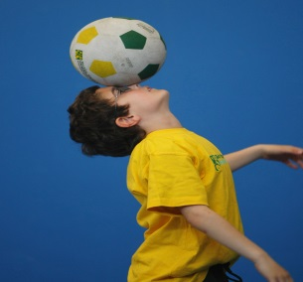

**WHEN:** Thursday

**COMMENCING:** 14/07/2016

**CONCLUDING:** 15/9/2016

**TIME:** 3.40pm –4.40pm

**YEAR LEVELS:** P – 4

DONT MISS OUT ON SHOOTING A GOAL! WICKED WINTER SPORTS allows your child to play a range of dynamic and active programs run over **10 weeks** these include; **Soccer, Cricket, Basketball, T-Ball and Cricket!** This Program will not only provide an essential base for your child's motor skills but help build awareness, co-ordination and friendship all in an enjoyable environment.



**GYM FUN**

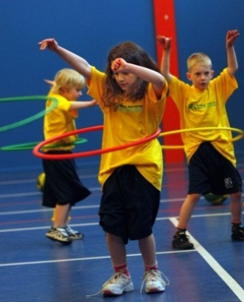

**WHEN:** Monday

**COMMENCING:** 11/07/2016

**CONCLUDING:** 12/9/2016

**TIME:** 1.00pm – 1.50pm

**YEAR LEVELS:** P – 4

This fun fast paced, highly active and non-stop program is an introduction for your child to the world of gymnastics. **Colourful ribbons, Entertaining Hula Hoops, Incredible** **Rhythmical Routines and Group Dynamics**. Allow your child to build their gymnastics skills and their thirst for exciting energetic activities.

**COST: $100-EARLY BIRD RATE –JUST $90 IF YOU ENROL BY Friday 1st July!** ( go to [**www.kellysports.com.au**](http://www.kellysports.com.au) and search for your school)

**It’s here online enrolments!**

**To enrol**, please visit [www.kellysports.com.au](http://www.kellysports.com.au) or

fill out the enrolment form & **send** with a cheque or credit card details to:

Kelly Sports PO BOX 71, Moonee Vale, VIC, 3055.

Payment options available!

Do **not** leave enrolment forms at the school office

**VENUE: Park Orchards Primary School**

**­**

To enrol, please visit [**www.kellysports.com.au**](http://www.kellysports.com.au)or fill out the   
below enrolment form & sendwith a cheque or credit card details to:   
**PO BOX 3011, The PinesVIC 3109**. Payment options available!   
**Do not** leave enrolment forms at the school office.

**It’s here online enrolments!**

**To enrol**, please visit [www.kellysports.com.au](http://www.kellysports.com.au) or

fill out the enrolment form & **send** with a cheque or credit card details to:

Kelly Sports PO BOX 71, Moonee Vale, VIC, 3055.

Payment options available!

Do **not** leave enrolment forms at the school office

**ENROLMENT FORM**

□ **Wicked Winter Sports** (After school) □ **Gym Fun** (Lunch time)

School: Year Level:

Name: Room No:

Address: Post Code:

Phone: Mobile/Work:

Email: Medical Conditions:

At the completion of after school clinics, does your child? □ Go to after care □ Get collected

**Parents’ consent**

**I hereby authorise Kelly Sports to act on my behalf should my child require medical attention, and release Kelly Sports Templestowe from   
any liability for injury incurred by my child at Kelly Sports programmes.**

□ **I authorise the use by Kelly Sports of any photographs or video image of my child or legal charge for any reasonable purpose.**

Parent/Caregiver name: Signature:

Amount Paid: $

**ONLINE ENROLMENT**

**www.kellysports.com.au**

**It’s here online enrolments!**

**To enrol**, please visit [www.kellysports.com.au](http://www.kellysports.com.au) or

fill out the enrolment form & **send** with a cheque or credit card details to:

Kelly Sports PO BOX 71, Moonee Vale, VIC, 3055.

Payment options available!

Do **not** leave enrolment forms at the school office

**It’s here online enrolments !**

**To enrol**, please visit [www.kellysports.com.au](http://www.kellysports.com.au) or

fill out the enrolment form & **send** with a cheque or credit card details to:

Kelly Sports PO BOX 71, Moonee Vale, VIC, 3055.

Payment options available!

Do **not** leave enrolment forms at the school office

**It’s here online enrolments !**

**To enrol**, please visit [www.kellysports.com.au](http://www.kellysports.com.au) or

fill out the enrolment form & **send** with a cheque or credit card details to:

Kelly Sports PO BOX 71, Moonee Vale, VIC, 3055.

Payment options available!

Do **not** leave enrolment forms at the school office