 P.O. Box 3011, the Pines, 3109

**M** 0414 381 368

**E** [davidkight@kellysports.com.au](mailto:davidkight@kellysports.com.au)

**MONTMORENCY SOUTH PRIMARY SCHOOL**

**WICKED WINTER SPORTS**

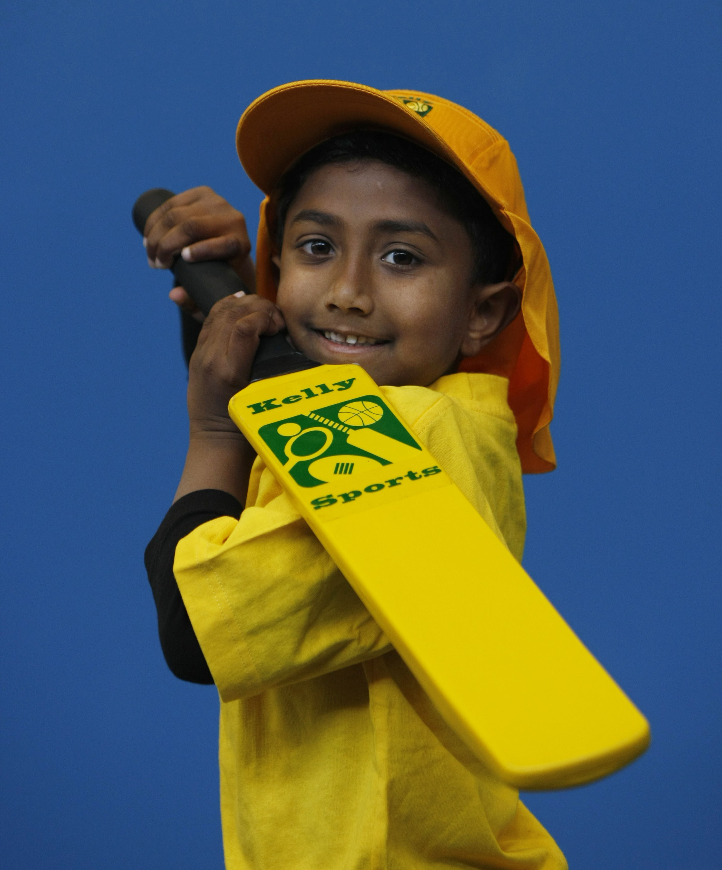

DONT MISS OUT ON KICKING A GOAL! WICKED WINTER SPORTS allows your child to play a range of dynamic and active programs run over **10 weeks**; these include; **Soccer, Football, Tee-Ball, Basketball and Netball!** This Program will not only provide an essential base for your child's motor skills but help build awareness, co-ordination and friendship all in an enjoyable environment.

**WHEN:** Tuesday

**COMMENCING:** 15/7/2014

**CONCLUDING:** 16/9/2014

**TIME:** 11.10am – 12.00pm

**YEAR LEVELS:** P – 4

**WHEN:** Friday

**COMMENCING:** 18/7/2014

**CONCLUDING:** 19/9/2014

**TIME:** 3.40pm – 4.40pm

**YEAR LEVELS:** P – 4



**DANCE**

Shake, move and let the beat enter your feet with Kelly Sports. Our trained dance coaches can get your child’s **hips swinging, heads bumping, feet rocking and bodies shaking** to all of modern contemporary music’s classics. Sign up fast as places are limited and let our coaches beat ignite your child’s dancing feet.

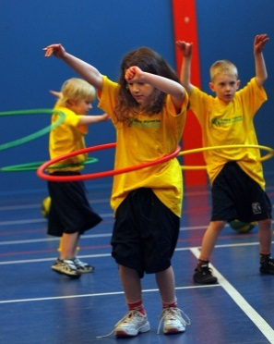



**COST: $100** ( go to [www.kellysports.com.au](http://www.kellysports.com.au)/zone/templestowe

**It’s here online enrolments!**

**To enrol**, please visit [www.kellysports.com.au](http://www.kellysports.com.au) or

fill out the enrolment form & **send** with a cheque or credit card details to:

Kelly Sports PO BOX 71, Moonee Vale, VIC, 3055.

Payment options available!

Do **not** leave enrolment forms at the school office

and search for your school)

**VENUE: Montmorency South Primary School**

**­**

**It’s here online enrolments!**

**To enrol**, please visit [www.kellysports.com.au](http://www.kellysports.com.au) or

fill out the enrolment form & **send** with a cheque or credit card details to:

Kelly Sports PO BOX 71, Moonee Vale, VIC, 3055.

Payment options available!

Do **not** leave enrolment forms at the school office

**ENROLMENT FORM**

□ **Wicked Winter Sports** (after school) □ **Dance** (Lunch time)

School: Year Level:

Name: Room No:

Address: Post Code:

Phone: Mobile/Work:

Email: Medical Conditions:

At the completion of after school clinics, does your child? □ Go to after care □ Get collected

**Parents’ consent: I hereby authorise Kelly Sports to act on my behalf should my child require medical attention, and release   
Kelly Sports Templestowe from any liability for injury incurred by my child at Kelly Sports programmes.**

Parent/Caregiver name: Signature:

Amount Paid: $

To enrol, please visit [**w**ww.kellysports.com.au/zone/templestowe](http://www.kellysports.com.au/zone/templestowe)

or fill out the below enrolment form & sendwith a cheque or credit

card details to: **PO BOX 3011, The Pines ,VIC 3109**. Payment options available! **Do not** leave enrolment forms at the school office.

**ONLINE ENROLMENT**

**www.kellysports.com.au/zone/templestowe**

**It’s here online enrolments !**

**To enrol**, please visit [www.kellysports.com.au](http://www.kellysports.com.au) or

fill out the enrolment form & **send** with a cheque or credit card details to:

Kelly Sports PO BOX 71, Moonee Vale, VIC, 3055.

Payment options available!

Do **not** leave enrolment forms at the school office

**It’s here online enrolments !**

**To enrol**, please visit [www.kellysports.com.au](http://www.kellysports.com.au) or

fill out the enrolment form & **send** with a cheque or credit card details to:

Kelly Sports PO BOX 71, Moonee Vale, VIC, 3055.

Payment options available!

Do **not** leave enrolment forms at the school office

**It’s here online enrolments !**

**To enrol**, please visit [www.kellysports.com.au](http://www.kellysports.com.au) or

fill out the enrolment form & **send** with a cheque or credit card details to:

Kelly Sports PO BOX 71, Moonee Vale, VIC, 3055.

Payment options available!

Do **not** leave enrolment forms at the school office