

 P.O. Box 3011, The Pines 3109

**T** 0414 381 368

**E**  [davidkight@kellysports.com.au](mailto:%20davidkight@kellysports.com.au)

**MILGATE PRIMARY SCHOOL**



**GYM FUN**

This fun fast paced, highly active and non-stop program is an introduction for your child to the world of gymnastics. **Colourful ribbons, Entertaining Hula Hoops, Incredible** **Rhythmical Routines and Group Dynamics**. Allow your child to build their gymnastics skills and their thirst for exciting energetic activities.

**WHEN:** Wednesday

**COMMENCING:** 16/7/2014

**CONCLUDING:** 17/9/2014

**TIME:** 12.50pm – 1.50pm

**YEAR LEVELS:** P – 4



**WICKED WINTER SPORTS**

DONT MISS OUT ON KICKING A GOAL! WICKED WINTER SPORTS allows your child to play a range of dynamic and active programs run over **10 weeks**; these include; **Soccer, Football, Tee-Ball, Basketball and Netball!** This Program will not only provide an essential base for your child's motor skills but help build awareness, co-ordination and friendship all in an enjoyable environment

**WHEN:** Tuesday

**COMMENCING:** 15/7/2014

**CONCLUDING:** 16/9/2014

**TIME:** 3.40pm – 4.40pm

**YEAR LEVELS:** P – 4



**COST: (**go to [www.kellysports.com.au](http://www.kellysports.com.au)/zone/templestoweand search for your school).

**It’s here online enrolments !**

**To enrol**, please visit [www.kellysports.com.au](http://www.kellysports.com.au) or

fill out the enrolment form & **send** with a cheque or credit card details to:

Kelly Sports PO BOX 71, Moonee Vale, VIC, 3055.

Payment options available!

Do **not** leave enrolment forms at the school office

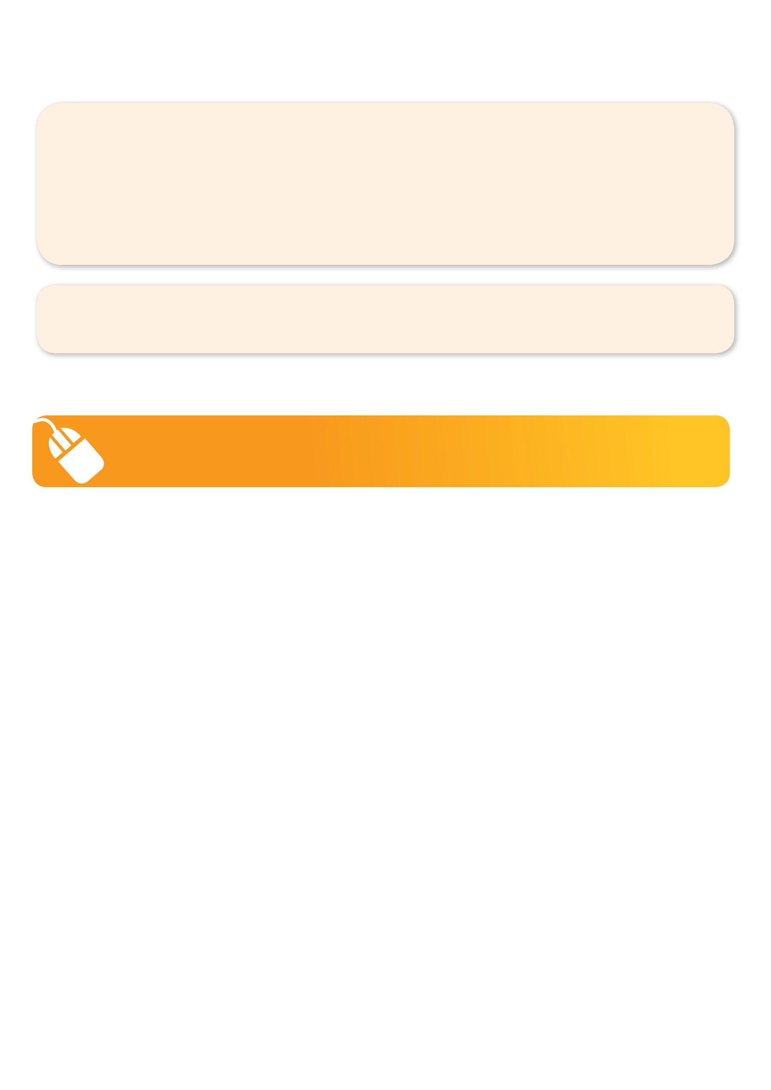**VENUE: Milgate Primary School**

**­**

To enrol, please visit [**www.kellysports.com.au**](http://www.kellysports.com.au)**/templestowe** or fill

out the below enrolment form & sendwith a cheque

to: **PO BOX 3011, The Pines VIC 3109**. Payment options available!   
**Do not** leave enrolment forms at the school office.

**ONLINE ENROLMENT**

**www.kellysports.com.au/zone/templestowe**

**It’s here online enrolments !**

**To enrol**, please visit [www.kellysports.com.au](http://www.kellysports.com.au) or

fill out the enrolment form & **send** with a cheque or credit card details to:

Kelly Sports PO BOX 71, Moonee Vale, VIC, 3055.

Payment options available!

Do **not** leave enrolment forms at the school office

**ENROLMENT FORM**

□ **Gym Fun** (Lunch time) □ **Wicked Winter Sports** (After school)

School: Year Level:

Name: Room No:

Address: Post Code:

Phone: Mobile/Work:

Email: Medical Conditions:

At the completion of after school clinics, does your child? □ Go to after care □ Get collected

**Parents’ consent: I hereby authorise Kelly Sports to act on my behalf should my child require medical attention, and release   
Kelly Sports Templestowe from any liability for injury incurred by my child at Kelly Sports programmes.**

**Payment Options: Go online and pay via Direct Deposit or credit card via Pay Pal.**

Parent/Caregiver name: Signature:

Amount Paid: $ __________________

**It’s here online enrolments !**

**To enrol**, please visit [www.kellysports.com.au](http://www.kellysports.com.au) or

fill out the enrolment form & **send** with a cheque or credit card details to:

Kelly Sports PO BOX 71, Moonee Vale, VIC, 3055.

Payment options available!

Do **not** leave enrolment forms at the school office

**It’s here online enrolments !**

**To enrol**, please visit [www.kellysports.com.au](http://www.kellysports.com.au) or

fill out the enrolment form & **send** with a cheque or credit card details to:

Kelly Sports PO BOX 71, Moonee Vale, VIC, 3055.

Payment options available!

Do **not** leave enrolment forms at the school office

**It’s here online enrolments !**

**To enrol**, please visit [www.kellysports.com.au](http://www.kellysports.com.au) or

fill out the enrolment form & **send** with a cheque or credit card details to:

Kelly Sports PO BOX 71, Moonee Vale, VIC, 3055.

Payment options available!

Do **not** leave enrolment forms at the school office