 P.O. Box 3011, The Pines 3109

**T** 0414 381 368

**E** [davidkight@kellysports.com.au](mailto:davidkight@kellysports.com.au)

**GOOD SHEPHERD PRIMARY SCHOOL**

**WICKED WINTER SPORTS**

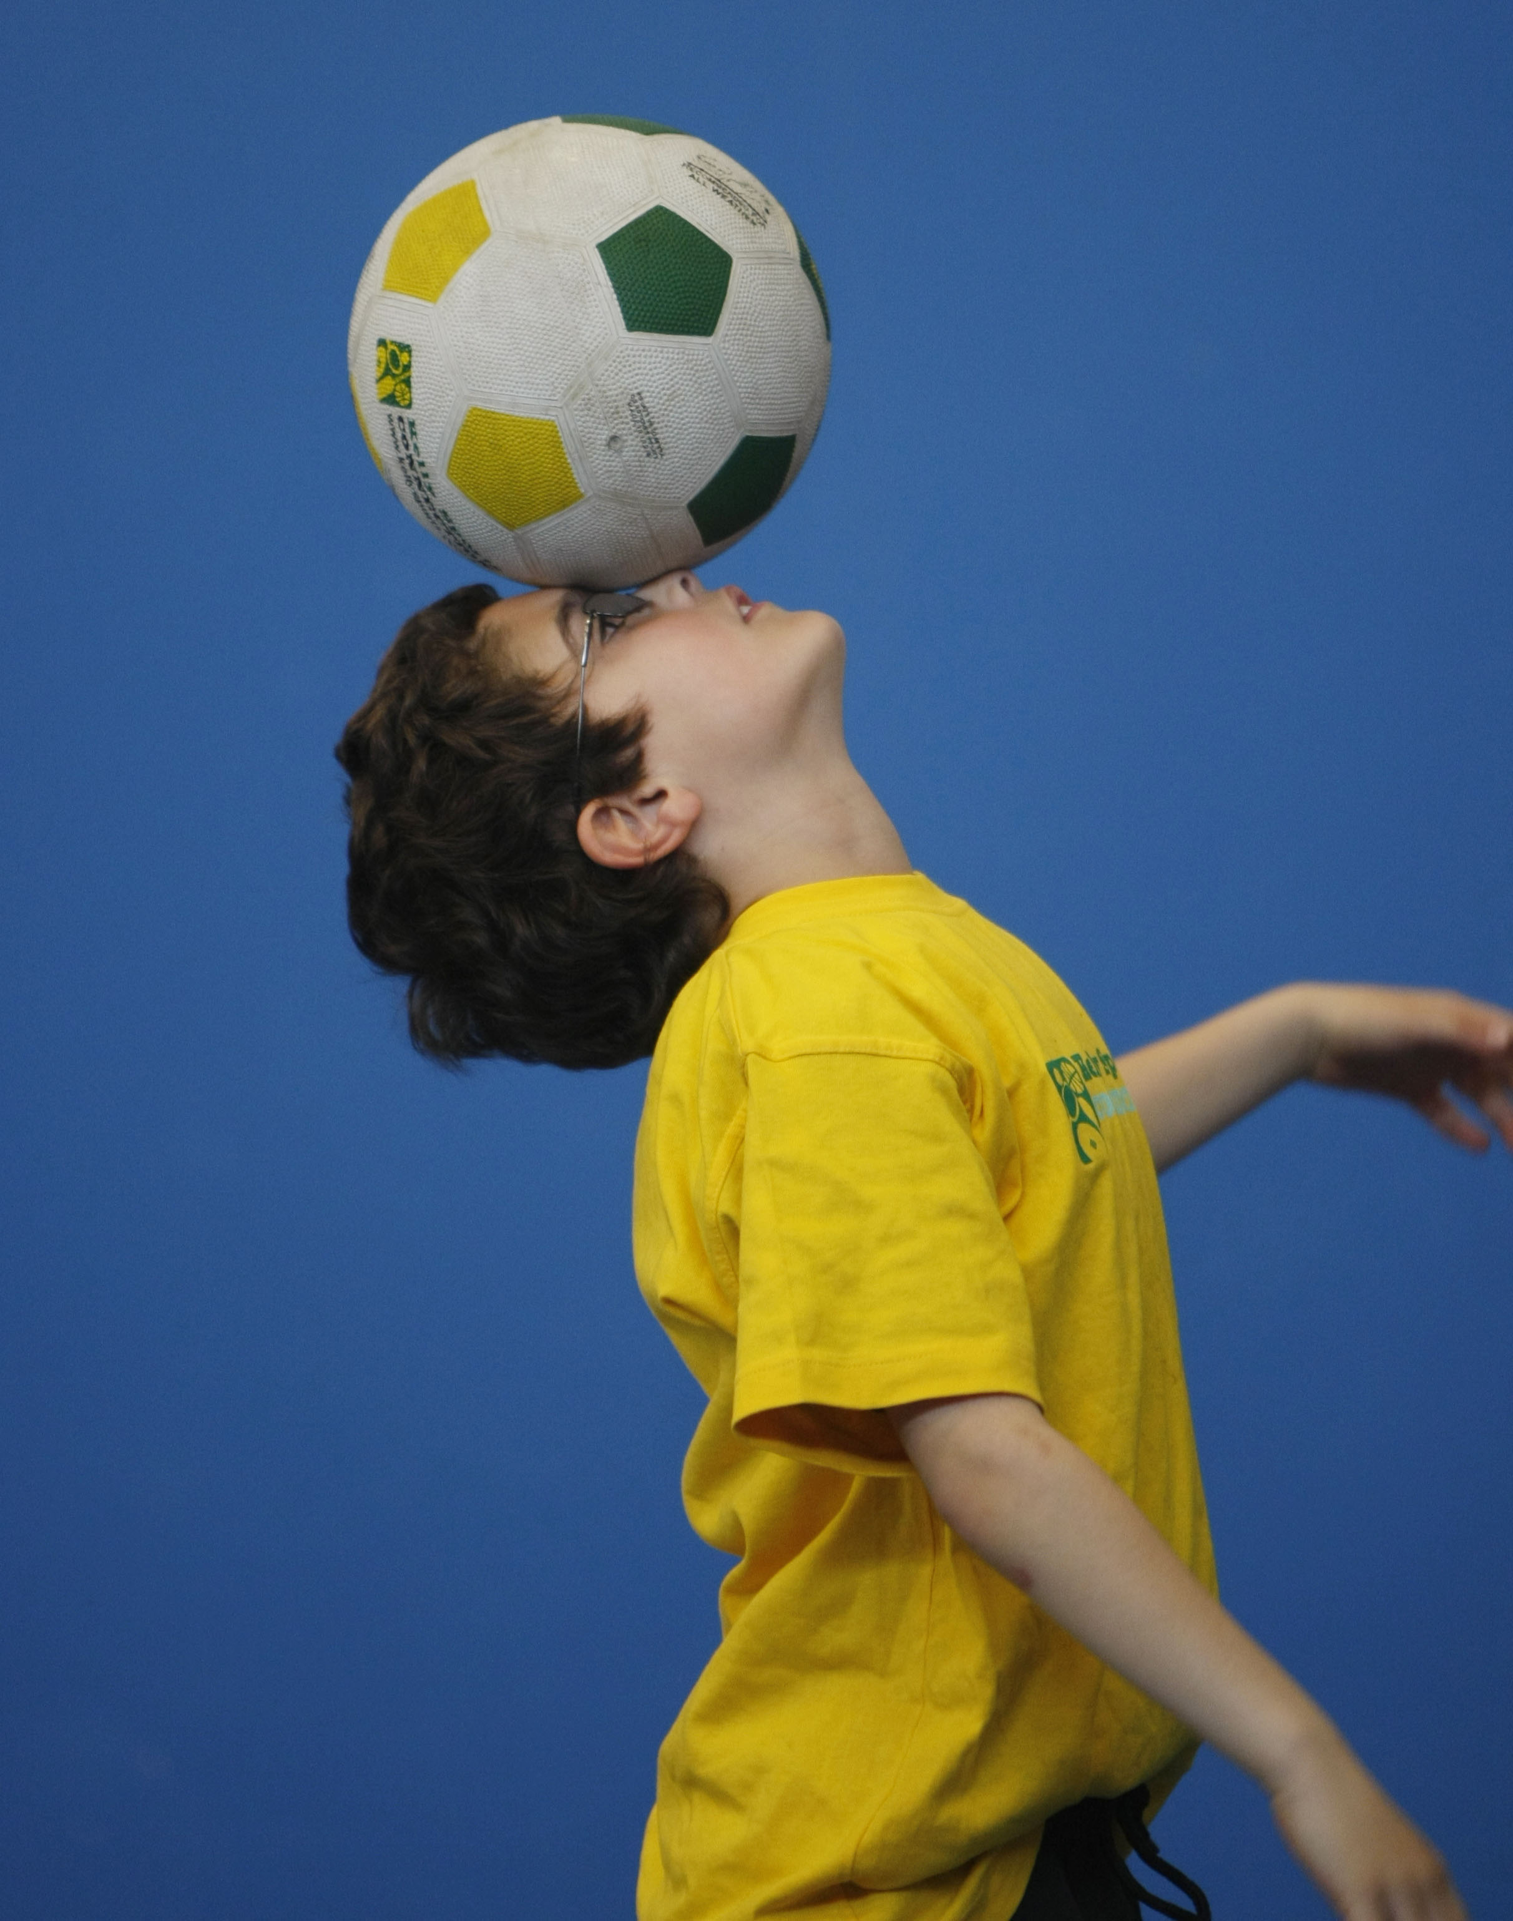

**WHEN:** Tuesday

**COMMENCING:** 21/07/2015

**CONCLUDING:** 15/09/2015

**TIME:** 3.40pm – 4.40pm

**YEAR LEVELS:** P – 4

DONT MISS OUT ON KICKING A GOAL! AWESOME AUTUMNSPORTS allows your child to play a range of dynamic and active programs run over **9 weeks** these include; **Soccer, Football, T-ball, Basketball and Crazy Games!** This Program will not only provide an essential base for your child's motor skills but help build awareness, co-ordination and friendship all in an enjoyable environment.

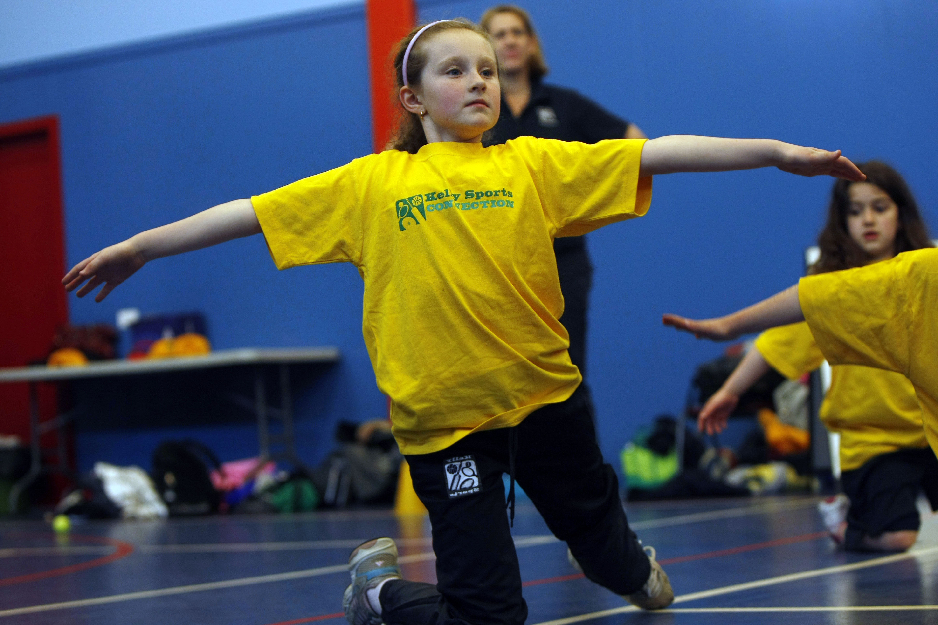

**DANCE**

**WHEN:** Monday

**COMMENCING:** 20/07/2015

**CONCLUDING:** 14/09/2015

**TIME:** 1.10pm –1.45pm

**YEAR LEVELS:** P – 4

LET THE BEAT ENTER YOUR FEET! Our specialized Dance coaches can get your child’s hips swinging, feet rocking and heads bumping to all of modern contemporary music’s classics. Sign up fast as places are limited and let our coaches beat ignite your child’s feet!



**COST: $90 (go to** [**www.kellysports.com.au**](http://www.kellysports.com.au) **and search for your school)**

**It’s here online enrolments !**

**To enrol**, please visit [www.kellysports.com.au](http://www.kellysports.com.au) or

fill out the enrolment form & **send** with a cheque or credit card details to:

Kelly Sports PO BOX 71, Moonee Vale, VIC, 3055.

Payment options available!

Do **not** leave enrolment forms at the school office

**VENUE: Good Shepherd Primary School**

**­**

To enrol, please visit [**www.kellysports.com.au**](http://www.kellysports.com.au)or fill

out the below enrolment form & sendwith a cheque to:

**PO BOX 3011, The Pines VIC 3109**. Payment options

available! **Do not** leave enrolment forms at the school office.

**ONLINE ENROLMENT**

**www.kellysports.com.au/zone/templestowe**

**It’s here online enrolments !**

**To enrol**, please visit [www.kellysports.com.au](http://www.kellysports.com.au) or

fill out the enrolment form & **send** with a cheque or credit card details to:

Kelly Sports PO BOX 71, Moonee Vale, VIC, 3055.

Payment options available!

Do **not** leave enrolment forms at the school office

**ENROLMENT FORM**

□ **Wicked Winter Sports** (After School) □ **Dance** (Lunchtime)

School: Year Level:

Name: Room No:

Address: Post Code:

Phone: Mobile/Work:

Email: Medical Conditions:

At the completion of after school clinics, does your child? □ Go to after care □ Get collected

**Parents’ consent: I hereby authorise Kelly Sports to act on my behalf should my child require medical attention, and release   
Kelly Sports Templestowe from any liability for injury incurred by my child at Kelly Sports programmes.**

**Payment Options: Go online and pay via Direct Deposit or credit card.**

Parent/Caregiver name: Signature:

Amount Paid: $

**It’s here online enrolments !**

**To enrol**, please visit [www.kellysports.com.au](http://www.kellysports.com.au) or

fill out the enrolment form & **send** with a cheque or credit card details to:

Kelly Sports PO BOX 71, Moonee Vale, VIC, 3055.

Payment options available!

Do **not** leave enrolment forms at the school office

**It’s here online enrolments !**

**To enrol**, please visit [www.kellysports.com.au](http://www.kellysports.com.au) or

fill out the enrolment form & **send** with a cheque or credit card details to:

Kelly Sports PO BOX 71, Moonee Vale, VIC, 3055.

Payment options available!

Do **not** leave enrolment forms at the school office

**It’s here online enrolments !**

**To enrol**, please visit [www.kellysports.com.au](http://www.kellysports.com.au) or

fill out the enrolment form & **send** with a cheque or credit card details to:

Kelly Sports PO BOX 71, Moonee Vale, VIC, 3055.

Payment options available!

Do **not** leave enrolment forms at the school office