 P.O. Box 3011, The Pines 3109

**T** 0414 381 368

**E** [davidkight@kellysports.com.au](mailto:davidkight@kellysports.com.au)

 **Cuddly Bear Child Care**

**FUNDAMENTAL**

**SKILLS PROGRAM**

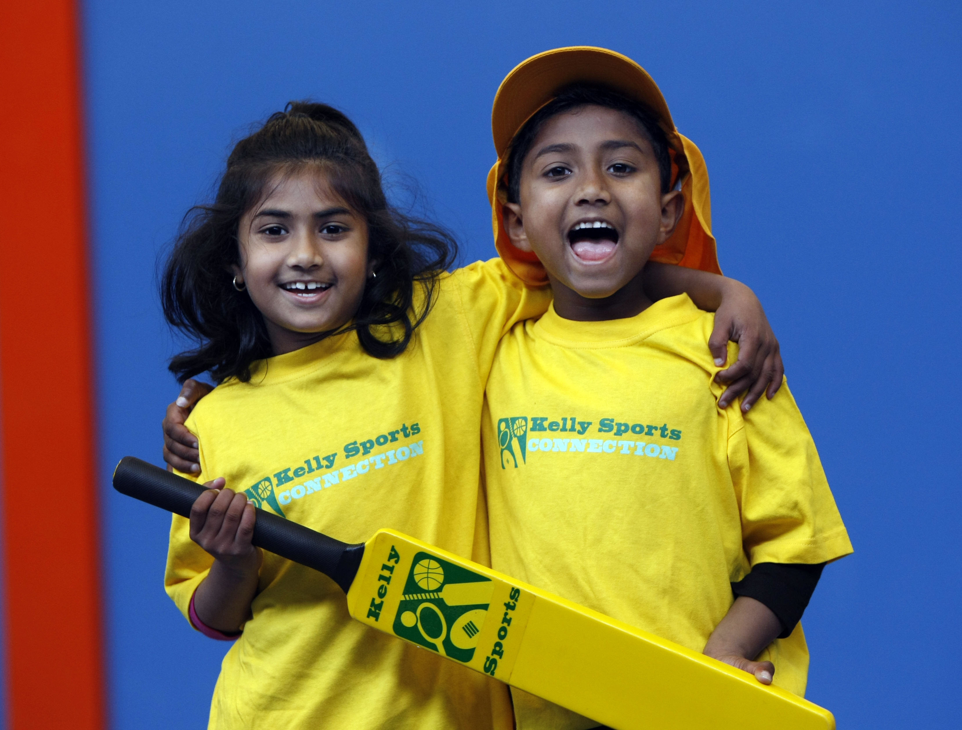

Kelly Sports runs programmes to teach children the fundamentals of sport. This **22 WEEK** program is all inclusive with high participation. Our key aims are to develop and enhance the following skills – **running, jumping, catching, throwing, passing, kicking and striking:**

The Fundamental Skills Program includes:

**- Motor Skill Development  
- Balance and Hand- Eye Cordination  
- Introduction to a variety of sports -Soccer, Basketball, Cricket, Hockey, Football and more.**

**WHEN: Thursday**

**COMMENCING:** 14/7/2016

**CONCLUDING:** 8/12/2016

**TIME:** 10.30am – 11.00am

**TIME:** 11.00am – 11.30am



**COST: $ 132** (enrol online – go to [www.kellysports.com.au](http://www.kellysports.com.au)

**It’s here online enrolments !**

**To enrol**, please visit [www.kellysports.com.au](http://www.kellysports.com.au) or

fill out the enrolment form & **send** with a cheque or credit card details to:

Kelly Sports PO BOX 71, Moonee Vale, VIC, 3055.

Payment options available!

Do **not** leave enrolment forms at the school office

and search for your centre)

**VENUE: Cuddly Bear Child Care and Kinder**

**­**

**It’s here online enrolments !**

**To enrol**, please visit [www.kellysports.com.au](http://www.kellysports.com.au) or

fill out the enrolment form & **send** with a cheque or credit card details to:

Kelly Sports PO BOX 71, Moonee Vale, VIC, 3055.

Payment options available!

Do **not** leave enrolment forms at the school office

**ENROLMENT FORM**

School: Year Level:

Name: Room No:

Address: Post Code:

Phone: Mobile/Work:

Email: Medical Conditions:

At the completion of after school clinics, does your child? □ Go to after care □ Get collected

**Parents’ consent: I hereby authorise Kelly Sports to act on my behalf should my child require medical attention, and release   
Kelly Sports Templestowe from any liability for injury incurred by my child at Kelly Sports programmes.**

**COST: Payment Options-Credit Card and Direct Deposit are options when enrolling online.**

Parent/Caregiver name: Signature:

Amount Paid: $

To enrol, please visit **www.kellysports.com.au**

or fill out the below enrolment form & sendwith a cheque to: **PO BOX 3011, The Pines VIC 3109**. Payment

options available! **Do not** leave enrolment forms at Childcare.

**ONLINE ENROLMENT**

**www.kellysports.com.au**

**It’s here online enrolments !**

**To enrol**, please visit [www.kellysports.com.au](http://www.kellysports.com.au) or

fill out the enrolment form & **send** with a cheque or credit card details to:

Kelly Sports PO BOX 71, Moonee Vale, VIC, 3055.

Payment options available!

Do **not** leave enrolment forms at the school office

**It’s here online enrolments !**

**To enrol**, please visit [www.kellysports.com.au](http://www.kellysports.com.au) or

fill out the enrolment form & **send** with a cheque or credit card details to:

Kelly Sports PO BOX 71, Moonee Vale, VIC, 3055.

Payment options available!

Do **not** leave enrolment forms at the school office

**It’s here online enrolments !**

**To enrol**, please visit [www.kellysports.com.au](http://www.kellysports.com.au) or

fill out the enrolment form & **send** with a cheque or credit card details to:

Kelly Sports PO BOX 71, Moonee Vale, VIC, 3055.

Payment options available!

Do **not** leave enrolment forms at the school office