

**TEMPLESTOWE VALLEY**

**PRIMARY SCHOOL P** (03) 9384 2204

**M** 0403 149 391

** E** [mitch@kellysports.com.au](mailto:mitch@kellysports.com.au)

**GROOVY JAZZ**

Come and experience all the fun in our 9 week Kelly Sports

Groovy Jazz Dance program.

Groovy Jazz is a new and exciting jazz based routine for term 3. Students will have a fantastic time learning the new moves in our high intensity, excitement-filled dance environment. Our experienced coaches will work through the steps each week, while also incorporating lots of fun dance related games and activities. Sign up fast for this popular program.





**How To Enrol?**Please visit [www.kellysports.com.au/events](http://www.kellysports.com.au/events) and search for your school.  
Our new booking system requires upfront payments to secure your position. For more information, please call the head office.



**"The Kelly Sports Programs offer our students opportunities for physical activities; including dance & multi-sports. Conveniently located on our school grounds, they are popular with students and their families. Staff are skilled in working with young people to love active participation.”**



***Amanda Hay, Principal – Newtown Primary School***

**CLASS INFORMATION**

Only 14 spots available so sign up fast to secure your position  
  
At the end of the term parents will be invited to an open class to watch the full dance routine.

Come & join us every Tuesday at Lunch Time.

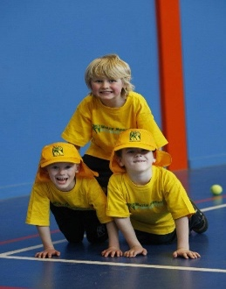

**When: Tuesday**  
**Starts: 24th July**  
**Finishes: 18th September**  
**Time: 1:30pm – 2:30pm**  
**Year Levels: Prep – 4  
Cost: $118.80 (Inc GST)**

