

**GOOD SHEPHERD**

**LUTHERAN PS P** (03) 9384 2204

**M** 0403 149 391

** E** [mitch@kellysports.com.au](mailto:mitch@kellysports.com.au)

**MIGHTY MULTI SPORTS**

Come and experience all the fun in our 9 week Kelly Sports

Mighty Multi Sport program.

Our Kelly Sports classes are all inclusive, fun & interactive with a key focus on maximum participation. Each week children will be introduced to new sports & activities in a positive environment. It’s a fantastic way to get your child active while having fun as well as building confidence and social skills!





**How To Enrol?**Please visit [www.kellysports.com.au/events](http://www.kellysports.com.au/events) and search for your school.  
Our new booking system requires upfront payments to secure your position. For more information, please call the head office.



**"The Kelly Sports Programs offer our students opportunities for physical activities; including dance & multi-sports. Conveniently located on our school grounds, they are popular with students and their families. Staff are skilled in working with young people to love active participation.”**



***Amanda Hay, Principal – Newtown Primary School***

**CLASS INFORMATION**

Only 14 spots available so sign up fast to secure your position  
  
Activities include **AFL, Soccer, Tee ball, Basketball/Netball, p**lus we will incorporate our Kelly Sports Modified games children love

Come & join us every Tuesday straight after school.

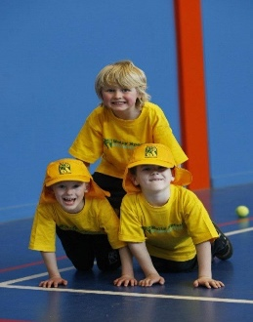

**When: Tuesday**  
**Starts: 24th July**  
**Finishes: 18th September**  
**Time: 3:40pm – 4:40pm**  
**Year Levels: Prep – 4  
Cost: $118.80 (Inc GST)**

