

**CUDDLY BEAR**

**CHILD CARE P** (03) 9384 2204

**M** 0403 149 391

** E** [mitch@kellysports.com.au](mailto:mitch@kellysports.com.au)

**Fundamental Motor Skills**

**Kelly Sports is offering our famous fundamental motor skills program again in Term 1 2019.   
Our program consists of fun-filled sports activities including Soccer, Basketball and AFL while also using bean bags, tennis balls, hula hoops, and more! Our focus as always with kinder aged children is fun, excitement, maximum participation and of course fundamental motor skill development including jumping, bouncing, striking, catching, throwing, balance and hand-eye coordination.**

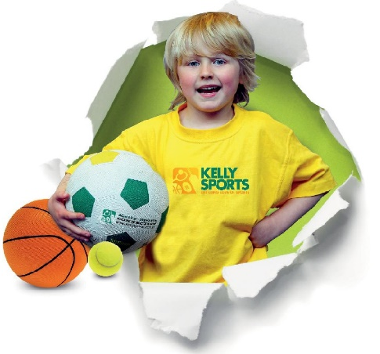



**How To Enrol?**Please visit [www.kellysports.com.au/events](http://www.kellysports.com.au/events) and search for your school.  
Our new booking system requires upfront payments to secure your position. For more information, please call the head office.



**"The Kelly Sports Programs offer our students opportunities for physical activities; including dance & multi-sports. Conveniently located on our school grounds, they are popular with students and their families. Staff are skilled in working with young people to love active participation.”**



***Amanda Hay, Principal – Newtown Primary School***

**CLASS INFORMATION**

Enrol now for all of semester 1. Program will not run over the Easter holidays (April 11th & April 18th) – 19 sessions total

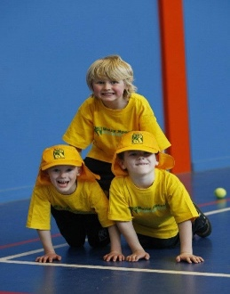

**When: Thursday**   
**Starts: February 7th**   
**Finishes: June 27th**   
**Time:**  **10.30am to 11:30am**   
**Year Levels: Pre kinder & Kinder  
Cost: $190(Inc GST)**

