

**FOLLOW US**

**ONLINE**



**T** 0457 421 662

**E** fiona@kellysports.com.au

**Contact** Fiona (Western Sydney Manager)

**ENGADINE TLC ELC**

**FUNDAMENTAL MOTOR SKILLS**

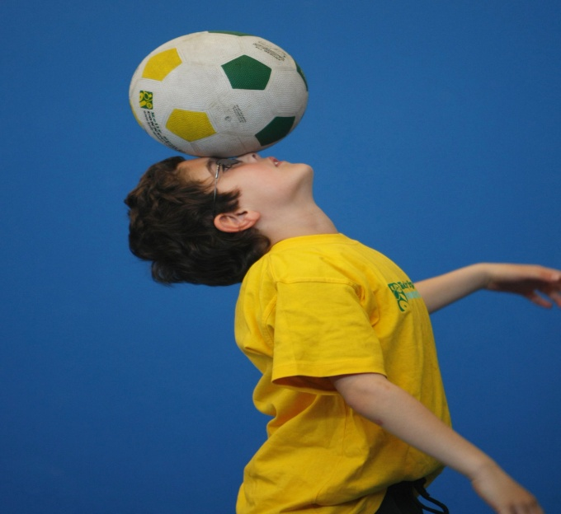

**WHEN:** Tuesday

**COMMENCING:** 6/2/18

**CONCLUDING:** 10/4/18

**TIME:** 10:00am – 11:00am

(30Min Blocks per group)

**YEAR LEVELS:** 2yrs +

**COST:** $75

**Kelly Sports is back offering our famous fundamental motor skills program. Our 10 week program consists of fun-filled sports activities using bean bags, tennis balls, soccer balls, footies, basketballs and more! Our focus as always with Pre School aged children is fun, excitement, maximum participation and of course fundamental motor skill development - including jumping, bouncing, kicking, striking, catching, throwing, balance and hand-eye coordination.**

**GET IN QUICK FOR TERM 1 AS PLACES ARE FILLING FAST**

**$75 FOR 10-WEEK PROGRAM**

**­**

NEW IMPROVED ONLINE BOOKING SYSTEM!!!

SIMPLY GO TO [WWW.KELLYSPORTS.COM.AU](http://WWW.KELLYSPORTS.COM.AU) ENTER YOUR POST CODE AND ENROL FROM THERE. OR

FILL OUT THE BELOW ENROLMENT FOR & RETURN TO THE OFFICE

PAYMENT OPTIONS AVALIABLE!

**It’s here online enrolments !**

**To enrol**, please visit [www.kellysports.com.au](http://www.kellysports.com.au) or

fill out the enrolment form & return to your centre

Kelly Sports PO BOX 71, Moonee Vale, VIC, 3055.

Payment options available!

Do **not** leave enrolment forms at the school office

**ENROLMENT FORM**

□ **Tuesday Fundamental Motor Skills Program**

Pre School: : Date of Birth: __

Child’s Name:

Address: Post Code:

Phone: Mobile/Work:

Email: Medical Conditions:

**Parents’ consent: I hereby authorise Kelly Sports to act on my behalf should my child require medical attention, and release   
Kelly Sports Penrith from any liability for injury incurred by my child at Kelly Sports programs.**

Parent/Caregiver name: Signature:

Amount Paid: $ Credit card payment: □ **Visa** □ **Master card**

Card Number: □□□□ □□□□ □□□□ □□□□Expiry Date: □□/□□CVV:□□□

**THINGS TO KNOW**

Kelly Sports is a Registered Child Care provider

Spaces are limited so please make sure you enrol online or return form to Kelly Sports.

**It’s here online enrolments !**

**To enrol**, please visit [www.kellysports.com.au](http://www.kellysports.com.au) or

fill out the enrolment form & **send** with a cheque or credit card details to:

Kelly Sports PO BOX 71, Moonee Vale, VIC, 3055.

Payment options available!

Do **not** leave enrolment forms at the school office

**It’s here online enrolments !**

**To enrol**, please visit [www.kellysports.com.au](http://www.kellysports.com.au) or

fill out the enrolment form & **send** with a cheque or credit card details to:

Kelly Sports PO BOX 71, Moonee Vale, VIC, 3055.

Payment options available!

Do **not** leave enrolment forms at the school office

**It’s here online enrolments !**

**To enrol**, please visit [www.kellysports.com.au](http://www.kellysports.com.au) or

fill out the enrolment form & **send** with a cheque or credit card details to:

Kelly Sports PO BOX 71, Moonee Vale, VIC, 3055.

Payment options available!

Do **not** leave enrolment forms at the school office