

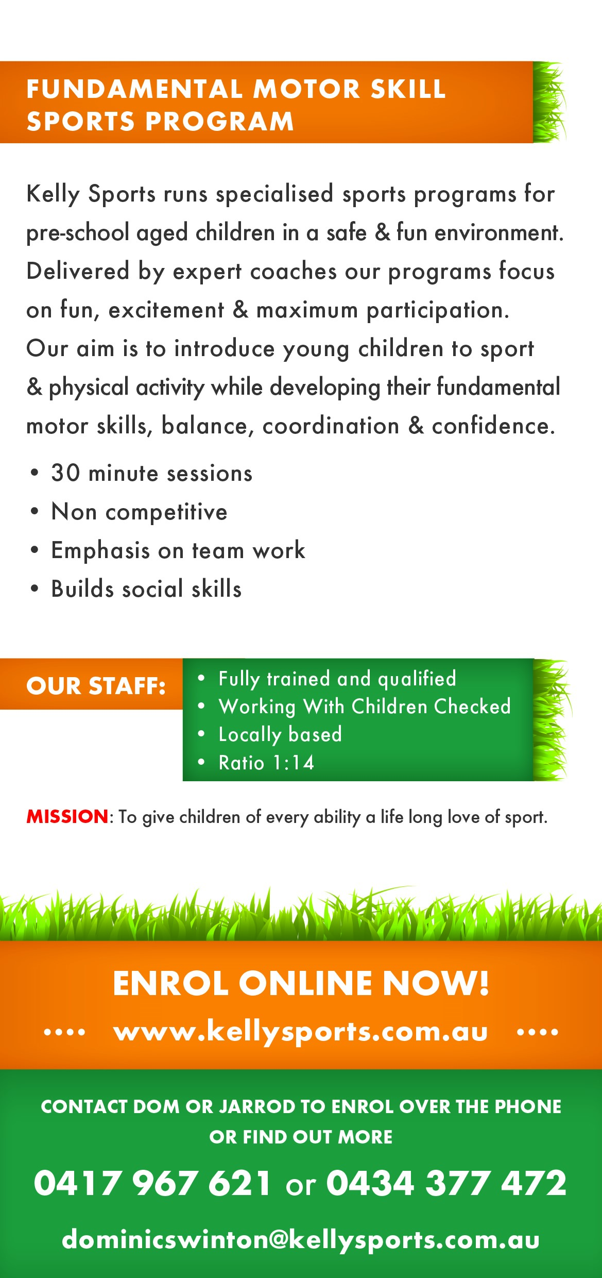

UNDERAM BOWL

* **Hold the ball in one hand**
* **Hang your arm straight to the ground so the ball is next to your leg**
* **Step your opposite foot forward and bend your legs a little bit**
* **Swing your arm backwards, ready to bowl**
* **Swing forwards and let go of the ball so it rolls along the ground**