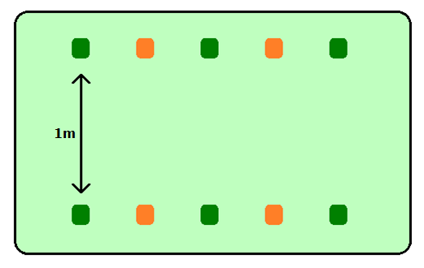



BASKETBALL: THROW AND CATCH

**THROW:**

* **Hold the ball with both hands**
* **Turn hands so your fingers touch your chest**
* **Push the ball towards your partners chest**

**CATCH:**

* **Hold both arms forwards - nice and straight, palms facing the sky**
* **Cuddle the ball to your chest**