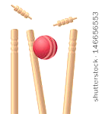

* **Put your hands together to make a bowl of soup**
* **Step your feet a little bit apart, so that they aren’t close to each other**
* **Bend your legs and crouch down so that you are almost sitting on the ground (like a frog)**
* **Put your bowl of soup on the ground so that it is ready to scoop up the ball**
* **Scoop up the ball  
  and close your hands  
  around it so that it  
  can’t get away**



FROGGY FIELDING