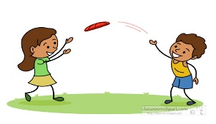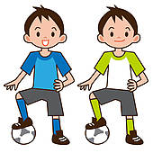

**BRING A FRIEND VOUCHER**

Your child has been chosen by their friend to attend a free session at Kelly Sports on Wednesday 28th Aug from 3:30pm – 4:40pm at Gymea Bay Public School. Anyone is welcome to attend – no booking is required, just turn up!

**BRING A FRIEND VOUCHER**

Your child has been chosen by their friend to attend a free session at Kelly Sports on Wednesday 28th Aug from 3:30pm – 4:40pm at Gymea Bay Public School. Anyone is welcome to attend – no booking is required, just turn up!

**BRING A FRIEND VOUCHER**

Your child has been chosen by their friend to attend a free session at Kelly Sports on Wednesday 28th Aug from 3:30pm – 4:40pm at Gymea Bay Public School. Anyone is welcome to attend – no booking is required, just turn up!

**BRING A FRIEND VOUCHER**

Your child has been chosen by their friend to attend a free session at Kelly Sports on Wednesday 28th Aug from 3:30pm – 4:40pm at Gymea Bay Public School. Anyone is welcome to attend – no booking is required, just turn up!

**BRING A FRIEND VOUCHER**Your child has been chosen by their friend to attend a free session at Kelly Sports on Wednesday 28th Aug from 3:30pm – 4:40pm at Gymea Bay Public School. Anyone is welcome to attend – no booking is required, just turn up!

**BRING A FRIEND VOUCHER**Your child has been chosen by their friend to attend a free session at Kelly Sports on Wednesday 28th Aug from 3:30pm – 4:40pm at Gymea Bay Public School. Anyone is welcome to attend – no booking is required, just turn up!